Shake table test of large scale structurEs subject to pounding

V. CROZET¹, I. POLITOPOULOS¹, Th. CHAUDAT¹

¹Commissariat à l’Energie Atomique (CEA), Gif-sur-Yvette, France

E-mail contact of main author: vincent.crozet@cea.fr

Abstract. Interaction between adjacent buildings during earthquakes is a source of considerable dynamic response modification of the impacting structures. In the case of industrial facilities, besides altering the forces and displacements of the impacting structures, pounding influences considerably their floor response spectra and thus may be unfavorable to the response of equipment. Despite considerable previous work regarding both experimental and numerical studies, only few large scale shake table tests were performed in the past. This article presents the results of large scale shake table tests of two adjacent two storey structures subject to pounding. Experimental results are then compared with numerical predictions. The proposed numerical model shows good agreement with the experimental results regarding the structures’ response and impact force amplitude and duration.
Key Words: buildings pounding; large scale shake table test; floor response spectra

INTRODUCTION
Occurrence of pounding has been observed in the past and has been source of structural and nonstructural damages (Wada et al. 1984, Maison and Ventura 1992, Rojas and Anderson 2012, Cole et al. 2012). These observations as well as experimental studies (Papadrakakis and Mouzakis 1995, Filiatrault et al. 1995) confirmed, as expected, that pounding may considerably modify the peak displacements and inter-storey drifts in comparison with the case without impact. Moreover, pounding generates large amplitude acceleration spikes in the vicinity of the pounding location which may be transmitted in the structures. These acceleration spikes largely influence floor response spectra and thus the response of equipment which is of paramount importancet in the case of industrial and power generation facilities. For instance, Maison and Ventura (1992) studied in-situ acceleration records due to the pounding of a base isolated structure with the surrounding moat wall. They pointed out that the recommended design floor response spectrum for telecommunication equipment was largely overpassed at both the basement and roof levels. Moreover, it is likely that peak accelerations of instrumented actual buildings, subject to pounding, are underestimated due to the sampling frequency of the records and the frequency bandwidth of the employed acceleration sensors.
Regarding experimental studies, to our knowledge, only two large dimension shake table tests were carried out in the past. Papadrakakis and Mouzakis (1995) tested two adjacent two storey frames made of reinforced concrete interacting at each floor level. The two frames were submitted along one direction to a sine wave excitation at the resonant frequency of the most flexible structure. These tests were carried out with two different gaps (a zero gap and a gap such that pounding did not occur) so that the results with pounding were directly compared to those without pounding. For this specific excitation, the displacements of the flexible structure decreased whereas those of the more rigid structure increased due to pounding. Peak accelerations of both structures were considerably amplified due to pounding. Filiatrault et al. (1995) tested pounding between an eight storey and a three storey steel frames at a 1/8 scale. The storeys height of the three storey structure was adaptable so that slab to slab and slab to column impact configurations have been studied.
Nevertheless, in the above experimental studies, strong assumptions were made in the design of the experimental models regarding the contact location and area. In Papadrakakis and Mouzakis (1995), the pounding could occur only locally through a small, highly reinforced contact area located at mid slab edges. In Filiatrault et al. (1995) the contact was possible only at the locations where the impact force measurement sensors were installed. Therefore, for both studies, it may be thought that, because of the localized impacts, the response of the structures may not be representative of the more complex dynamics of two slabs which may interact over their entire edges’ length.
In order to gain a further insight into the consequences of pounding between structures and examine issues which have not been addressed in previous studies, an experimental campaign was carried out on one of the shake tables of the French Commissariat à l’Energie Atomique (CEA) in Saclay, France. The paper presents the main findings of these experiments as well as the results of numerical simulations which are in a good agreement with the experimental results.

Experimental campaign

Experimental set up
Two 5 meters high, two storey steel frames models were uni-axially tested on a 6 m x 6 m, 6 degrees of freedom, shake table. The general lay out of the tested models is presented in Figure 1. At each floor reinforced concrete slabs are installed. The in plane dimensions of the slabs are bigger than those of the frames so that interaction may occur only between slabs, over their entire edge length. HE100AA and HE140AA steel columns are used for the more flexible structure (Structure I) and the more rigid structure (Structure II) respectively. Hence, the “rigid” frame is approximately three times stiffer than the “flexible” frame in the direction of the excitation (denoted as principal direction in Figure 1). The columns are bolted to horizontal rectangular frames composed of IPEA200 steel beams. The joints of these horizontal frames have been reinforced with 1.5 cm thick stiffeners and connecting plates. For both structures, columns were made of S355 steel grade while beams were made of S275 steel grade. The 22 cm thick slabs are mounted on the beams with prestressed bolts which prevent slipping even when pounding occurs. Of course, after the assembly of the whole models on the table, the edges of the slabs of the two models were not perfectly parallel and thus, discrepancies might appear with respect to theoretical models without imperfections. Nevertheless, despite the additional difficulties that imperfections may induce for the interpretation of the results, this configuration is obviously, more representative of impact conditions of actual buildings.
The models are not scaled models of prototype structures. Instead, they have been designed so that their eigenfrequencies, in the longitudinal direction, are in the range of eigenfrequencies of commonly met buildings. In the transverse direction, the models have been reinforced with bracing systems to reduce torsional response due to inevitable imperfections and eccentricity. The design fundamental frequencies of the two models were 2.1 Hz and 4 Hz. This peculiar choice of frequencies has been based on a previous sensitivity study (Crozet et al. 2017) which has shown that impact effects are likely to be amplified for this combination of frequencies. The total weights of the flexible and rigid structures were 9200 kg and 7000 kg respectively.
To obtain accurate measures of the effect of pounding on the structures’ responses, high frequency and low-medium frequency responses were recorded using dedicated instrumentation. For instance, slabs accelerations were measured using both high frequency (10 – 4000 Hz) and low-medium frequency (0 - 150 Hz) acceleration sensors. Besides providing a measure of the impacts’ durations, the high frequency acceleration sensors exhibit a higher amplitude measurement capacity and thus are suitable to measure the large acceleration spikes generated by the impacts. A pair of medium and high frequency acceleration sensors was installed at each corner of the four slabs. Moreover, the motion of the shake table itself was accurately monitored using low-medium frequency acceleration sensors. Rigid body components (translations and rotations) of the motion of the structures’ slabs and of the shake table were determined by the least square method considering the redundant acceleration measures. In addition, strain gauges were also mounted on the first storey columns close to the bottom. As for displacement sensors, LVDT, wire sensors and video-metric methods were used.
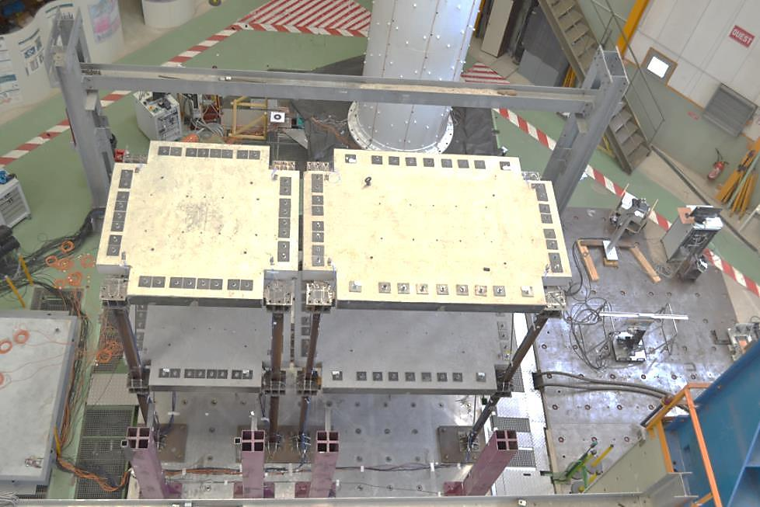
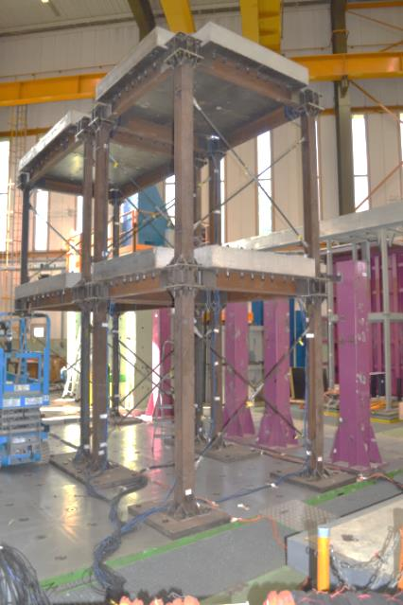
Structure I
Structure II
Transverse direction
Principal direction

FIG. 1. General lay out of the models on the shake table.

Test series
First of all, modal identification of the models was carried out both by impact hammer and low intensity white noise shake table excitations. Then, several seismic tests were carried out. Three different gap configurations (5 cm, 2 cm and 0 cm) were tested. Similar tests (i.e. same target excitation waveforms and peak ground accelerations (PGA)) were also performed considering a gap, big enough, so that pounding did not occur. Hence, results with pounding can directly be compared to those without pounding. Moreover, additional models’ arrangements were considered such as a configuration with a rigid link installed at each floor between the two models and a configuration with only one storey impacting structures. Nevertheless, for the sake of brevity, only results corresponding to 5 cm and 2 cm gaps will be discussed here. To investigate the influence of the excitation signal on the structures’ responses, four different excitation signals, denoted in Table 1, were applied to each of the aforementioned configurations.

TABLE 1: EXCITATION SIGNALS.

 | Designation
Cadarache | Artificial signal, compatible with the spectrum of Cadarache site in south France, with considerable energy in the 4 Hz – 10 Hz frequency range
El Centro | Natural record of the 1940 Imperial valley earthquake, El Centro recording site S90W component
Northridge | Natural record of the 1994 Northridge Earthquake, USC# 0003 recording site, S00E component
Kobe | Natural record of the 1995 Kobe earthquake, JR Takatori recording site, 000 component

Experimental campaign

The tests with pounding highlighted the important effect of the impacts on acceleration, in particular for the impacting slabs. Examples of acceleration time histories and corresponding floor response spectra for the second floor slab of Structure II are shown in Figure 2. The frequency axes of the shown floor response spectra go much beyond the frequency range commonly considered (e.g. up to 30 Hz), because for some industrial facilities (e.g. nuclear power plants) the response of equipment at higher frequencies may be of interest. The time histories shown in Figure 2 correspond to the rigid body translation in the excitation direction (i.e. to the mean longitudinal acceleration). In fact, as already mentioned, the slabs exhibit also rotational (yaw) acceleration due the inevitable asymmetry of the impact forces. Hence, the recorded accelerations may vary considerably depending on the location of each sensor. As shown in Figure 2, the peak acceleration is amplified considerably when pounding occurs. For example, for a 2 cm gap the peak acceleration is 35 times higher than that in the case without impact. Further, it is confirmed that the corresponding floor response spectra present the characteristics discussed in a previous work of the authors (Crozet et al. 2017).Actually, besides two peaks, corresponding to the first two modes in the considered direction, the floor response spectra in Figure 2 exhibit, in the lower-medium frequency range, a quasi-constant slope. It may be shown that this part of the spectrum may be approximated by the floor response spectrum of a Dirac pulse (i.e. a zero duration pulse) whose intensity is equal to the maximum impact impulse. The Dirac pulse response spectrum is a straight line whose slope is proportional to the pulse intensity. Depending on the time intervals between successive impacts, additional spikes may be superposed to this straight line. In the higher frequency range, the floor response spectrum deviates more from the straight line of the Dirac pulse response spectrum due to the actual finite duration of the impacts.

As expected, in general, the number and intensity of impacts increase with decreasing of the gap. The impacts, of course, excite, also, the higher modes which have a weak contribution when pounding does not occur. This is illustrated in Figure 3 which depicts the short time Fourier transforms of the mean horizontal acceleration of the second storey slab of Structure II in the excitation direction. For small initial gap, and thus important number of high intensity impacts, the second eigenmode, in the principal direction, at 10.3 Hz becomes predominant. Similar tendencies can be drawn from the response of Structure I.
To compare the effect of pounding on inter-storey drifts for the two different gap configurations discussed here, we carried out a series of tests using the records presented in Table 2. These records have been chosen on the basis of dimensional analysis considerations (Crozet et al. 2017). First, the PGA in the left column, considered for the 5 cm gap case, result in similar maximum displacements at the top of the more flexible structure during the tests without pounding. Strictly speaking, for the 2 cm gap case, to obtain the same dimensionless gap parameter, the PGA values of the second column should have been 2/5 those of the first column. Nevertheless, in some cases, such a reduction of the PGA would have resulted in excitation signals with non-negligible ratio of noise to actual excitation amplitudes. That is why, eventually, the PGA for the 2 cm gap configuration are those of the 5 cm case, divided only by 2. Of course, pounding influences also forces and inter-storey drifts of both floors. However, its contribution to the second floor response is higher, due, in particular, to the amplification of the second mode response. As it may be observed, in Figure 4, for most of the considered excitations, the effect of pounding on the second floor inter-storey drift increases considerably with the number and the intensity of impacts (i.e., in general, with gap decrease). For all the considered excitations, at least twice more impacts have been recorded for the 2 cm gap configuration than for the 5 cm case. For the more rigid structure, the amplification of the second floor inter-storey drift in the case of 2 cm gap with respect to the case without impact is of about 110% under Kobe excitation. Nevertheless, although the above experimental comparison gives a meaningful trend, it must be acknowledged that the experimental conditions of the two configurations differ to some extent. In particular, because of inevitable control issues, the realized excitation signals for the 5 cm gap configuration are not exactly those of the 2cm case with just a 200% higher PGA. Hence, the above trends should also be confirmed by pure analytical comparison of the above cases getting rid of discrepancies between excitation signals.

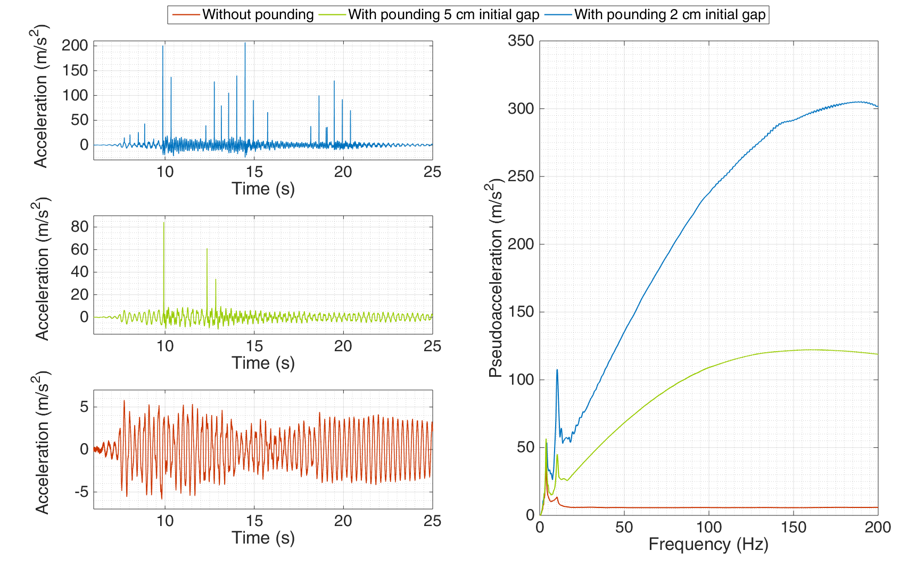
FIG. 2. Second floor slab of Structure II acceleration time histories and corresponding floor response spectra in the excitation direction, for Kobe 0.2g PGA excitation.

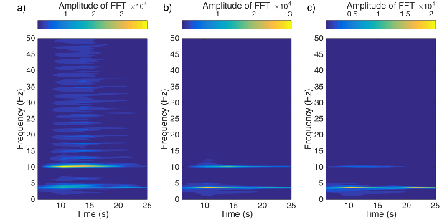
FIG. 3. Short-time Fourier transforms of Structure II second floor slab mean acceleration in the excitation direction, for Kobe 0.2g PGA excitation: a) with pounding 2 cm initial gap, b) with pounding 5 cm initial gap, c) without pounding.

TABLE 2: PGA OF THE DESIRED EXCITATION SIGNAL APPLIED TO THE SHAKE TABLE WITH RESPECT TO THE STRUCTURES INITIAL GAP

 | 5 cm gap | 2 cm gap
Cadarache | 0.4 g | 0.2 g
El Centro | 0.3 g | 0.15 g
Northridge | 0.2 g | 0.1 g
Kobe | 0.2 g | 0.1 g

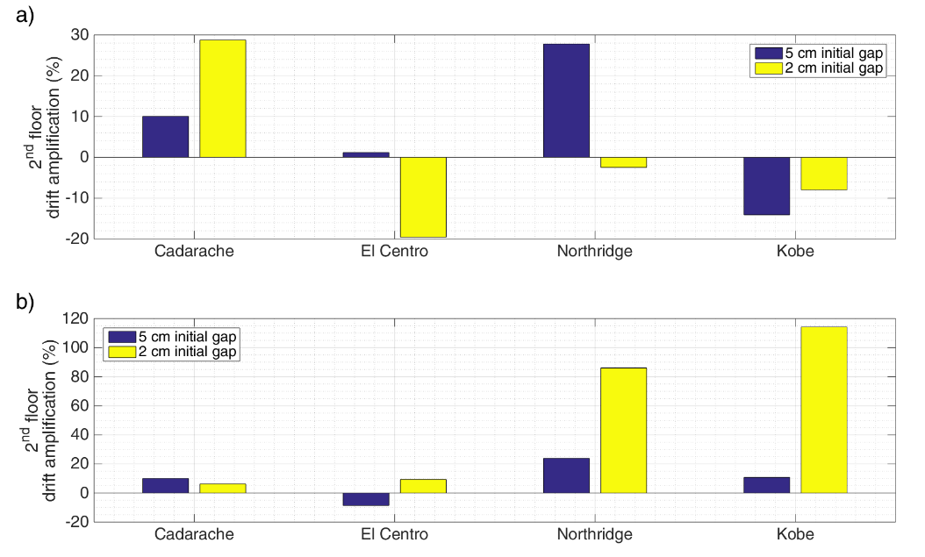
FIG. 4. Second floor drift amplification with respect to the tests without pounding for different gap configurations and excitation signals: a) Structure I b) Structure II.

Comparison between experimental and analytical results
The response of the structures has also been computed analytically using a three-dimensional linear elastic model composed of beam elements for the columns and beam and shell elements for the slabs. The analytical and experimentally determined eigenfrequencies are in a good agreement; nevertheless, a small discrepancy exists, especially for the rigid structure. In fact, the first and second analytical frequencies are 8% and 11% higher than the experimental ones. Though this discrepancy is rather small, it has a considerable influence on the time history response, even in the case without impact, due to the low damping of the structures. Its influence in the case of pounding is even bigger given the well-known sensitivity of impact problems to small changes of the parameters values. The beam elements of the model cannot fully account for local flexibility at member connections. Therefore, rotational springs are inserted at these locations. The values of the stiffness of these springs have been determined after minimization of the divergence between numerical and analytical frequencies. Table 3 summarizes the eigenfrequencies determined experimentally and numerically.
In most earthquake response analyses, to reduce the computation time, each structure was represented only by the generalized coordinates corresponding to its first 6 eigenmodes. Impact is modelled with the penalty method, considering uniformly distributed stiffness and damping along the edges of the impacting slabs. The value of the impact stiffness is set to reproduce the experimentally observed impact duration while the damping constant is set to obtain the correct impact force amplitude (i.e. the correct amplitude of the acceleration spikes). Further, as already mentioned, inevitable geometrical defects and eccentricities exist which induce torsional response also. In the numerical model, these defects are taken into account considering that the impacting edges of the slabs, are straight but not parallel. The considered defects are consistent with those measured experimentally. However, it should be acknowledged that, as already mentioned, due to the high sensitivity of impact problems, small variations of these parameters may result in significant differences.
TABLE 3: COMPARISON BETWEEN EXPERIMENTAL AND ANALYTICAL EIGENFREQUENCIES.
 |  | Translation in the principal direction |  | Translation in the transverse direction |  |  | Rotation around vertical axis
 |  | 1st freq. (Hz) | 2nd freq. (Hz) | 1st freq. (Hz) | 2nd freq. (Hz) |  | 1st freq. (Hz) | 2nd freq. (Hz)
Structure I | Experiment | 2.1 | 5.6 | 6.1 | 17.5 | 8.6 |  | 24.4
Structure I | Initial Numerical | 2.1 | 5.7 | 6.3 | 17.8 | 8.6 |  | 23.9
Structure I | Tuned Numerical | 2.1 | 5.5 | 6.1 | 17.1 | 8.2 |  | 22.8
Structure II | Experiment | 3.7 | 10.3 | 8.2 | 25.2 | 10.2 |  | 28.0
Structure II | Initial Numerical | 4.0 | 11.4 | 9.1 | 26.1 | 11 |  | 30.6
Structure II | Tuned Numerical | 3.6 | 10.2 | 8.6 | 24.4 | 10.2 |  | 28.4

Floor accelerations
A few comparisons between experimental and numerical accelerations time histories in the excitation direction, of the second floor slab of Structure II, are shown in Figures 5a and 6a. The corresponding floor response spectra are shown in Figures 5b and 6b. A good agreement between analytical and experimental results is observed. However, given the aforementioned high sensitivity of nonlinear impact problems, even unpredictability if the exact time history is of interest, the higher the number of impacts the more difficult for the numerical model to reproduce the experimental results. That is why, in the case of more severe impacts (i.e. smaller gap, Figure 6) the numerical model is less accurate regarding both the detection of the impacts and the corresponding acceleration spikes amplitudes. For instance, the impacts at 7.7 s and 19 s are not reproduced by the numerical model whereas an additional impact is detected at 10.9 s. Nonetheless, even in this case, the peak acceleration and both the acceleration time history and floor response spectrum are computed with a satisfactory accuracy for such a highly nonlinear problem.
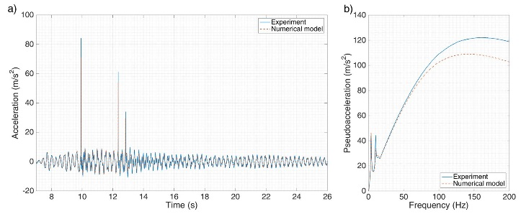
FIG. 5. Structure II second floor slab mean acceleration in the excitation direction and corresponding floor response spectra for Kobe excitation 0.2g PGA, 5cm initial gap configuration.

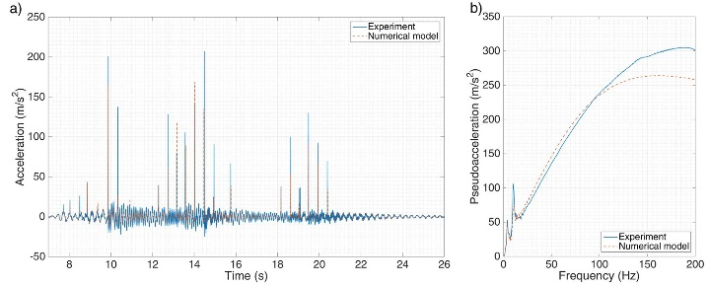
FIG. 6. Structure II second floor slab mean acceleration in the excitation direction and corresponding floor response spectra for Kobe excitation 0.2g PGA, 2cm initial gap configuration.

4.2 Rotations around the vertical axis due to pounding
As already mentioned, geometrical defects, especially the fact that the impacting slab edges are not completely parallel, induce torsional motion. This was expected and that is why bracings have been put in the transverse direction to increase torsional stiffness. The measured defects were rather small (the angle between the impacting edges was less than 0.2°) and thus they resulted in low yaw angles. Nevertheless, they caused noticeable yaw acceleration of the structures’ slabs as observed in Figure 7. The effect of torsion on longitudinal acceleration is demonstrated in Figure 8a which shows the floor response spectra at four different locations of the second floor slab of Structure II. The sensors’ locations are shown in Figure 8b, where the slab defect has been amplified, for illustration purposes. As observed, the pounding acceleration pulses of sensors 5_2 and 6_2 are higher than those of accelerometers 7_2 and 8_2. This is revealed, in Figure 8a, by the higher slopes in the response spectra of these sensors in the low-medium frequency range.
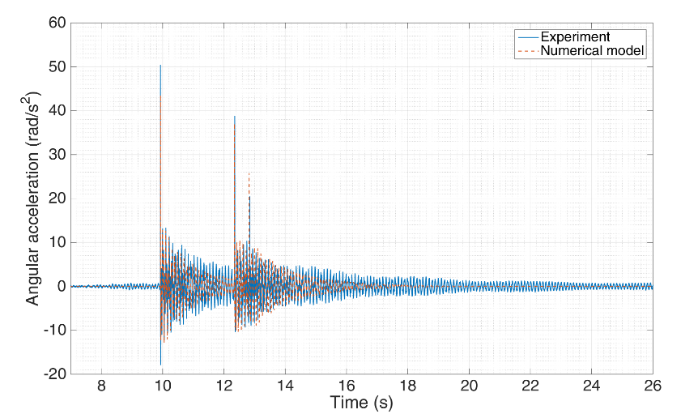
FIG. 7. Second floor slab of Structure II yaw acceleration for Kobe excitation 0.2g PGA, 5cm initial gap configuration.

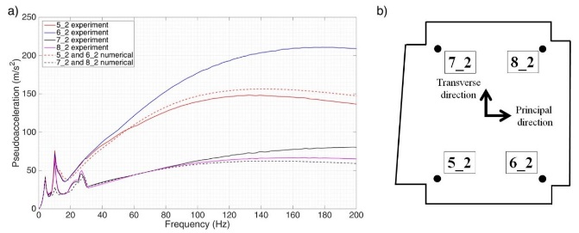
FIG. 8. Floor response spectra in the excitation direction depending on sensors’ locations. a) Floor response spectra, b) Sensors’ locations.

4.3 Inter-storey drifts.

The analytically computed inter-storey drifts are in good agreement with those measured experimentally. This is illustrated for Structure II in Figure 9. The analytical model gives slightly lower peak values. Actually, the numerical model underestimates the first and second floor inter-storey drifts by 10% and 20% respectively. It is worth noting that, it seems, that this small discrepancy between numerical and experimental peak drift values is not due to pounding effects only. In fact, a similar discrepancy between numerical and experimental results was observed even for the tests without pounding.

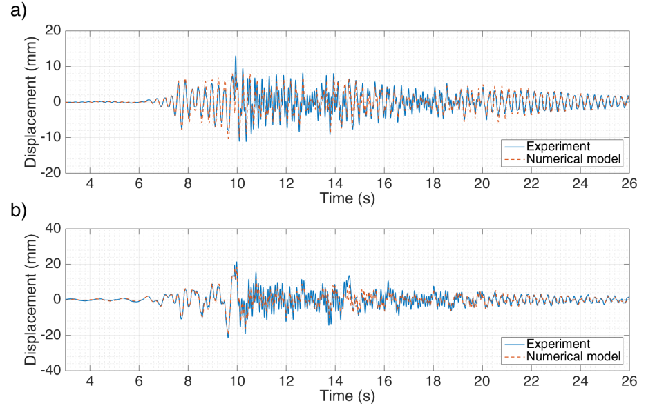
FIG. 9. Structure II inter-storey drifts. a) First floor, b) Second floor.

5. Conclusions

This work investigates the effect of earthquake induced pounding between adjacent structures by means of a large scale shake table experimental campaign using dedicated instrumentation. The tests highlighted the influence of pounding on structural response quantities such as inter-storey drifts and peak accelerations. One novel feature of this work is that it focuses, also, on floor response spectra of impacting structures which may be of paramount importance in the case of industrial facilities.
In addition, the employed numerical model efficiently reproduces the essential characteristics of the response of the impacting structures observed during the tests with a low computational cost.

6. Acknowledgments
The work carried out under the SINAPS@ project receives funding by the French National Research Agency under the program “Future Investments” (SINAPS@ reference No. ANR-11-RSNR-0022). SINAPS@ is a SEISM Institute project (http://www.institut-seism.fr/).

REFERENCES
- WADA, A., et al., “Collapse of buildings with expansion joints through collision caused by earthquake motion”, Proceedings 8th World Conference on Earthquake Engineering, 21-28 July, San Francisco, California, USA (1984).
- MAISON, B.F., VENTURA, C.E. “Seismic analysis of base-isolated San Bernardino county building”, Earthquake Engineering and Structural Dynamics (1992), 8(4): 605-633.
- ROJAS, F.R., ANDERSON, J.C. “Pounding of an 18 story building during recorded earthquakes”, Journal of Structural Engineering (2012), 138(12): 1530-1544.
- COLE, G.L., et al. “Building pounding damage observed in the 2011 Christchurch earthquake”, Proceeding 14th World Conference on Earthquake Engineering, 24-28 September, Portugal (2012).
- PAPADRAKAKIS, M., MOUZAKIS, H. “Earthquake Simulator testing of pounding between adjacent buildings”, Earthquake Engineering and Structural Dynamics (1995), 24(8): 811-834.
- FILIATRAULT, A., et al. “Analytical prediction of experimental building pounding”, Earthquake Engineering and Structural Dynamics (1995), 24(8): 1131-1154.
- CROZET, V., et al. “Sensitivity analysis of pounding between adjacent structures”, Earthquake Engineering and Structural Dynamics (1995), 47(1): 219-235.

