PROCEDURE OF EVALUATING FAULT PARAMETERS OF SUBDUCTION PLATE-BOUNDARY EARTHQUAKES WITH SURFACE FAULT BREAKINGS FOR STRONG MOTION PREDICTION

K. DAN¹, D. JU¹, S. DORJPALAM¹, K. IRIE¹, S. SUZUKI², H. FUJIWARA³, N. MORIKAWA³

¹ Ohsaki Research Institute, Inc., Tokyo, Japan
² International Atomic Energy Agency, Vienna, Austria
³ National Research Institute for Earth Science and Disaster Resilience, Ibaraki, Japan

E-mail contact of main author: dan@ohsaki.co.jp

Abstract. For prediction of ground motions from subduction plate-boundary earthquakes, the Recipe by the Headquarters for Earthquake Research Promotion (e.g., 2016, [1]) is used to determine fault parameters in Japan. The underlying physics in the current Recipe are based on the circular crack equation by Eshelby (1957, [2]). This circular crack equation is applicable to smaller sized earthquakes of M_{W} 8 or less with no surface fault breakings. However, for larger events, where the rupture reaches surface and the stresses are released at the surface, the boundary conditions are different from those of a circular crack. Therefore, in this study, we adopted an alternative equation for the stress drop for larger events obtained by the dynamic fault rupturing simulations, and proposed a new procedure of evaluating fault parameters for subduction plate-boundary earthquakes with surface fault breakings. The proposed fault model consists of asperities, background, and large-slip and very large-slip areas near the surface. We validated our procedure on the example of the 2011 Tohoku, Japan, earthquake (M_{W} 9.0) in terms of predicting strong ground motions.
Key Words: Fault model, Subduction plate-boundary earthquake, Surface fault breaking, Strong motion prediction

Introduction
Based on the severe accident at Fukushima Daiich NPPs caused by the large tsunami in the 2011 Tohoku, Japan, earthquake (M_{W} 9.1), Nuclear Regulation Authority (2013, [3]) published ‘Examination guideline for design-basis tsunami and design policy’ and showed three examples of source areas of large tsunamis as in Figure 1. Among them, the largest area is located along the Nankai Trough and South-West Islands Trench, about 2000 km long, and its moment magnitude is 9.6.
Shimazaki (2012, [4]) described his understanding that recent subduction plate-boundary earthquakes of M_{W} 8 in Japan correspond to crustal earthquakes with no surface breaking and that the 2011 Tohoku, Japan, earthquake of M_{W} 9 corresponds to crustal earthquakes with a surface breaking which is recognized by trench investigation. He interpretated that the recent subduction plate-boundary earthquakes of M_{W} 8 are inferior to M_{W} 9 earthquakes and that the M_{W} 9 earthquakes are the most basic subduction plate-boundary earthquakes.
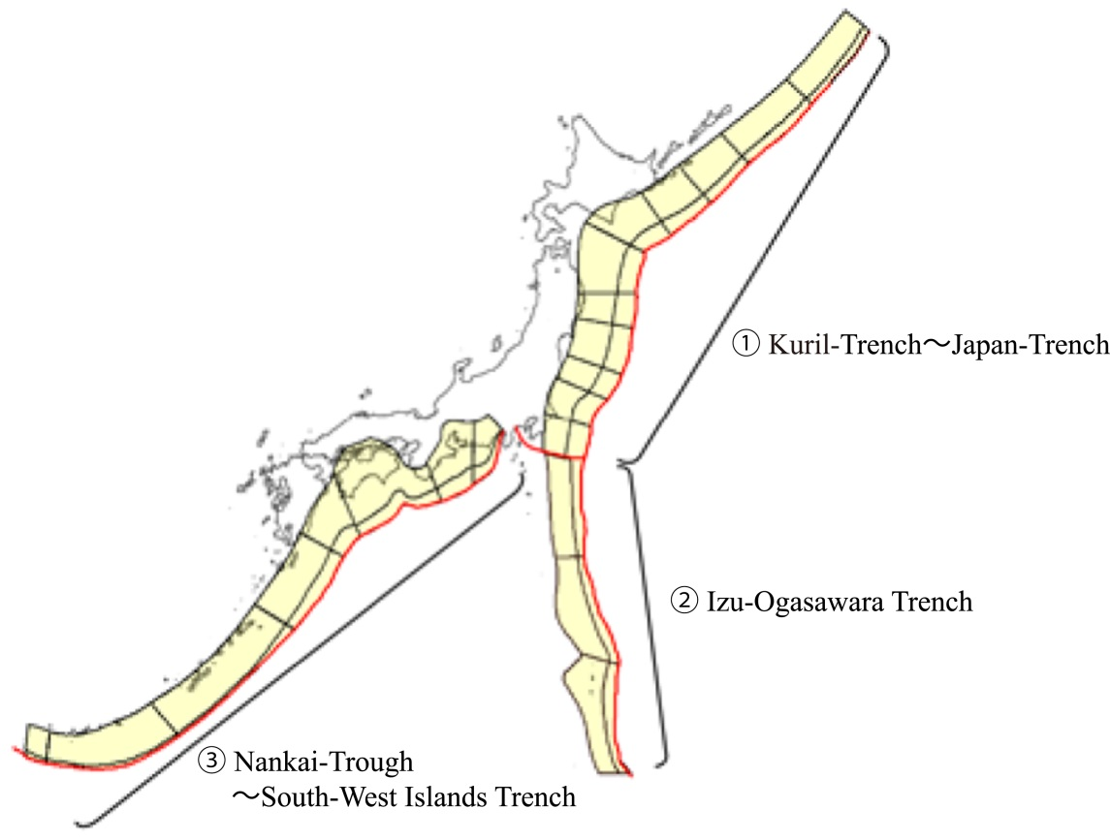
FIG. 1. Tsunami source areas caused by subduction plate-boundary earthquakes around Japan (modified from Nuclear Regulation Authority, 2013, [3])

Moreover, Tajima et al. (2013, [5]) pointed out that subduction plate-boundary earthquakes transfer, as their magnitudes become greater, from the first stage in which the fault length, width, and slip grow proportionally to each other (self-similar) to the second stage in which the fault width saturates because of the thickness of the seismogenic layer and the fault length and slip grow proportionally to each other.
Hereafter in this paper, according to Scholz (2002, [6]), we call subducting plate-boundary earthquakes with no surface fault breakings small earthquakes and those with surface fault breakings large earthquakes.
The headquarters for Earthquake Research Promotion, Japan (e.g., 2016, [1]) published a procedure of evaluating fault parameters, so called Recipe, for predicting ground motions from subduction plate-boundary earthquakes based on the averaged stress drop equation of the circular crack model (Eshelby, 1957, [2]):
(1)
Here, Δσ is the averaged stress drop, M₀ is the seismic moment, and S is the fault area.
This official procedure was adopts an asperity model (Das and Kostrov, 1986, [7]) as a source model, and it validated by reproducing strong ground motions recorded in the 1978 Miyagi-Oki earthquake (M_{W} 7.6) and the 2003 Tokachi-Oki earthquake (M_{W} 8.1).
However, these earthquakes belong to the first-stage earthquakes. The averaged stress drop equation (1) of the circular crack model can be applied to the earthquakes in the first stage, but it can not be applied to the earthquakes in the second stage of M_{W} 9 class because the stress is released on the ground surface or sea bottom.
On the other hand, Dorjpalam et al. (2015, [8]) carried out a number of dynamic fault rupturing simulation of long thrust faults with surface fault breakings and obtained an approximate description of the averaged dynamic stress drop equation.
Hence, we categorized subduction plate-boundary earthquakes into small and large earthquakes, and applied the averaged dynamic stress drop equation for long rectangular faults obtained by Dorjpalam et al. (2015, [8]) to large earthquakes to calculate their averaged dynamic stress drops and obtain scaling laws of fault parameters.
Next, we proposed a new procedure of evaluating fault parameters for subduction plate-boundary earthquakes with surface fault breakings. Here, we adopted an asperity model and added some large-slip and very-large-slip areas (Sugino et al., 2014, [9]) to it to generate both strong ground motions and large tsunamis.
Finally, we evaluated fault parameters for the 2011 Tohoku earthquake and reproduced strong ground motions to show the validation of our proposed procedure for subduction plate-boundary earthquakes with surface fault breakings.
- Scaling Law of Fault Parameters of Subduction Plate-Boundary Earthquakes with Surface Fault Breakings
2.1.Dataset of fault parameters of subduction plate-boundary earthquakes
We collected fault lengths L, widths W, seismic moments M₀, and short-period levels A to examine an empirical relationship between the seismic moment and fault area and that between the seismic moment and short-period level. Here, the short-period level is the flat level of the acceleration source spectra in the short-period range.
Table 1 lists the collected fault parameters of 56 subduction plate-boundary earthquakes ([10] to [18]).
Figure 2 shows a relationship between the fault width and length. Watanabe et al. (2002, [19]) described that the fault width is proportional to the fault length when the fault length is about 300 km or shorter and that the fault width is constant and about 150 km when the fault length is longer. Hence, in Figure 2, we classified the earthquakes into small ones with the fault length shorter than about 300 km, plotted by the solid circles, and large ones with the fault length longer then about 300 km, plotted by the open circles. Here, we classified the 2005 Nias earthquake (M_{W} 8.6) and the 1957 Andreanof Is. earthquake (M_{W} 8.6) with their fault lengths of 295 km into large earthquakes.

2.2.Scaling law between seismic moment and fault area
Dorjpalam et al. (2015, [8]) obtained an approximate description of the averaged dynamic stress drop equation as follows:
(2)
Here, Δσ# is the averaged dynamic stress drop.
We evaluated the averaged dynamic stress drop Δσ# of the large earthquakes in Table 1 by equation (2) from the seismic moment M₀, fault length L, and fault width W. The averaged dynamic stress drop Δσ# evaluated for each earthquake are listed in Table 1. The geometric mean of the averaged dynamic stress drop was calculated to be 1.0 MPa.
We also evaluated the averaged stress drop Δσ of the small earthquakes by equation (1), and the results are listed in Table 1.
TABLE 1: Fault parameters of subduction plate-boundary earthquakes
* indicates large earthquakes.
†1 Δσ is the averaged stress drop calculated by equation (1) for small earthquakes. Δσ is the averaged dynamic stress drop Δσ# calculated by equation (2) for large earthquakes.
†2 Δσ_{asp} is the averaged stress drop on the asperity calculated by equation (8) for small earthquakes. Δσ_{asp} is the averaged dynamic stress drop Δσ#_{asp} on the asperity calculated by equation (7) for large earthquakes.

We obtained an empirical scaling law between the fault area and the seismic moment of large earthquakes from equation (2) when adopting Δσ#=1.0 MPa as follows:
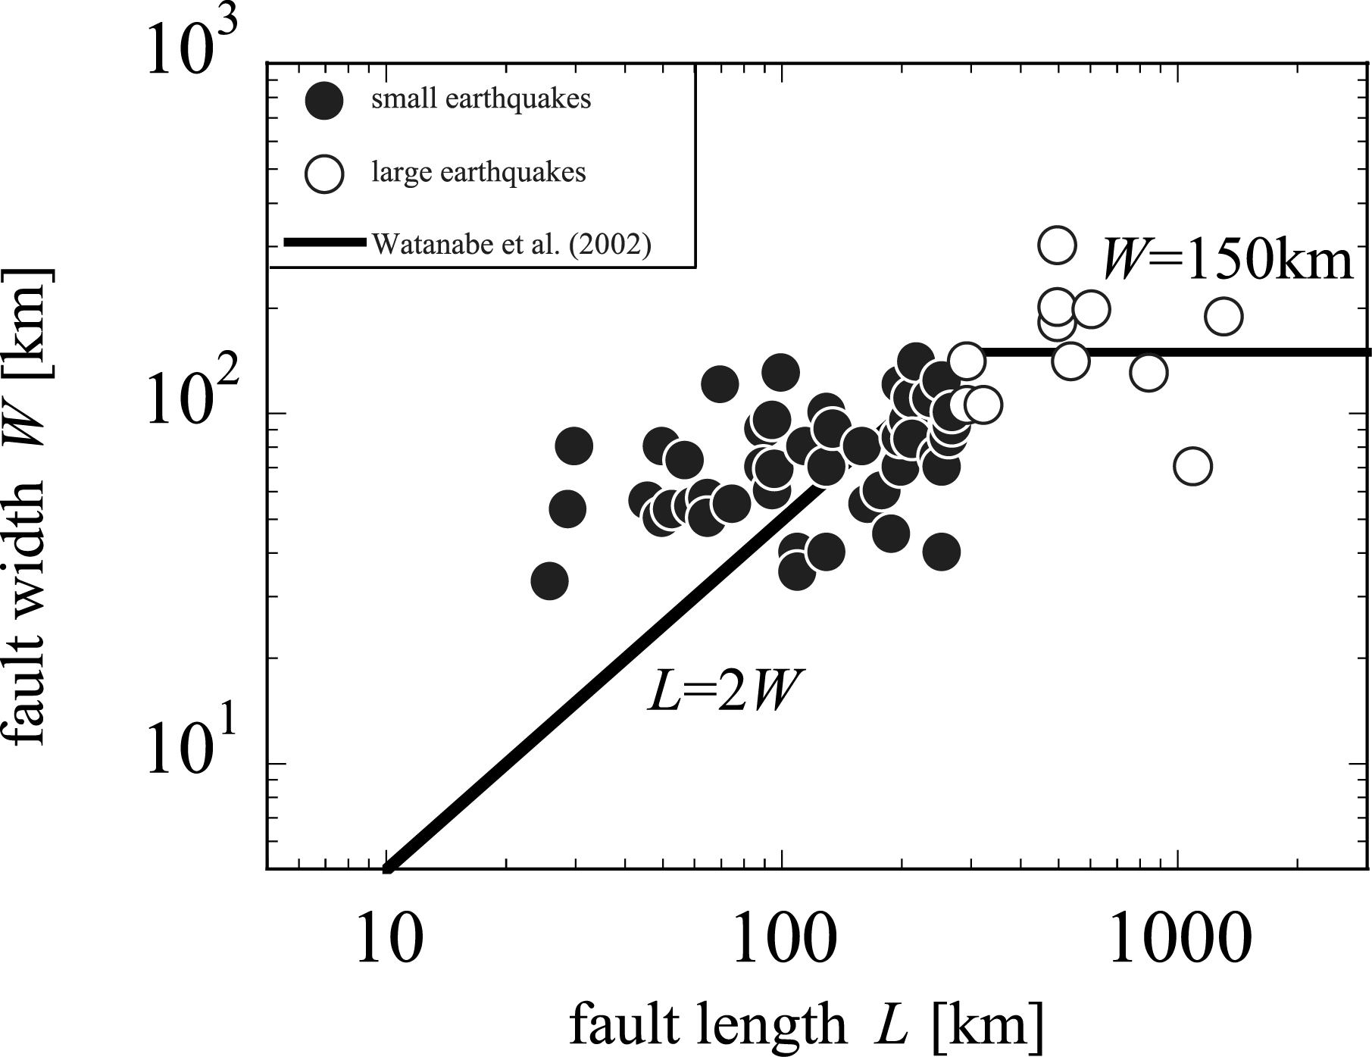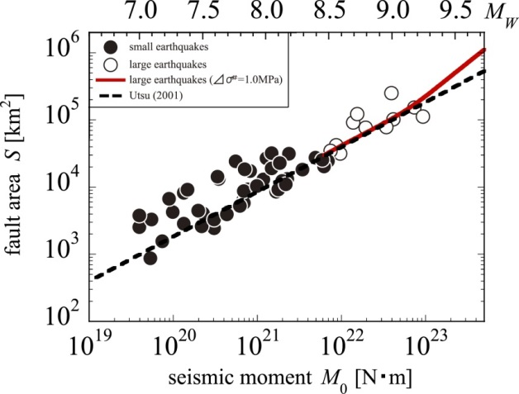
FIG. 2. Relationship between fault width and length of subduction plate-boundary earthquakes

FIG. 3. Relationship between fault area and seismic moment of subduction plate-boundary earthquakes

(3)
The red line in Figure 3 shows the obtained relationship between the fault area and the seismic moment. The data in Table 1 are also plotted in this figure. The broken line in the figure is the empirical relationship of equation (4) proposed by Utsu (2001, [20]), which is adopted in the Recipe by the Headquarters for Earthquake Research Promotion (e.g., 2016, [1]).
(4)
This empirical relationship leads to the averaged stress drop Δσ of 3.0 MPa by equation (1).
The red line by equation (3) is almost the same as the broken line by equation (4) at the moment magnitudes of 8.5 and 9.0. However, the red line becomes larger than the broken line at the moment magnitudes of about 9.5. This is because S in equation (3) is proportional to M₀ for large M₀, while S in equation (4) is proportional to M₀^{2/3}.

2.3.Scaling law between seismic moment and short-period level
The short-period level is calculated from the area of the asperity S_{asp} and the dynamic stress drop on the asperity Δσ#_{asp} as follows (Dan et al., 2001, [21]; Dan et al., 2011, [22]):
(5)
Here, the static stress drop Δσ_{asp} on the asperity is assumed to be the same as the dynamic stress drop Δσ#_{asp}, and β is the S wave velocity of the seismogenic layer.
On the other hand, the averaged dynamic stress drop Δσ# is defined by
(6)
In order to calculate the dynamic stress drop on the asperity Δσ#_{asp} for each earthquake listed in Table 1, we deleted Δσ# and S_{asp} from equations (2), (5), and (6), and obtained
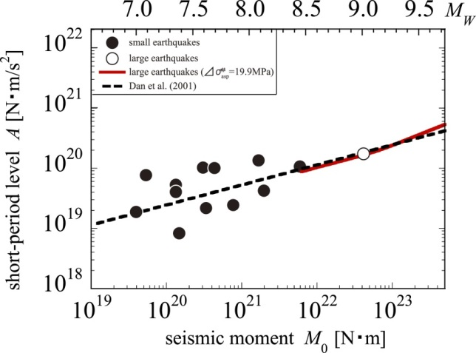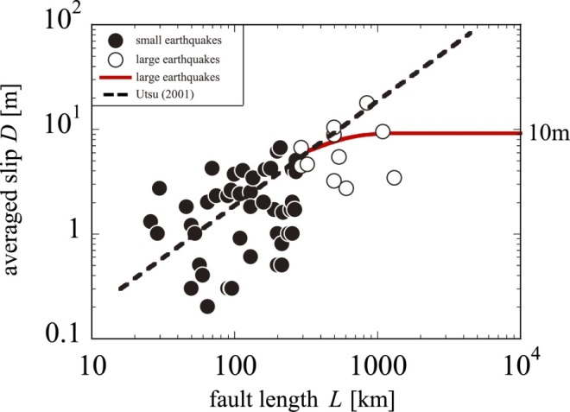
FIG. 5. Relationship between averaged slip and fault length of subduction plate-boundary earthquakes

FIG. 4. Relationship between short-period level and seismic moment of subduction plate-boundary earthquakes

(7)
The short-period level A is obtained for only one large earthquake, i.e. the 2011 Tohoku earthquake, and we evaluated the dynamic stress drop on the asperity Δσ#_{asp} by equation (7) to derive Δσ#_{asp}=19.9 MPa. Here, we adopted β=4 km/s (Yoshida et al., 2011, [23]).
As for the small earthquakes, the stress drop on the asperity Δσ_{asp} can be calculated by
(8)
Here, we deleted Δσ and S_{asp} from equation (1), A=4π(S_{asp}/π)^{1/2}Δσ_{asp}β², and Δσ=(S_{asp}/S)Δσ_{asp}.
We evaluated the stress drop on the asperity Δσ_{asp} of the small earthquakes by equation (8), and the results are listed in Table 1.
We obtained an empirical scaling law between the short-period level and the seismic moment of large earthquakes from equation (7) when adopting Δσ#_{asp}=19.9 MPa as follows:
(9)
The red line in Figure 4 shows the obtained relationship between the short-period level and the seismic moment. The data in Table 1 are also plotted in this figure. The broken line in the figure is the empirical relationship of equation (10) proposed by Dan et al. (2001, [21]), which is adopted in the Recipe by the Headquarters for Earthquake Research Promotion (e.g., 2016, [1]).
(10)
This empirical relationship leads to the stress drop on the asperity Δσ_{asp} of 8.3 MPa by equation (8).
The red line by equation (9) is almost the same as the broken line by equation (10) at the moment magnitudes of 8.5 and 9.0. However, the red line becomes slightly larger than the broken line at the moment magnitudes over 9.5. This is because A in equation (9) is proportional to M₀^{1/2} for large M₀, while A in equation (10) is proportional to M₀^{1/3}.
We need to accumulate more short-period levels for large earthquakes, because we have only one short-period level for large earthquakes.

2.4.Confirmation of relationship between fault length and averaged slip
We confirmed the relationship between the averaged slip and the fault length expected from the scaling law between the fault area and the seismic moment of equation (2). By using the definition of the seismic moment M₀=μDS, we derived the averaged slip by
(11)
Here, we assumed the fault width W to be 200 km and the shear rigidity μ to be 4.8×10¹⁰ N/m² (Dorjpalam et al., [8]).
The red line in Figure 5 shows the relationship between the averaged slip D and the seismic moment by equation (11). The broken line in the figure shows the relationship by equation (4) of Utsu (2001, [20]). Here, we adopted the empirical relationship between the fault width W and the fault length L of L=2W for both small and large earthquakes.
The average slip of small earthquakes grows proportionally to the fault length, while it is constant of about 10 m for the fault length longer than about 1000 km.

Procedure for Evaluating Fault Parameters of Large Subduction Plate-Boundary Earthquakes
Based on the averaged dynamic stress drop Δσ# over the entire fault of 1 MPa and the dynamic stress drop Δσ#_{asp} on the asperity of 19.9 MPa, we proposed a new procedure of evaluating fault parameters for predicting strong ground motions from subduction plate-boundary earthquakes with surface fault breakings, as shown in Figure 6.
Here, we classified earthquakes with the areas of 30,000 km² or over into large earthquakes, because we had classified the 2005 Nias earthquake with the area of 30,975 km² into large earthquakes. This areal criterion may vary because the boundary between large earthquakes and small earthquakes depends on whether the rupture reaches the sea bottom or not. In the figure, we introduced large-slip areas and added very-large-slip areas for earthquakes of M_{W} 8.9 or which had been proposed by Sugino et al. (2014, [9]) to simulate tsunamis, shown in Figure 7.

Validation of the Proposed Procedure by the 2011 Tohoku Earthquake

4.1.Fault parameters evaluated by the proposed procedure
We evaluated fault parameters for the 2011 Tohoku earthquakes by the proposed procedure in Figure 6. Here, we assumed the fault length to be 500 km and the fault width to be 200 km as shown in Table 1. We took the S-wave velocity of 4.0 km/s from Yoshida et al. (2011, [23]), and assumed the density of 3.0 g/cm³ by the relationship between the S-wave velocity and the density (Ludwig et al., 1970, [24]).
Figure 9 shows the fault model for the 2011 Tohoku earthquake. Here, we assigned the asperities on the deep part of the fault and the large-slip and very-large-slip areas on the shallow part according to the results by Lay et al. (2012, [25]). We set the boundary depth between the deep and shallow parts to be 22.7 km as Dan et al. (2013, [11]) did. They separated the deep part of the fault, generating strong motions and Tsunamis, and the shallow part, generating Tsunamis, based on the slip distribution inverted by Yoshida et al. (2011, [23]).
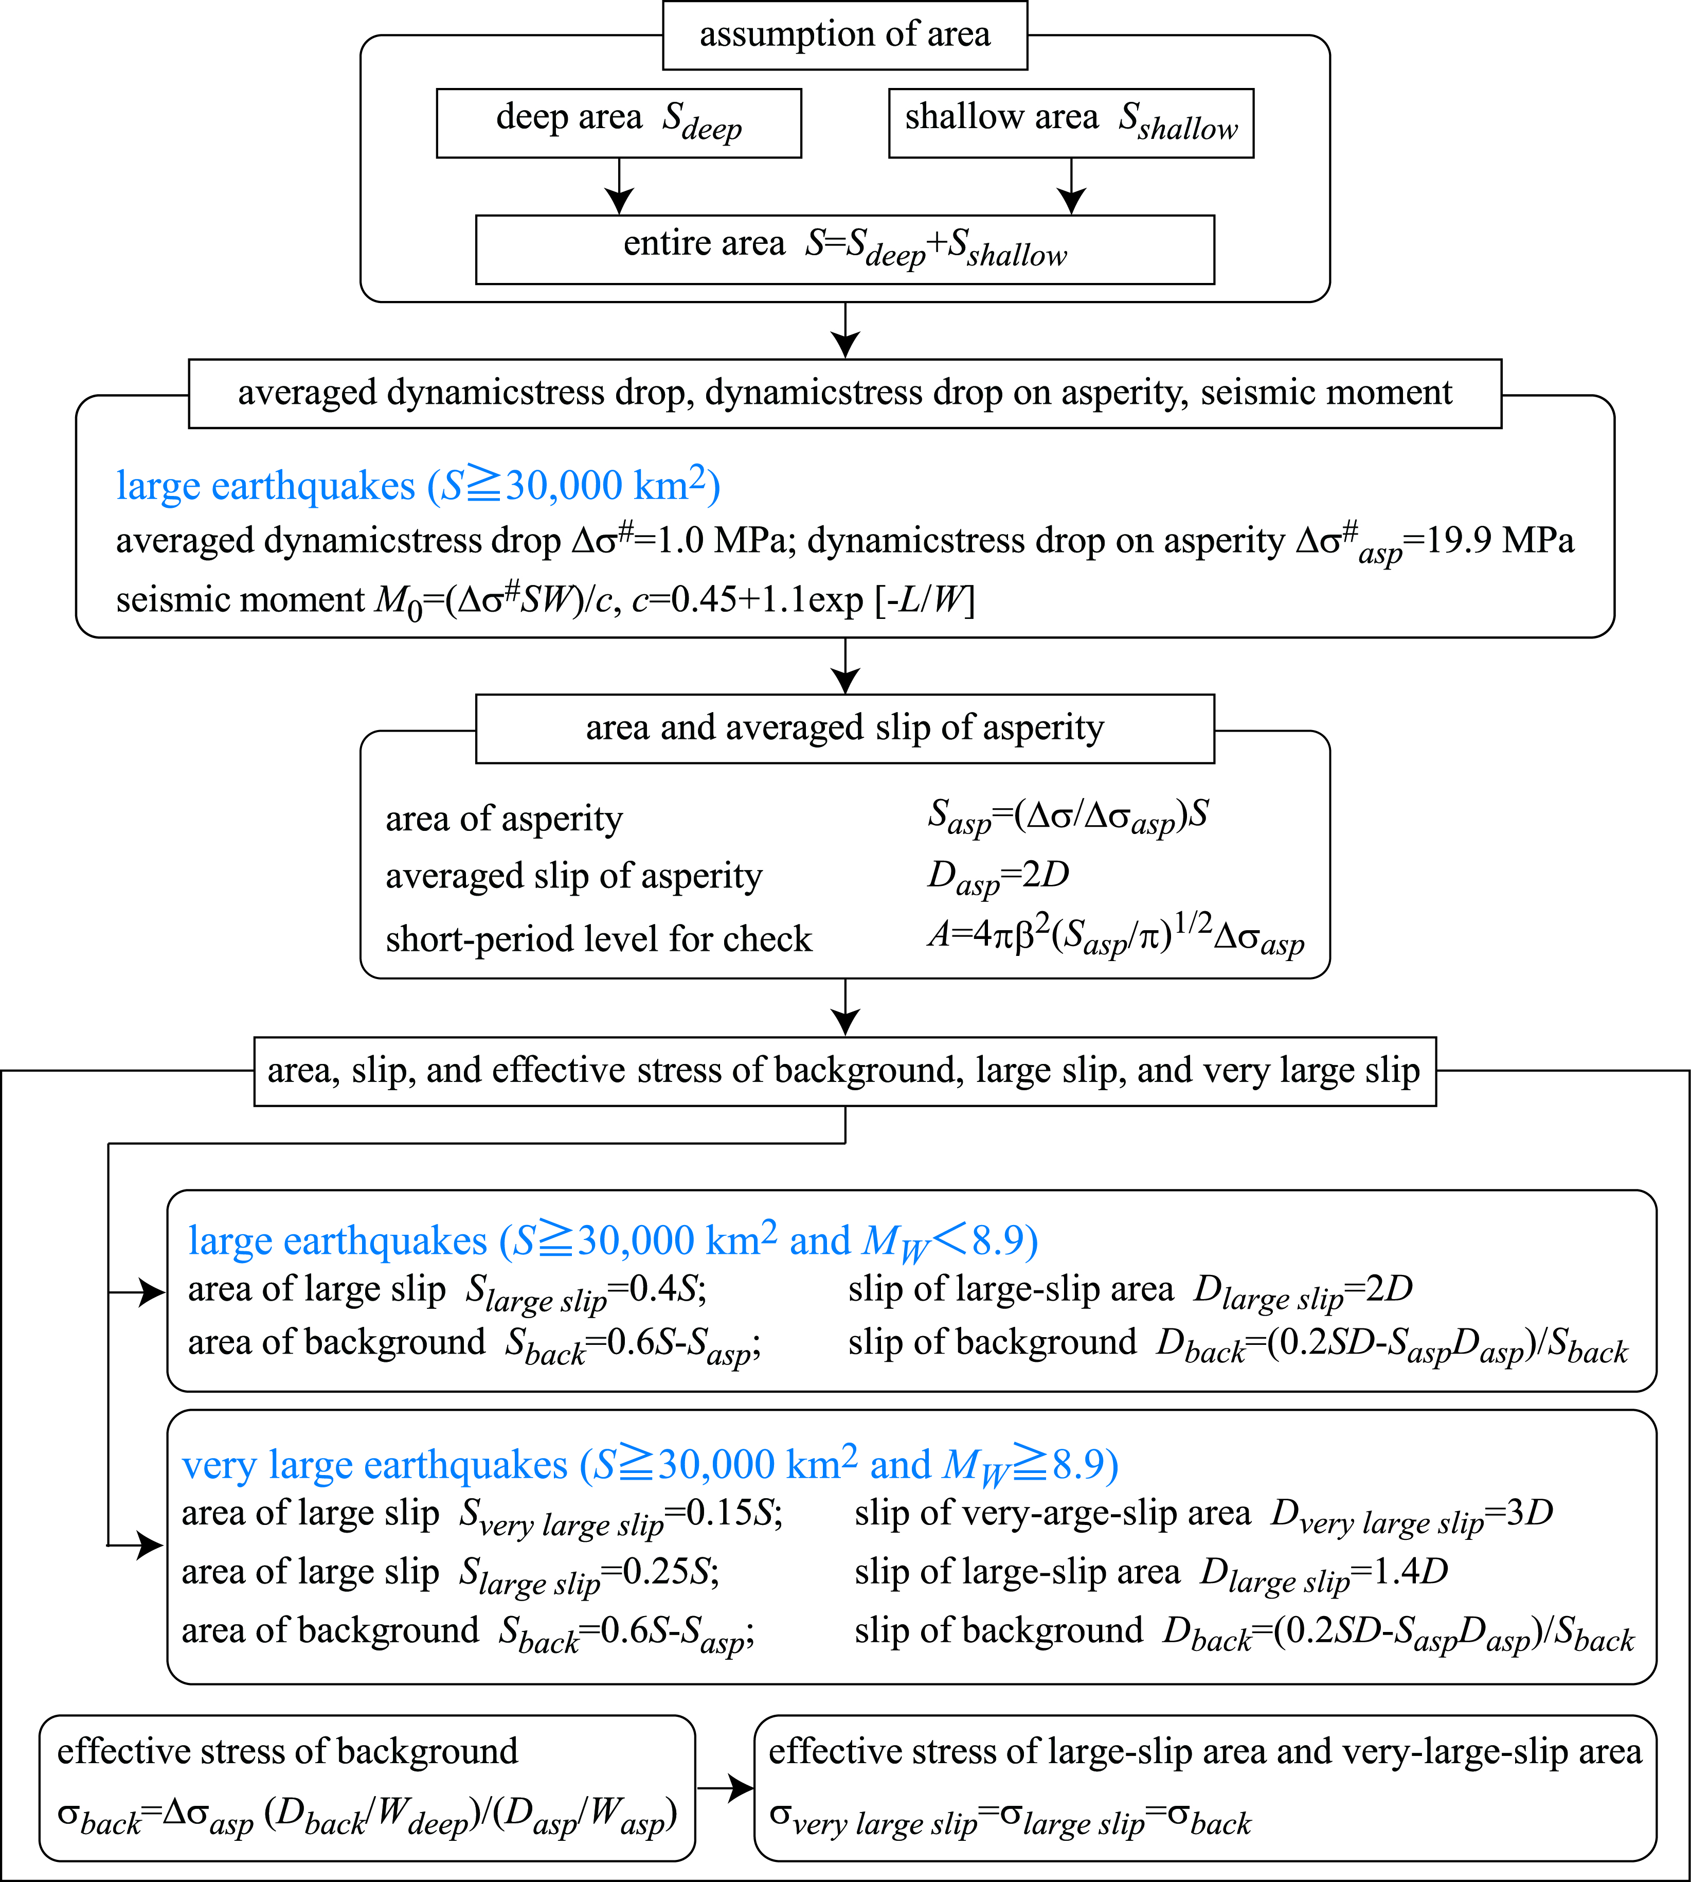

FIG. 6. Procedure of evaluating fault parameters for predicting strong ground motions from subduction plate-boundary earthquakes with surface fault breakings

We decided the size and location of each asperity and its rupture initiation location and timing from the results identified by Kawabe and Kamae (2013, [12]). We decided the locations and shapes of the large-slip and very-large-slip areas from the results identified by Sugino et al. (2014, [9]). We assigned Δσ#_{asp}=19.9 MPa to all asperities, and this value is almost the same as those of 10.5 to 23.1 MPa, idendified by Kawabe and Kamae (2013, [12]). We assigned 10.8 m to the large-slip area and 23.1 m to the very-large-slip area, and these values are a little smaller than 14.6 m and 31.2 m, respectively, modelled by Sugino et al. (2014, [9]).
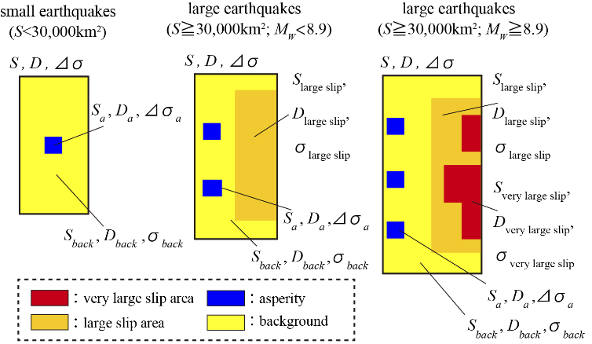
FIG.7. Slip distribution for predicting tsunami (modified from Sugino et al. (2014), [9])
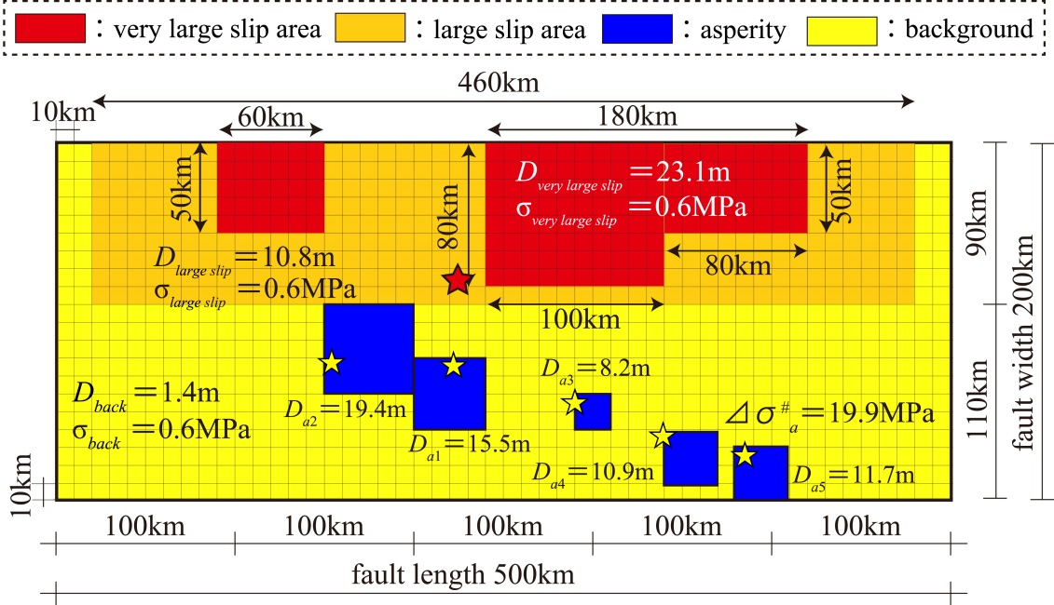
FIG.8. Example of a fault model for the 2011 Tohoku earthquake

4.2.Simulation of the strong ground motions
We simulated ground motions at MYGH12, FKSH17, and IBRH14 by the empirical Green’s function method (Dan et al., 1989, [26]). We used the bore-hole records from Event 1 to Event 4 in Kawabe and Kamae (2013, [12]) as empirical Green’s functions. We processed the records by a band-pass filter of 0.1 to 10 Hz. The fault parameters (seismic moment, area, stress drop) were also taken from Kawabe and Kamae (2013, [12]).
Figure 9 shows the fault model, the locations of the recording stations, and the epicentres of Event 1 to Event 4. Here, we adopted the strike of N195E and the dip of 15 degrees. The rupture propagation velocity was set to be 0.72 times 4.0 km of S-wave velocity (Yoshida et al., 2011, [23]) according to the statistical results by Geller (1976, [27]).
Figure 10 compares the synthesized time histories and pseudo velocity response spectra (5% damping) with the observed ones during the 2011 Tohoku earthquake (M_{W} 9.0). The observed time histories and response spectra are found to be reproduced by the empirical Green’s function method. Especially synthesized time histories and response spectra at IBRH14 agree well with the observed ones.
Conclusions
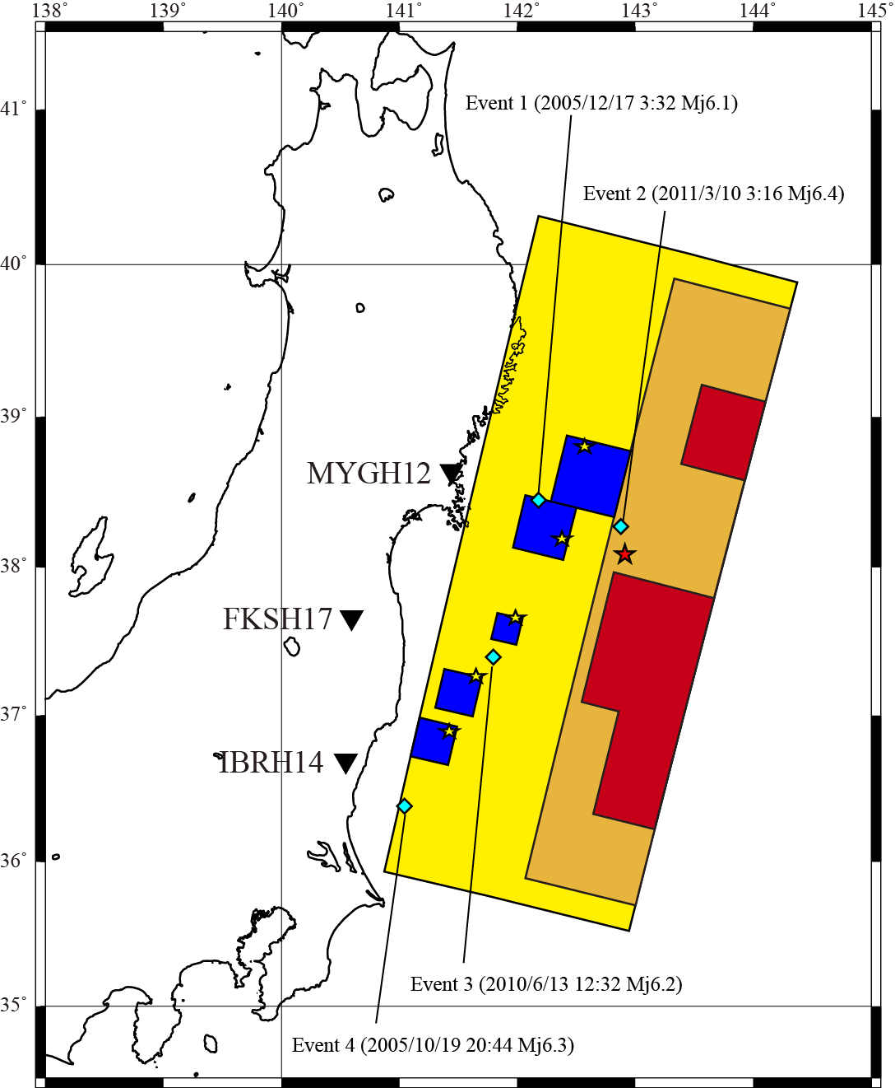
FIG.9. Location of ground motion simulation stations for the 2011 Tohoku earthquake and element earthquakes as empirical Green’s functions (▼:observation stations, ◆:element earthquakes)
First, we classified subduction plate-boundary earthquakes into small earthquakes and large earthquakes. Then we calculated the averaged dynamic stress drop over the entire fault and the dynamic stress drop on the asperities for large earthquakes, and obtained empirical scaling law between the fault area and the seismic moment and that between the short-period level and the seismic moment.
Next, we proposed a procedure of evaluating fault parameters for ground motion prediction of large earthquakes with surface fault breakings based on the averaged dynamic stress drop over the entire fault and the dynamic stress drop on the asperities. We also considered large-slip and very-large slip areas on shallow part of the fault to simulate large tsunamis.
Finally, we evaluated the fault parameters of the 2011 Tohoku earthquake (M_{W} 9.0) and simulated the observed strong ground motions to validate our proposed procedure.

Acknowledgments
Some parts of this study are the results of the research project by National Research Institute for Earth Science and Disaster Resilience, Japan, in the fiscal year of 2017.
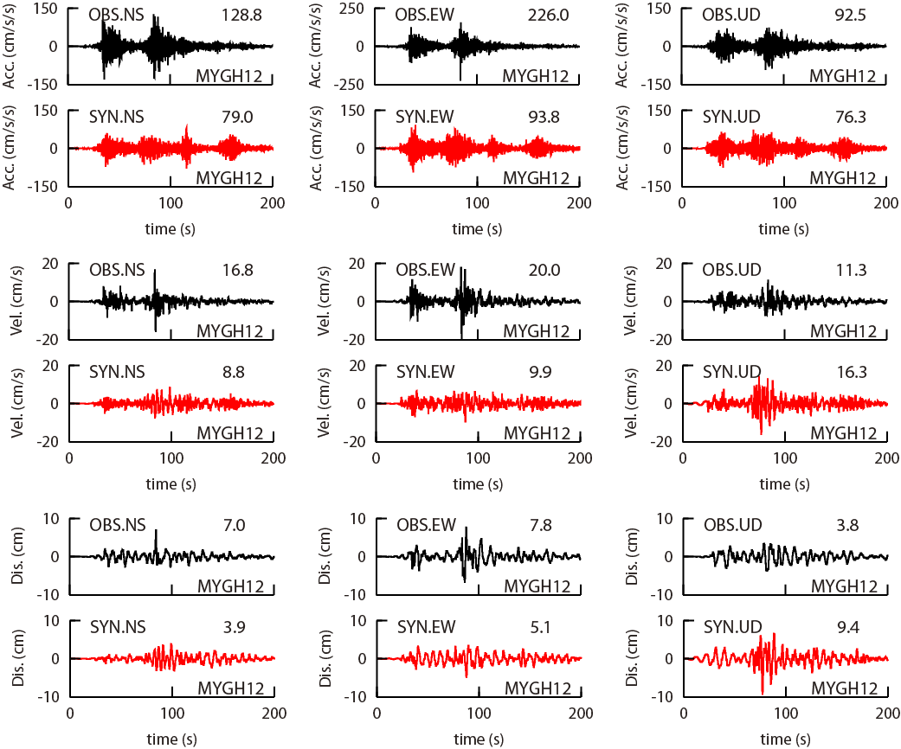
(a) Time histories at MYGH12
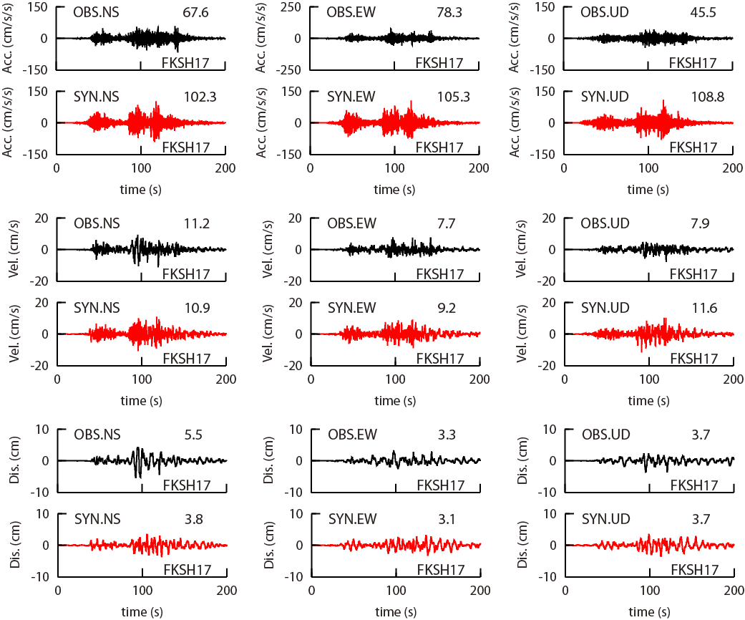
(b) Time histories at FKSH17

FIG.10. Comparison of the synthesized time histories and their pseudo velocity response spectra (5% damping) with the observed ones during the 2011 Tohoku earthquake (M_{W} 9.0)

REFERENCES
- HEADQUARTERS FOR EARTHQUAKE RESEARCH PROMOTION: Strong ground motion prediction method for earthquakes with specified source faults ( “Recipe” ),
http://www.jishin.go.jp/main/chousa/16_yosokuchizu/recipe.pdf, 2016 (in Japanese).
- ESHELBY, J.D.: The determination of the elastic field of an ellipsoidal inclusion, and related problems, Proceedings of the Royal Society of London, Series A, Vol. 241, pp. 376-396, 1957.
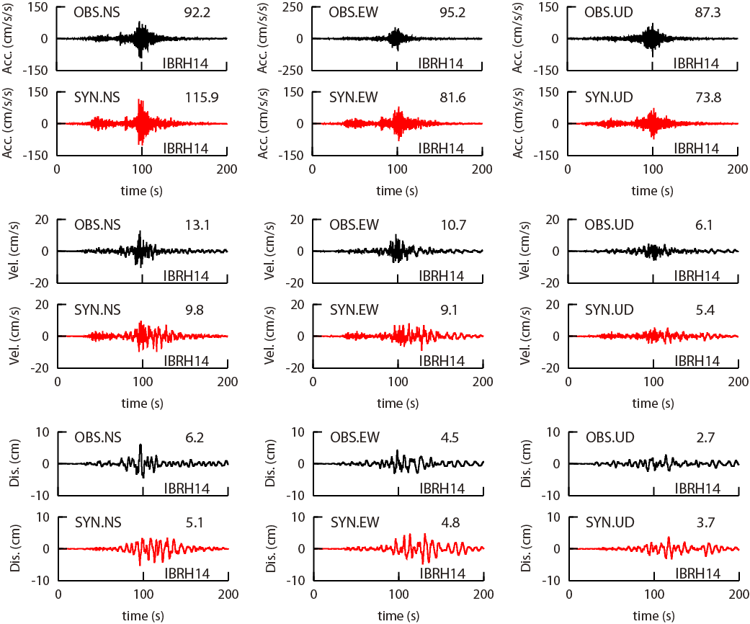
(c) Time histories at IBRH14
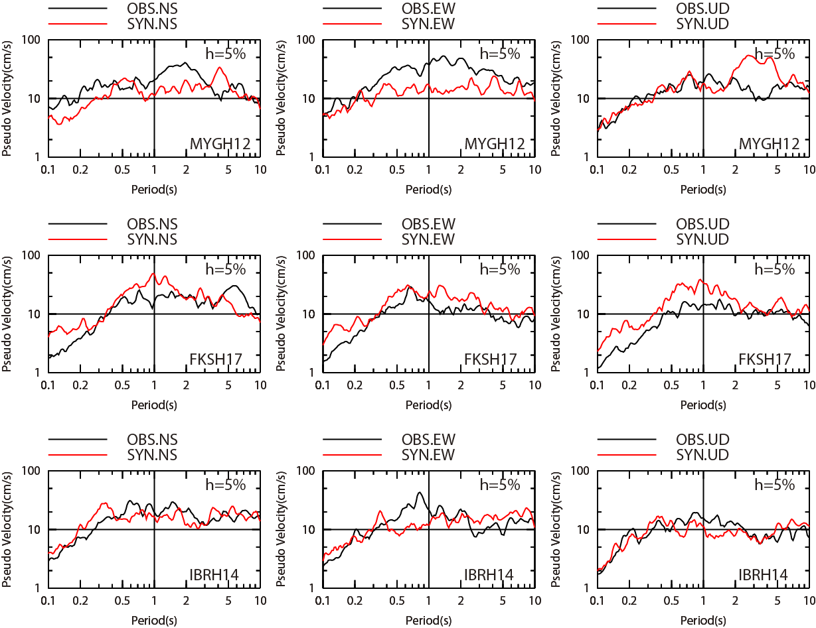
(d) Pseudo velocity response spectra (5% damping)

FIG.10. Comparison of the synthesized time histories and their pseudo velocity response spectra (5% damping) with the observed ones during the 2011 Tohoku earthquake (M_{W} 9.0)

- NUCLEAR REGULATION AUTHORITY: Examination guideline for design-basis tsunami and design policy, 2013 (in Japanese).
- SHIMAZAKI, K.: First actual image of subducting Pacific plate and the Nankai trough earthquake sequence, Report of the coordinating committee for earthquake prediction, Vol. 87, pp. 507-508, 2012 (in Japanese).
- TAJIMA, R., et al.: Comparative study on scaling relations of source parameters for great earthquakes in inland crusts and on subducting plate-boundaries, Journal of the Seismological Society of Japan, Second Series, Vol. 66, pp. 31-45, 2013.
- SCHOLZ, C.H.: The Mechanics of Earthquakes and Faulting, 2nd Edition, Columbia University, New York, pp. 201-202, 2002.
- DAS, S. and KOSTROV, B.V.: Fracture of a single asperity on a finite fault: A model for weak earthquakes? In “Earthquake Source Mechanics”, Maurice Ewing Vol. 6, American Geophysical Union, pp. 91-96, 1986.
- DORJPALAM, S., et al.: Examination of the geometric constant in the average dynamic stress drop equation for long thrust faults by dynamic rupture simulation, Part 3: Asperity model simulation results, Summaries of Technical Papers of Annual Meeting, Architectural Institute of Japan, B-2, pp. 103-104, 2015 (in Japanese).
- SUGINO, H., et al.: The characterizing model for tsunami source regarding the inter-plate earthquake tsunami, Journal of the Japan Association for Earthquake Engineering, Vol.14, pp. 1-18, 2014.
- SENO, T.: Stress drop as a criterion to differentiate subduction zones where M_{W} 9 earthquakes can occur, Tectonophysics, Vol. 621, pp. 198-210. 2014.
- DAN, K., et al.: Modeling of fault rupturing of subduction plate-boundary earthquakes with magnitude 9 for predicting strong motions -Application to the Nankai trough and examples of strong motions predicted in Tokai region-, Journal of Structural and Construction Engineering (Transactions of the Architectural Institute of Japan), Vol. 78, No. 692, pp. 1685-1694, 2013 (in Japanese).
- KAWABE, H. and KAMAE, K.: Source modeling of the 2011 off the Pacific coast of Tohoku earthquake, Journal of the Japan Association for Earthquake Engineering, Vol. 13, No. 2, pp. 75-87, 2013 (in Japanese).
- KAMAE, K.: Simulation of strong ground motion during the 1946 Nankai earthquake, Architectural Institute of Japan, The 24th Symposium of Earthquake Ground Motion, pp. 81-90, 1996 (in Japanese).
- DAN, K., et al.: Short-period source spectra inferred from variable-slip rupture models and modeling of earthquake faults for strong motion prediction by semi-empirical method, Journal of Structural and Construction Engineering (Transactions of the Architectural Institute of Japan), No. 545, pp. 51-62, 2001 (in Japanese).
- SATOH, T.: Scaling law of short-period source spectra for crustal earthquakes in Japan considering style of faulting of dip-slip and strike-slip, Journal of Structural and Construction Engineering (Transactions of the Architectural Institute of Japan), Vol. 75, No. 651, pp. 923-932, 2010 (in Japanese).
- DAN, K., et al.: Isoseismal map of strong motions for the 1923 Kanto earthquake (MJMA 7.9) by stochastic Green’s function method, Journal of the Structural and Construction Engineering (Transactions of the Architectural Institute of Japan), No. 530, pp. 53-62, 2000 (in Japanese).
- MENDOZA, C. and FUKUYAMA, E.: The July 12, 1993, Hokkaido-Nansei-Oki, Japan, earthquake: Coseismic slip pattern from strong-motion and teleseismic recordings, Journal of Geophysical Research, Vol. 101, No. B1, pp. 791-801, 1996.
- MENDOZA, C.: Coseismic slip of two large Mexican earthquakes from teleseismic body waveforms: Implications for asperity interaction in the Michoacan plate boundary segment, Journal of Geophysical Research, Vol. 98, No. B5, pp. 8197-8210, 1993.
- WATANABE, M., et al.: Scaling relations among macroscopic fault parameters, Summaries of Technical Papers of Annual Meeting, Architectural Institute of Japan, B-2, pp. 117-118, 2002 (in Japanese).
- UTSU, T.: Seismology (Third Edition), Kyoritsu Shuppan Co. Ltd., 2001 (in Japanese).
- DAN, K., et al.: Short-period source spectra inferred from variable-slip rupture models and modeling of earthquake faults for strong motion prediction by semi-empirical method, Journal of Structural and Construction Engineering, No. 545, pp. 51-62, 2001 (in Japanese with English abstract).
- DAN, K., et al.: Estimation of averaged dynamic stress drops of inland earthquakes caused by long strike-slip faults and its application to asperity models for predicting strong ground motions, Journal of Structural and Construction Engineering, No. 670, pp. 2041-2050, 2011 (in Japanese with English abstract).
- YOSHIDA, K., et al.: Source process of the 2011 off the Pacific coast of Tohoku earthquake inferred from waveform inversion with long-period strong-motion records, Earth Planets Space, Vol. 63, pp. 577-582, 2011.
- LUDWIG, W.J., et al.: Seismic refraction, The Sea, New York, Vol.4, Part 1, pp. 53-84, 1970.
- LAY, T., et al.: Depth-varying rupture properties of subduction zone megathrust faults, Journal of Geophysical Research, Vol. 117, B04311, doi:10.1029/2011JB009133, 2012.
- DAN, K., et al.: A semi-empirical method to synthesize earthquake ground motions based on approximate far-field shear-wave displacement, Journal of Structural and Construction Engineering (Transactions of AIJ), No. 396, pp. 27-36, 1989.
- GELLER, R.J.: Scaling relations for earthquake source parameters and magnitudes, Bulletin of the Seismological Society of America, Vol. 66, No. 5, pp. 1501-1523, 1976.

