EXTENSHION OF CHARACTERIZED SOURCE MODEL FOR NEAR-SOURCE LONG-PERIOD GROUND MOTIONS: EXPERIENCE OF THE 2016 Mw 7.0 KUMAMOTO EARTHQUAKE IN JAPAN

K. IRIKURA¹, S. KURAHASHI¹

¹ Aichi Institute of Technology (AIT), Toyota, Japan

E-mail contact of main author: irikura@geor.or.jp

Abstract. The mainshock with Mw 7.0 of the 2016 Kumamoto earthquake occurred on April 16, 2016 along the Futagawa fault and a part of the Hinagu fault. Surface breaks caused by the mainshock were found to be associated with Futagawa-Hinagu fault system by field surveys. Near-field strong motions with high accuracy during the earthquake were recorded by the NIED strong motion network (K-NET and KiK-net) and the JMA and local-government seismic-intensity network. In particular, there are located two stations, Mashiki town-hall station (93051) less than 2 km and Nishihara village-hall station (93048) less than 1 km away from the surface traces along the Futagawa fault zone. We successfully simulated the ground motions of the 2016 Kumamoto earthquake using a characterized source model consisting of strong motion generation areas (SMGAs) based on the empirical Green's function (EGF) method for periods 0.1 to 3 s) and the numerical Green’s function method (periods 1 to infinity) except the very-near-fault stations. The locations and areas of the SMGAs were determined inside the seismogenic zone deeper than 3 km through comparison between the synthetic ground motions and observed motions. Long-period motions more than 2 s observed at very-near-fault stations are not well simulated from the conventional characterized source model. We put long-period motion generation areas (LMGAs) from fault surface to a certain depth above the seismogenic zone to reproduce the long-period ground motions at those very-near-fault stations. Then, we propose a new characterized source model adding LMGAs into the conventional source model. The LMGA for the 2016 Kumamoto earthquake has a rectangle area with a length of 16 km and a width of 3 km and a smoothed-ramp-function with 2.5 second as slip velocity time function to reproduce the long-period motions observed at the very-near-fault stations and surface displacement distribution derived from the InSAR data. We confirmed that the synthetic ground motions and surface displacements from the new characterized source model agree well with the observed ones at the very-near-fault stations as well as intermediate-distance stations. .
Key Words: characterized source model, long-period strong motions, strong-motion generation area, long-period motion generation area

Introduction

Strong ground motions are more closely related to regions of slip heterogeneity rather than the entire rupture area and total seismic moment (Irikura and Miyake, 2011^{[1]}). A characterized source model was proposed, consisting of one or several asperities with large slips and a background area with less slip (Miyake et al., 2003^{[2]}) based on source characterizations defined based on slip distributions from the waveform inversion of strong-motion data. From studies of crustal earthquakes, we recognized strong ground motions are mainly generated from the asperities as strong motion generation areas (SMGAs) which yield about half of seismic moment from entire rupture area (Somerville et al., 1999)^{[3]}. Contributions from the background area are mostly longer-period motions to match total seismic moment. The SMGAs are principally located at seismogenic zone in shallow crust (Miyake et al., 2003^{[2]}; Irikura and Miyake, 2011^{[1]}).
For the 2016 Kumamoto earthquake, surface breaks caused by the mainshock were found associated with Futagawa-Hinagu fault system by field surveys. Near-field strong motions with high accuracy during the earthquake were recorded by the NIED strong motion network (K-NET and KiK-net) and the JMA and local-government seismic-intensity network. Mashiki Town-hall station and Nishihara Village-hall station are located extremely near surface breaks along the Futagawa fault zone. Strong long-period motions more than 2 s including permanent displacements are observed at very-near-fault stations (Iwata, 2016^{[4]}).
The synthetic ground motions from the 2016 Kumamoto earthquake using the characterized source model have been found to agree well with the observed motions in terms of acceleration, velocity, and displacement in the frequency range of 0.3–10 Hz except very-near-fault stations (Irikura et al., 2017^{[5]}).
One of problems for reproducing strong ground motions from the 2016 Kumamoto earthquake is that observed long-period motions more than 2 s seen at the very-near-fault stations are not well simulated based on the conventional characterized source model. To generate such long-period motions near the fault traces, a long-period motion generation area (LMGA) located from fault traces down to a certain depth has been taken into account. Then, we propose a new characterized source model for reproducing strong ground motions with long-period ground motions including permanent displacements near fault traces for surface fault earthquakes such as the 2016 Kumamoto earthquake.

Data
For the Kumamoto Mw 7.0 (01:25, April 16, 2016, JST, Mjma 7.3), K-NET and KiK-net, respectively, obtained strong-motion data at 370 surface stations and at 328 stations on surface and in the borehole, and therefore recorded ground motions at, in total, 698 stations (Suzuki et al., 2016^{[6]}). The largest PGA among K-NET and KiK-net is 1362 gals observed again at KiK-net KMMH16 station, located 7 km from the epicenter (the shortest distance to the fault trace about 3 km). JMA seismic intensity is calculated as 7 (maximum intensity in JMA scale) from the acceleration waveform of KiK-net KMMH16. The attenuation feature of peak ground accelerations generally follows the empirical relation by Si and Midorikawa (1999)^{[7]}.
During this earthquake, surface breaks caused by the mainshock were found to extend about 34km long with maximum 2.2 m offset associated with Futagawa-Hinagu fault system by field surveys (Shirahama et al., 2016^{[8]}).
Near-field strong motions with high accuracy during the earthquake were recorded by the NIED strong motion network (K-NET and KiK-net) and the JMA and local-government seismic-intensity network. There are located two stations, Mashiki Town-hall station (93051) less than 2 km and Nishihara Village-hall station (93048) less than 1 km away from the surface traces along the Futagawa fault (Iwata, 2016^{[4]}).
Velocity and displacements are obtained from the acceleration records carefully removing the baseline errors. The PGAs and PGVs are 825 gals and 177 cm/s (EW) at 93051 and 770 gals and 239 cm/s at 93048. The observed permanent displacements were about 1.2m in horizontal direction and about 0.7m sinking in vertical direction at 93051 about 1.7m and 1.8m, respectively, at 93048 (Iwata and Asano, 2016^{[9]}).

Long-period ground motions from SMGA-LMGA model
Many studies of slip distributions in the source faults obtained from the waveform inversion of the strong-motion data for this event have already been published (e.g., Asano and Iwata, 2016^{[10]}; Kubo et al., 2016a^{[11]}; Kubo et al., 2016b^{[12]};Yoshida et al., 2016^{[13]}). Irikura et al. (2017)^{[5]} simulated the ground motions from two different source models with strong motion generation areas (SMGAs) based on the waveform inversion results using the empirical Green’s function (EGF) method. They tried to use two different source models. One is three-segment fault model with three SMGAs, one SMGA in each segment, based on the inversion result by Yoshida et al. (2016)^{[13]}. The other is a single segment model with a SMGA based on the inversion result of Kubo et al. (2016a)^{[11]}(Fig. 1).
They successfully simulated short-period ground motions from the 2016 Kumamoto earthquake (Fig. 2) using both models mentioned (Irikura et al., 2017^{[5]}). This indicates that this method of estimating ground motion based on the SMGA models is very robust because the simulation results do not differ so much between these different SMGA models as long as the combined area of SMGAs is almost the same. However, using those SMGA models, we were not able to simulate long-period ground motions observed at very near-fault stations such as 93048 (Nishihara Village-Hall) and 93051 (Mashiki Town-Hall).

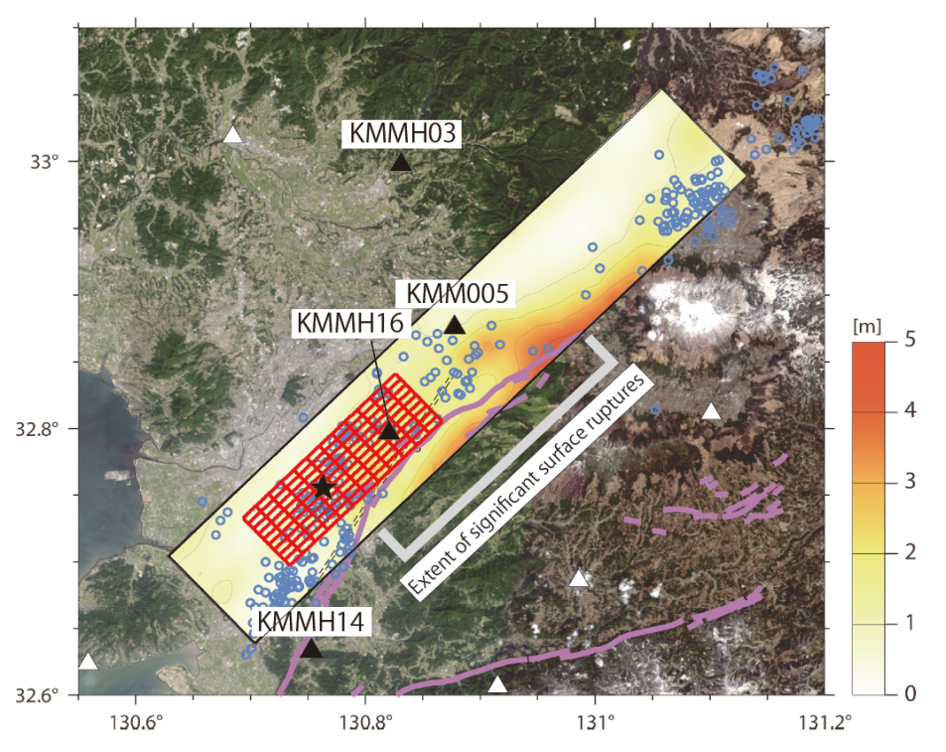
FIG. 1. Map projection of the slip distribution for the 2016 M 7.3 Kumamoto earthquake by Kubo et al. (2016a) and the best-fit model of the SMGA (red rectangle). The locations of active faults are indicated by purple lines and aftershocks are marked by blue circles. Background map was made using GSI Maps from the Geospatial Information Authority of Japan (http://maps.gsi.go.jp). This figure is modified from Kubo et al. (2016a)

FIG. 2. Comparison of the observed (black) and synthetic (red) velocity ground motions (cm/s) of three components (EW, NS and UD) using the empirical Green’s function method (Irikura et al., 2017). The available frequency range is from 0.3 to 10 Hz. The numbers in each trace indicate the maximum amplitude.

FIG. 3. Left. Map projection of the total slip distribution by Kubo et al. (2016b). The star denotes the rupture starting point. Sky blue and gray circles denote the hypocenters of aftershocks (M ≥ 1) 1 day and 1 month after the M 7.3 event, respectively, which were determined by the NIED Hi-net. Circle sizes indicate event magnitudes. Open triangles denote stations used in the analysis. Right. The SMGA model with two SMGAs (SMGA1 and SMGA2).

Kubo et al. (2016b)^{[12]} had the waveform inversion assuming the curved fault model (Fig. 3 left). They confirmed that the use of the curved fault model led to improved waveform fit at the stations south of the fault, comparing it with the result of using a single fault plane model. We constructed a characterized source model consisting of two fault segments with one SMGA in each segment (Fig. 3 right), based on the slip distribution model of Kubo et al. (2016b)^{[12]}.
The long-period ground motions are simulated using the SMGA model in which Green’s functions are estimated by the discrete wavenumber method for calculating ground motions in elastic layered media (Bouchon, 1981^{[14]}). The synthetic velocity motions obtained as sum of the contributions of SMGA1 and SMGA2 to ground motions agree well with the observed ones at near- and intermediate-fault distance stations in Fig. 4.
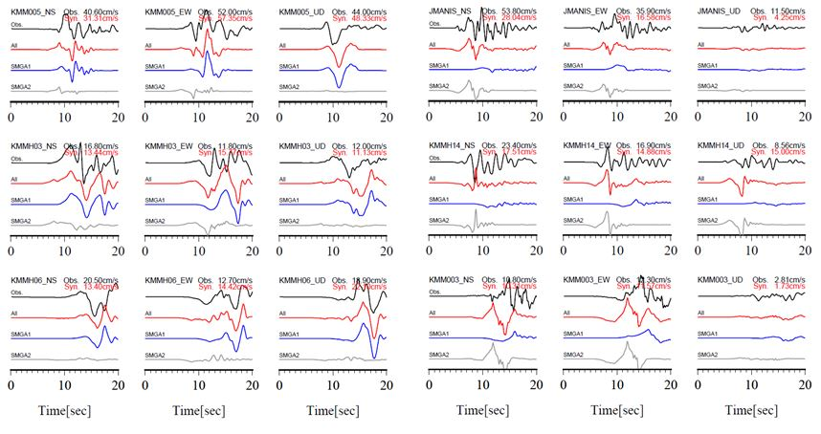
FIG. 4. Comparison of the observed (black) and synthetic (red) velocity ground motions of three components (NS, EW, and UD) at intermediate-distance stations (fault distance of more than 2 km). Contributions from SMGA1 and SMGA2 are plotted by blue and gray lines, respectively. The available frequency range is less than 1 Hz.

On the other hand, synthetic velocity motions at very-near-fault stations (93051, 93048, and KMMH16) using the SMGA model (Fig.3 right) are clearly underestimated without long-period motions more than 2 s compared with the observed ones as shown in Fig. 5. Then we propose a new characterized model adding long-period motion generation areas (LMGA) from fault surface to a certain depth in the weak zone over the seismogenic zone. The slip velocity time function inside the LMGA is defined to be a smoothed ramp function with a certain duration. The long-period ground motions including permanent displacement are simulated using the SMGA-LMGA model in which Green’s functions are estimated by the wavenumber integration method for calculating ground motions in layered half space media ( Hisada and Bielak, 2003^{[15]}).
We find two LMGAs through a trial and error procedure to reproduce long-period motions observed at 93051, 93048, and KMMH16 as shown in Fig. 6. Source parameters for the two LMGAs are listed in Table 1. The slip time function is given to be a smoothed ramp function with 2.5 s duration. Ground motions generated from the LMGA have less amplitudes at short-periods and large amplitudes at long-periods including permanent displacements, being consistent with the observed motions in Fig. 7. The synthetic ground motions as a sum of ground motions from the LMGAs as well as the SMGAs and the background area agree well with the observed ones at very-near-fault stations (93051, 93048, and KMMH16) and intermediate-fault stations such as KMM005 in Fig. 8.

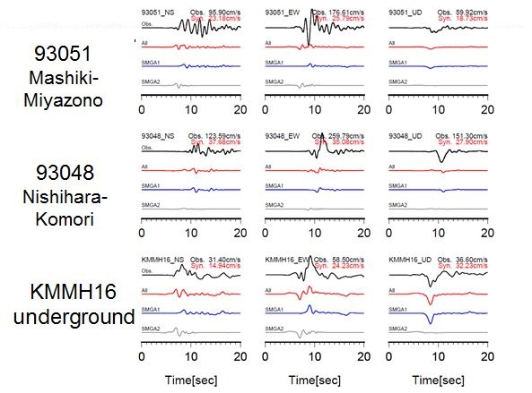
FIG. 5. Comparison of the observed (black) and synthetic (red) velocity ground motionsof three components (NS, EW, and UD) at near- and very-near stations (fault distance of less than 2 km). Contributions from SMGA1 and SMGA2 are plotted by blue and gray lines, respectively. The available frequency range is less than 1 Hz.

FIG. 6. Left Map view of a new characterized source model with two SMGAs (SMGA1 and SMGA2) and two LMGAs (LMGA1 and LMGA2). Right The new characterized source model projected on the fault plane with two SMGAs and two LMGAs. The hypocenter of the mainshock (closed black star), the rupture starting point (open black star) of each SMGA and LMGA, and observation stations (reverse triangle) are indicated

Table 1. Parameters of two LMGAs
 | LMGA1 | LMGA2
Strike/dip/rake-angle | 235°/ 65°/ -150° | 235°/ 65°/ -150°
Seismic Moment | 1.11×10¹⁸Nm | 1.49×10¹⁸Nm
Lx×Lw | 3km×3km | 4km×3km
Rise Time | 2.5sec | 2.5sec
Slip | 4m | 4m
Lag Time | 5.5sec | 3.0sec
Rupture Velocity | 2.8km/s | 2.8km/s

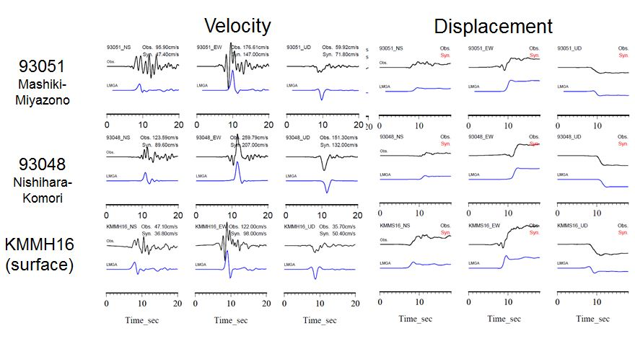
FIG. 7. Comparison of observed and synthetic ground motions (velocity and displacement) generated from the LMGA model at very-near-fault stations, 93051 (Mashiki Town Hall), 93048 (Nishihara Village Hall), and KMMH16 (KiK-net Mashiki surface).

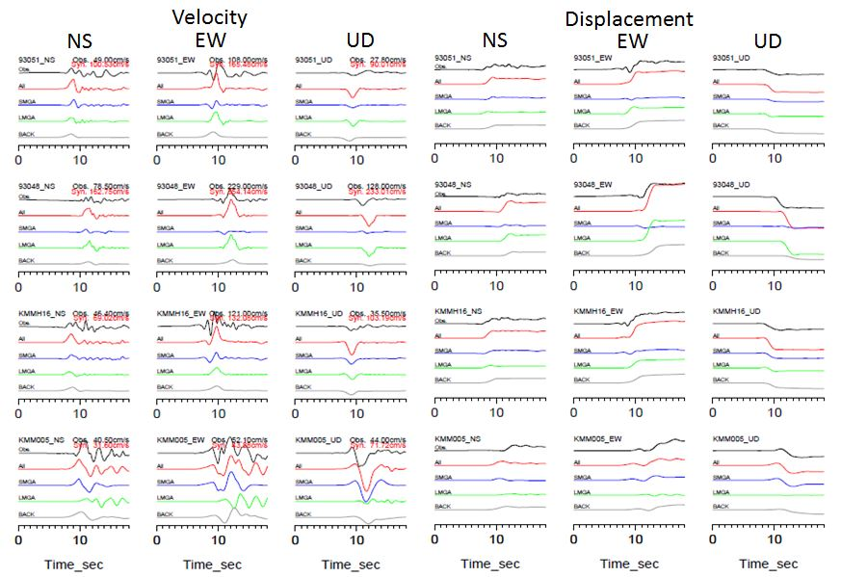
FIG. 8. Comparison of observed (black) and synthetic (red) ground motions from a new characterized source model with SMGAs and LMGAs at very-near fault stations (93051, 93048, and KMMH16surface) and a near-fault station (KMM005). Left Velocity motions of three-components (NS, EW, and UD). Right Displacement motions of three-components (NS, EW, and UD). Contributions from the SMGAs (blue) and LMGAs green and background (gray) are plotted. The available frequency range is from less than 1 Hz.

Extension of characterized source model
The conventional characterized model consists of a few SMGAs with large stress drop and a background region with less stress drop in each fault segment. We successfully simulated the ground motions of the 2016 Kumamoto earthquake based on the characterized source model consisting of strong motion generation areas (SMGAs) using the empirical Green's functions (EGF) method and the discrete wavenumber method except very-near-fault stations such as 93051, 93048, and KMMH16. The long-period motions at those stations extremely near the surface fault traces are not well simulated against the observation from the conventional characterized source model.
Then, the validity of the new characterized source model has to be examined for the 2016 Kumamoto earthquake. The new characterized source model is constructed as the following procedure. It is composed of two fault segments, one the Futagawa fault system and the other the Hinagu fault system. The SMGAs are distributed one each segment. Two LMGAs are located on the Futagawa segment and no LMGA on the Hinagu segment.
Each part of the new characterized model for the 2016 Kumamoto earthqake has been already checked for each part. The model with two SMGAs, SMGA1 and SMGA2, reproduce ground motions observed widely at intermediate-distance stations from fault-trace as shown Fig.2 and Fig. 4. The model with two LMGAs, LMGA1 and LMGA2, reproduce long-period ground motions observed at very-near-fault stations in terms of velocity and displacement as shown in Fig 7. Further, we show that synthetic ground motions from the new characterized source model agree well with the observed motions at broadband periods including very-near-fault stations as shown in Fig. 8. However, the examination mentioned above is limited at stations where ground motions are observed.
Then, we try to examine whether the new characterized source model can reproduce the surface displacements derived from ALOS-2/PALSAR-2 data in Fig. 9 (Himematsu and Furuya, 2016^{[16]}). The surface displacements are simulated mainly from the LMGAs. Therefore, we test some LMGA models comparing simulated with observed ones. First, we examine Model A with two LMGAs shown in Fig. 6. The surface displacement from Model A are compared with those from InSAR data in Right of Left of Fig. 10. Displacements at calculated points (reverse triangles) are shown with color of the triangle marks. There are smaller calculations at areas sandwiched between two LMGAs compared with the observed displacements. The calculated points near LMGA2 have a little larger amplitudes than the observed ones. Second, we construct Model B with a long LMGA combined two LMGAs into one, keeping the other parameters unchanged. The displacements calculated from Model B are consistent well with the observed displacements in north-eastern half region but a little overestimated in south-western half region. Third, we construct Model C with heterogeneous slip changing 4 m in north-east to 2 m in south-west inside the LMGA. The displacements calculated from Model C are consistent with the observed ones in the whole region. Forth, we take into consideration Model D with uniform slip of 3 m inside the LMGA. The calculated displacements are comparable with the observed ones, although the degree of agreement is a little lower compared with Model C.
FIG. 9. Cumulative 3D displacement from offset tracking results of tracks 23 and 130 (Himematsu and Furuya, 2016^{[16]}). a EW horizontal displacement. b NS horizontal displacement. c UD vertical displacement. Positive signal indicates eastward, northward and uplift movement. Color scale shows displacements in centimeters. Black lines indicate the Hinagu and Futagawa fault by Nakata and Imaizumi (2002)^{[17]}.

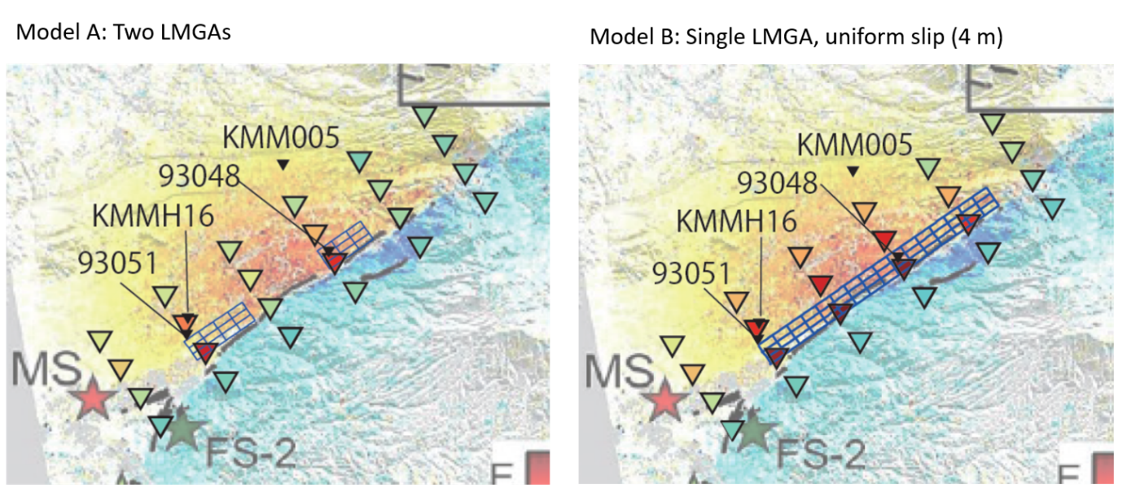
FIG. 10. Comparison of the observed displacement distribution by the pixel-offset data (left end of Fig. 9) and calculated displacements with colors at calculation points (reverse triangles) by the new characterized model. Left Model A with two LMGAs. Right Model B with a uniform LMGA (Slip 4m).

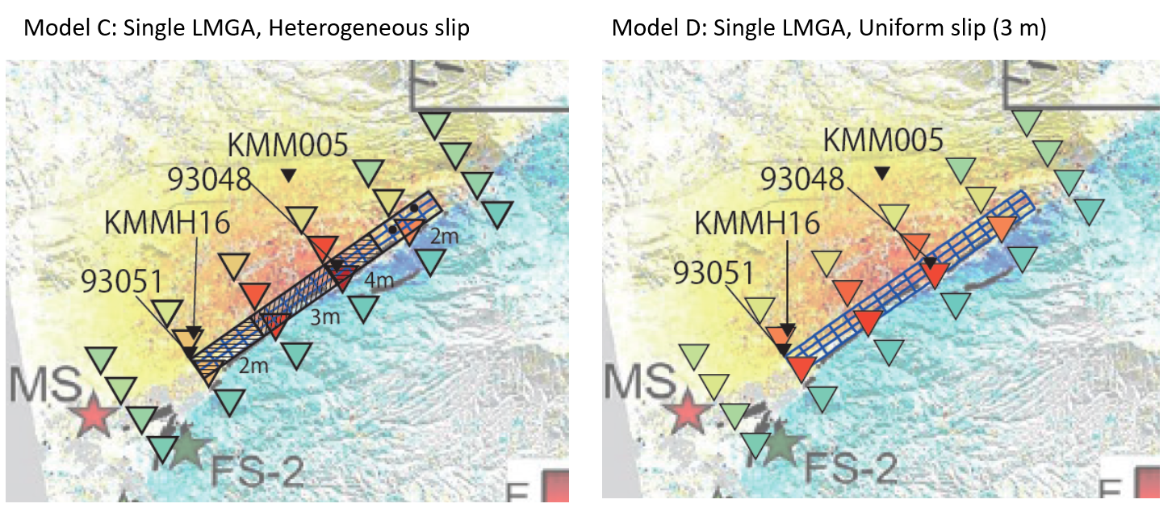
FIG. 11. Comparison of the observed displacement distribution by the pixel-offset data (left end of Fig. 9) and calculated displacements with colors at calculation points (reverse triangles) by the new characterized model. Left Model C with a heterogeneous LMGA. Right Model D with a uniform LMGA (Slip 3m).

2m
3m
４m
3m

Conclusion
We confirmed that ground motions from the 2016 Mw 7.0 Kumamoto earthquake are simulated from the conventional characterized source model consisting of strong motion generation areas (SMGAs) based on the empirical Green's function (EGF) method and the numerical Green’s function method except very-near-fault stations. The locations and areas of the SMGAs were determined inside the seismogenic zone deeper than 3 km through comparison between the synthetic ground motions and observed motions.
Long-period ground motions more than 2 s observed at very-near-fault-distance stations such as 93048 (Nishihara Village Hall), 93051 (Mashiki Town Hall), KMMH16 (Mashiki-KiK-net station) are well reproduced adding long-period motion generation areas (LMGAs) from fault-surface down to a certain depth above the seismogenic zone into the conventional source model.
Then, we propose a new characterized source model adding the long-period motion generation areas (LMGAs) from fault-surface down to a certain depth above the seismogenic zone into the conventional source model. The LMGA for the 2016 Kumamoto earthquake has a rectangle area with a length of 16 km and a width of 3 km and a slip velocity time function with 2.5 second. The new characterized source model with two SMGAs and two LMGAs can reproduce the ground motions during the 2016 Mw 7.0 earthquake including three very-near-fault-distance stations, 93048, 93051, and KMMH16.
We examine whether the model can reproduce surface displacements derived from ALOS-2/PALSAR-2 data (Himematsu and Furuya, 2016). We found that Model C with heterogeneous slip model for a long LMGA connecting LMGA1 with LMGA2, changing 4 m in north-east to 2 m in south-west, and keeping the SMGAs and background area unchanged, reproduces the surface displacements derived from the InSAR data well. Observed ground motions and surface displacements can also be reproduced from Model D with uniform slip of 3 m inside the LMGA, although the degree of agreement is a little lower compared with Model C with LMGA of heterogeneous slip.

ACKNOWLEDGEMENTS
Strong motion data from K-NET and KiK-net were provided by the National Research Institute for Earth Science and Disaster Resilience (NIED), Japan. The strong motion data from the seismic intensity observation network were released by the Japan Meteorological Agency and Kumamoto prefectural government. We also used moment tensor solutions routinely determined by F-net, NIED. The JMA unified earthquake catalog was produced by JMA in cooperation with the Ministry of Education, Culture, Sports, Science and Technology (MEXT). This work was supported in part by the Grants-in-Aids for Scientific Research (B) (P.I.: Hidenori Kawabe, Grant number: 16H03144) from the Ministry of Education, Culture, Sports, Science and Technology of Japan.

REFERENCES
- IRIKURA, K., and MIYAKE, H., “Recipe for predicting strong ground motion from crustal earthquake scenarios”, Pure Appl. Geophys. 168(2011), 85-104.
- MIYAKE, H., et al., “Source characterization for broadband ground-motion simulation: Kinematic heterogeneous source model and strong motion generation area”, Bull. Seism. Soc. Am., 93(2003), 2531-2545.
- Somerville P, Irikura K, Graves R, Sawada S, Wald D, Abrahamson N, Iwasaki Y, Kagawa T, Smith N, Kowada A, “Characterizing crustal earthquake slip models for the prediction of strong ground motion”. Seismol Res Lett 70 (1999):59–80.
- IWATA, T., Analysis of strong-motion-records at Miyazono station, Mashiki Town, and Komori station, Nishihara Village, from the maishock of the 2016 Kumamoto earthquake, April 28, 2016 (Ver. 2), http://sms.dpri.kyoto-u.ac.jp/topics/masiki-nishihara0428ver2.pdf
- IRIKURA, K., et al., “Applicability of source scaling relations for crustal earthquakes to estimation of the ground motions of the 2016 Kumamoto earthquake”, Earth Planets Space, 69:10(2016), DOI 10.1186/s40623-016-0586-y.
- SUZUKI, W., et al., “Strong motions observed by K‑NET and KiK‑net during the 2016 Kumamoto earthquake sequence”, 69:19(2017), DOI 10.1186/s40623-017-0604-8.
- Si H. and Midorikawa S., “New attenuation relationships for peak ground acceleration and velocity considering effects of fault type and site condition”, J. Struct. Constr. Eng., AIJ, 523(1999):63–70 (in Japanese with English Abstract)
- SHIRAHAMA, Y., et al., “Characteristics of the surface ruptures associated with the 2016 Kumamoto earthquake sequence, central Kyushu, Japan”, Earth Planets Space, 68:191(2016), DOI 10.1186/s40623-016-0559-1.
- IWATA, T. and ASANO, K., “Near-Fault Strong Ground Motions during the 2016 Kumamoto, Japan, Earthquake”, AGU Fall General Assembly 2016, abstract id. S53B-2867
- ASANO, K., and IWATA, T., “Source rupture processes of the foreshock and mainshock in the 2016 Kumamoto earthquake sequence estimated from the kinematic waveform inversion of strong motion data”, Earth Planets Space, 68:147(2016), DOI 10.1186/s40623-016-0519-9.
- KUBO, H,, SUZUKI, W,, AOI S, and SEKIGUCHI, H., “Rupture process of the Mj 7.3,April 16, mainshock of the 2016 Kumamoto earthquake obtained from strong-motion data”, 2016 http://www.kyoshin.bosai.go.jp/kyoshin/topics/Kumamoto_20160416/inversion_v2/index_en.html
- KUBO, H., et al., “Source rupture processes of the 2016 Kumamoto, Japan, earthquakes estimated from strong-motion waveforms”, Earth Planets Space, 68:161(2016), DOI 10.1186/s40623-016-0536-8.
- YOSHIDA, K, MIYAKOSHI, K, and SOMEI, K., “Kinematic source model of the 2016 Kumamoto earthquake (Mj 7.3) inverted from strong motion records (ver.2)”. Fall meeting of 2016 Seismological Society of Japan, 2016, S15–P02
- BOUCHON, M., “A simple method to calculate Green’s function for elastic layered media”. Bull. Seism. Soc. Am., 71(1981):959-971.
- HISADA Y, and BIELAK, J., “A theoretical method for computing near-fault ground motions in layered half-spaces considering static offset due to surface faulting, with a physical interpretation of fling step and rupture directivity”. Bull Seismol Soc Am 93(2003):1154–1168.
- HIMEMATSU, Y. and FURUYA, M., “Fault source model for the 2016 Kumamoto earthquake sequence based on ALOS‑2/PALSAR‑2 pixel‑offset data: evidence for dynamic slip partitioning”,, Planets and Space 68 (2016):169, DOI 10.1186/s40623-016-0545-7
- NAKATA, T., and IMAIZUMI, T. (Ed.), Digital active fault map of Japan (2002), University of Tokyo Press, Tokyo.

