Validation of synthetic ground motions based on stochastic finite fault models using observed records during the 2016 Kumamoto earthquake

M. AOKI¹, S. IGARASHI¹, Y. UCHIYAMA¹, S. SAKAMOTO¹

¹Taisei Corporation, Yokohama, Kanagawa, Japan

E-mail contact of main author: aokmss00@pub.taisei.co.jp

Abstract. A physics based method to generate hazard-consistent synthetic ground motions using finite fault models was proposed by Nishida et al. (2015) for probabilistic risk assessment (PRA). They applied Monte Carlo simulation-based approach for incorporating the uncertainties of seismic-source characteristics such as stress drop and location of asperities and simulated a large amount of ground-motion time histories using the stochastic Green’s function method. For conducting more precise PRA, however, it is important to validate whether the simulated ground motions could cover realistic ground motion level at specific site. In this paper, the authors validate simulated ground motions based on stochastic fault models by comparing them with observed strong motion records during the 2016 Kumamoto earthquake (M_{JMA}6.5, foreshock) April 14 as an example. The Kumamoto earthquake is regarded as specified fault activity, Futagawa-Hinagu fault zone. The Headquarters for Earthquake Research Promotion (HERP) in Japan, had reported seismic-source characteristics for Futagawa-Hinagu fault zone activity. We generate 1,000 fault models with the seismic-source parameters that are median reported by HERP and variance used in previous studies, where the magnitude and fault rupture area are fixed. The ground-motion time histories at several KiK-net stations by NIED were simulated. The effects of the uncertainties of seismic-source characteristics on the synthetic ground motions are examined, and the validity of simulated ground motions are discussed.
Key Words: Monte-Carlo simulation, stochastic green’s function method, the 2016 Kumamoto earthquake

INTRODUCTION
In recent years, synthetic ground-motions simulated based on finite fault models have been utilized for probabilistic seismic risk assessment (PRA) of nuclear power plants. Nishida et al. (2015)[1] proposed a methodology to generate a lot of ground-motion time histories which incorporate seismic-source uncertainties by Monte Carlo simulation (MCS). These ground motions are generated based on physics-based fault models that have stochastic seismic source characteristics. This method has the advantages that the seismic intensity of ground motions such as peak acceleration as well as their duration and frequency content can be considered. Therefore, these ground motions can bring about more detailed and useful information when we conduct seismic response analysis of nuclear power structures, systems, and components (SSCs), and they can contribute to appropriate decision making for seismic safety measures.
For conducting more precise PRA, however, it is important to validate whether the simulated ground motions could cover the realistic ground-motion level at specific site. In this study, synthetic ground motions using finite fault models which have stochastic seismic-source characteristics are generated, and validate them by comparing with observed strong motion records during the 2016 Kumamoto earthquake (M_{JMA}6.5, foreshock) April 14th. The Kumamoto EQ is regarded as specified fault activity, Futagawa-Hinagu fault zone. The Headquarters for Earthquake Research Promotion (HERP) in Japan, had reported seismic source characteristics for Futagawa-Hinagu fault zone activity. The synthetic ground motions at several KiK-net stations are evaluated using 1,000 fault models with the seismic-source parameters which are median reported by HERP and the variance used in previous studies, where the magnitude and fault rupture area are fixed. The influence of the uncertainties of seismic-source characteristics on the synthetic ground motions and the validity of simulated ground motions are examined.

METHOD FOR GROUND MOTION CALCULATION
The stochastic Green’s function method (SGFM), which taking uncertainties of seismic-source parameters into account, is employed for ground motion calculation. In a study by Takada et al. (2014)[2], the seismic-source uncertainties can be classified into epistemic uncertainties due to different empirical equations for macro-scopic (outer fault parameters) which are considered by logic-tree (LT), and into aleatory uncertainties due to randomness of micro-scopic (inner fault parameters) characteristics which are considered by MCS. For simple comparison with synthetic and observed ground motions during the foreshock, only aleatory uncertainties are considered, and macro-scopic characteristics, such as a magnitude, size of the fault, and location of the fault, are fixed to estimated values for the foreshock, in this paper.

Stochastic Green’s function method
One thousand waves of synthetic ground motions at each KiK-net station using SGFM are generated based on Equation (1) through (8).
$$A\left(f\right)=\frac{R_{θϕ}∙FS∙P_{RTITN}}{4πρβ^{3}}M_{0}\frac{{(2πf)}^{2}}{1+{(f/f_{c})}^{2}}\frac{1}{\sqrt{1+{(f/f_{max})}^{m}}}\frac{1}{R_{c}}exp\left[-\frac{πfR}{Q(f)β}\right]$$ |  |  | (1)
$$f_{c}=4.9×{10}^{6}β{(Δσ/M_{0})}^{\frac{1}{3}}$$ | (2) | $$Q\left(f\right)=Q_{0}f^{α}$$ |  | (3)
$$τ=α_{tr}W/V_{r}$$ | (4) | $$C_{Sa}=S_{a}/S$$ |  | (5)
$$C_{Sa12}=S_{a2}/S_{a1}$$ | (6) | $$C_{Da}=D_{a}/D$$ |  | (7)
$$V_{r}=C_{Vr}β$$ | (8)
where, A(f) is the Fourier amplitude spectrum if ground motion acceleration from discrete fault element, R_{θφ} is the radiation pattern coefficients, FS is the amplification due to the free surface, P_{RTITN} is the reduction factor that accounts for the partitioning of energy into two horizontal components, and m is the coefficient of the decay rate at high frequencies. ρ is the density, M₀ is the seismic moment of the fault element, f_{c} is the corner frequency, β is shear velocity, Q(f) is the Q-value, τ is rise time, which is the rapture time of fault element, W is the fault width, Vr is the rupture velocity, Sa is the sum of asperities area, S_{a1} is the area of 1st asperity (larger), S_{a2} is the area of 2nd asperity (smaller), S is the area of fault, Da is the dislocation of asperity, and D is the dislocation of fault.

Uncertainties of seismic-source characteristics
In MCS, the ground motions are repeatedly generated for each fault model where realized values for stochastic parameters are given in the way that the realized values are randomly set according to the corresponding distribution of seismic-source stochastic parameter. TABLE 1 shows stochastic parameters in seismic-source characteristics. The medians and averages are set based on the “Recipe” for strong ground motion prediction with specified source faults by HERP [3], and their variance are set based on the previous study [1].

TABLE 1: STOCHASTIC PARAMETERS FOR SEISMIC SOURCE CHARACTERISTICS
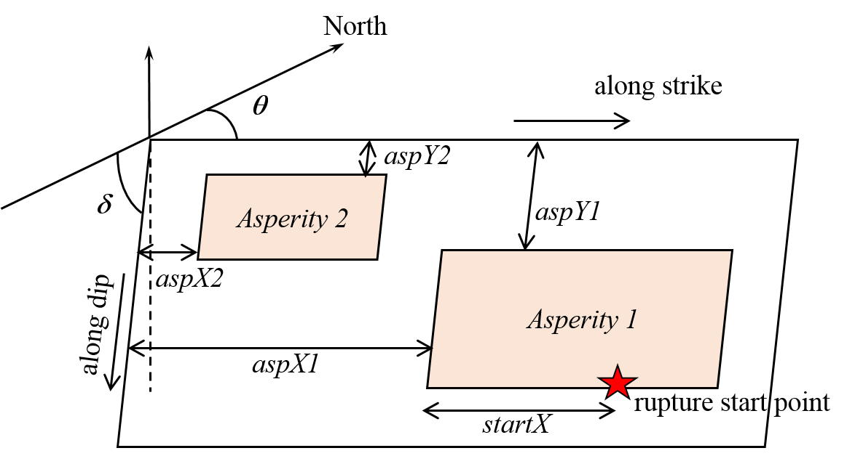
FIG. 1. Notations of the fault model

REPRODUCING THE KUMAMOTO EQ FORESHOCK
Kinematic source inversion results by Asano and Iwata (2016)[4] to several macro-scopic source parameters and spectral inversion results by Uchiyama and Yamamoto (2016)[5] to short-period spectral level A and Q-value are applied. The sum of asperity area S_{a} and Δσ_{a} are calculated from M₀ and A based on Equation (9) and (10).
$$r=\sqrt{S_{a}/π}=(7π/4)\left\{M_{0}/(A∙\sqrt{S/π})\right\}∙β^{2}$$ | (9)
$$A=4π∙r∙{Δσ}_{a}∙β^{2}$$ | (10)
As for micro-scopic source characteristics such as M_{0a}, location of asperities, etc., the report by Port and Airport Research Institute (PARI)[6] are referred. They have estimated characterized fault model for the foreshock, and well reproduced the observed records by the empirical Green’s function method.
The seismic-source parameters for the foreshock by SGFM is shown in TABLE 2, and location of asperities and rupture start point is shown in FIG. 3. A subfault size was set to 1km×1km. In order to confirm whether these parameters are included in range of the variance in TABLE 1, the deviations of parameters were calculated (TABLE 3). Although C_{Vr}, α_{tr}, and C_{Sa} seems to be somewhat far from the average (the deviations show 2~3ζ), these may be possibly realized. The other parameters can be regarded as standard values.
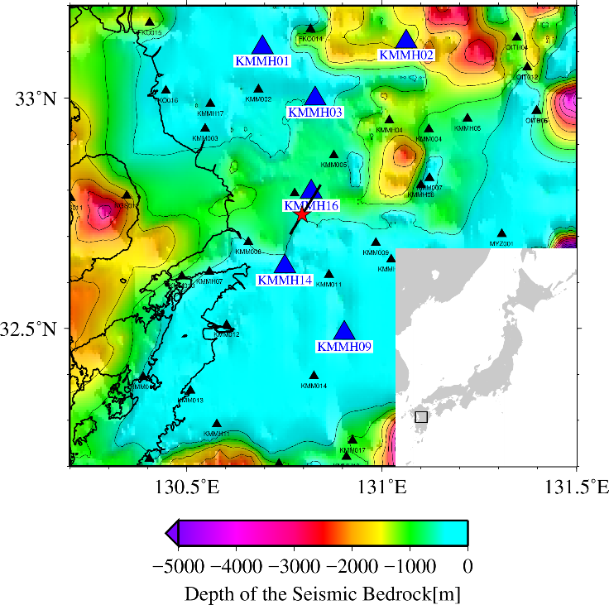  FIG. 2. Location of fault of the 2016 Kumamoto earthquake foreshock and target stations. Blue triangles show target stations, and a red star shows the hypocenter of the foreshock. | FIG. 3. Location of asperities and rupture start point for reproducing the 2016 Kumamoto EQ foreshock by SGFM

The results of reproducing the foreshock by SGFM is shown in FIG. 4. Although synthetic ground motions are well reproduced in a short period range, long period spectral level (T >1.0s) is underestimated. Commonly, SGFM is used for simulation in short-period range, and a theoretical or numerical method is used for in long-period range. For this reason, response spectra in short-period range (T ≦1.0s) are discussed.

TABLE 2: ESTIMATED SOURCE CHARACTERISTICS OF THE 2016 KUMAMOTO EQ FORESHOCK BY PREVIOUS STUDIES AND MODIFIED PARAMETERS FOR SGMF
TABLE 3 : DEVIATION OF SEISMIC-SOURCE PARAMETERS OF FORESHOCK FOR SGFM

FIG. 4. Comparison of response spectra (pSv, h=5%) of the Kumamoto EQ foreshock between obseved and synthetic ground motions

RESULTS OF MONTE CARLO SIMULATION
At each station, synthetic ground motions from 1,000 realized fault models following the distribution in TABLE 1 are simulated. FIG. 5. shows the response spectra obtained at KMMH01 as an example.
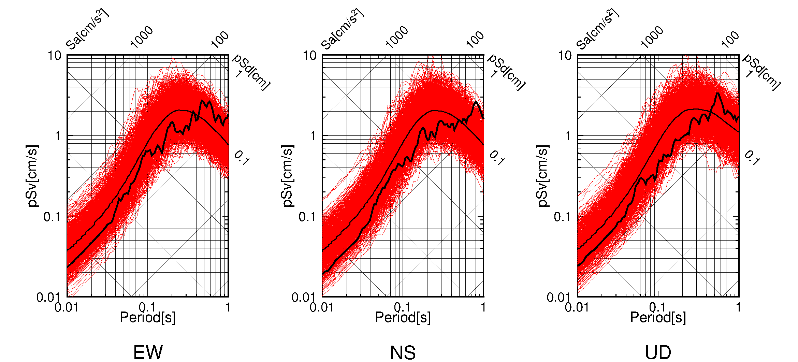
FIG. 5. Response spectra (pSv, h=5%) of synthetic ground motions at KMMH01 (red lines). Black thick lines show observed records, and black thin lines show median of synthetic ground motions.

FIG. 6. Deviations of the observed response spectra
The deviation of pseudo velocity response of observed ground motion in lognormal space were calculated comparing with the synthetic ground motions. FIG. 6. shows the deviations of the observed response spectra for each station. It is clarified that the observed ground motions are included in the range of ±3σ of the results of MCS in short-period range. It can be said the conditions of MCS used in this study have the reproducibility of observed ground motions.

DISCUSSION
The multiple linear regression analysis was conducted for examining the sensitivities of seismic-source characteristics to response spectra of synthetic ground motions. The pseudo velocity response of synthetic waves is set as objective variable (output), and seismic-source characteristics with uncertainties in TABLE 1 are set as explanatory variables (input). To equivalently evaluate the sensitivity of the input variables to the output variable, the multiple liner regression analysis was performed with normalized input and output variables whose means are 0, standard deviations are 1. It is assumed that the pseudo velocity responses of synthetic wave can be expressed as the linear combination of the seismic-source parameters x_{i} (i=1, 2,…, m) and residual ε, such as Equation (11).
$$y\left(T\right)=a_{0}\left(T\right)+a_{1}\left(T\right)x_{1}+a_{2}\left(T\right)x_{2}+a_{3}\left(T\right)x_{3}+…a_{m}\left(T\right)x_{m}+ε(T)$$ | (11)
where, a₀(T)=0, a_{i}(T) (i = 1, 2,…, m) : regression coefficients.
FIG. 7. shows regression coefficients of each seismic-source characteristic. The upper figure shows parameters related to asperity, such as size and location, and the lower figure shows other parameters. The sensitivity of Δσ, α_{tr}, C_{Da}, C_{Vr}, and f_{max} shows a similar trend between all stations. On the other hand, the sensitivity of the parameters related to location of asperities, such as aspX1, aspY1, aspX2, or aspY2 depends strongly on the relative location of the station to fault asperity. The closer the location of asperity to a station, the stronger the response become, therefore the higher the sensitivity is obtained as for the parameters related to location of asperities.
As a result, it was found that seismic-source parameters Δσ, f_{max}, and location of 1st asperity show high sensitivity to pseudo velocity response. In case of the foreshock, the deviation of Δσ is -0.79σ, f_{max} is 0.00ζ, aspX1 is -0.16σ and aspY1 is -1.39σ (shown in TABLE 3). The effects of the parameters which have the large absolute value of the deviation, Δσ and aspY1, are discussed. Δσ, which has the negative deviation for the foreshock, has positive correlation to the MCS results, so it has the negative effect on the deviation of observed response spectra. As shown in FIG. 6., response spectra show negative deviations at KMMH01, KMMH02, KMMH03 and KMMH09. However, at KMMH14 and KMMH16, the deviations of observed records are larger than those at the other stations. This may be caused by the effect of aspY1. aspY1 has negative correlations at KMMH14 and KMMH16, and has negative deviation for the foreshock. This means that aspY1 has positive effect on the deviation of observed response spectra. This effect appears in FIG. 6. On the other hand, aspY1 has low correlations to the MCS results at KMMH01, KMMH02, KMMH03, and KMMH09. (FIG. 7.) It can be seen in FIG. 6. that observed response spectra have negative deviations at these stations.

FIG. 7. Regression coefficients spectra for each characteristic

CONCLUSION
Validation of the method to generate a lot of ground-motion time histories which incorporate seismic-source uncertainties by MCS was conducted. It was indicated that the simulated ground motions could cover observed ground motion level in short-period range. The multiple linear regression analysis yielded that Δσ, f_{max}, and location of 1st asperity had high sensitivity to pseudo velocity response of the MCS results.
In this study, however, only short-period range was targeted because SGFM could not reproduce the foreshock in long-period range. In a study by Igarashi et al. (2015)[7], the hybrid method of SGMF and wave-number integration method were conducted to generate synthetic ground motions. It is necessary that we apply the hybrid method to generate synthetic ground motions.

REFERENCES
- Nishida, A., Igarashi, S., Sakamoto, S., Uchiyama, Y., Yamamoto, Y., Muramatsu, K., and Takada, T., (2015), “Characteristics of Simulated Ground Motions Consistent with Seismic Hazard”, Elsevier, UK
- Takada, T., et al. (2014). “Comparison with Ground Motions Generated by Different Methods Considering Source Uncertainties (in Japanese)”, AIJ, 1-2.
- Headquarters for Earthquake Research Promotion, (2016), “Strong ground motion prediction method for earthquakes with specified source faults (“Recipe”)”
- Asano, K. and T. Iwata (2016), Source rupture processes of the foreshock and mainshock in the 2016 Kumamoto earthquake sequence estimated from the kinematic waveform inversion of strong motion data, Earth Planets Space, 68:147
- Uchiyama, Y., and Yamamoto, Y., (2016), “Short-period Spectral Level and Path Characteristics of the 2016 Kumamoto Earthquake Using Spectral Inversion Method”, Journal of JAEE, Vol.16, No.10, 146-150
- Port and Airport Research Institute Web pages, “Characterized Source Model for 2016 Kumamoto earthquake (M6.5, Foreshock) (in Japanese)”, <http://www.pari.go.jp/bsh/jbn-kzo/jbn-bsi/taisin/sourcemodel/somodel_2016kumamoto_z.html> (accessed Jan. 16th)
- Igarashi, S., Sakamoto, S., Nishida, A., Muramatsu, K., and Takada, T., (2015), Structural Response by Ground Motions from Sources with Stochastic Characteristics, Proceedings of ICONE-23, ICONE23-1548

