CURRENT STATUS AND ISSUES OF STRONG-MOTION PREDICTION METHOD IN SEISMIC HAZARD ASSESSMENT FOR THE NATIONAL SEISMIC HAZARD MAPS FOR JAPAN

Hiroyuki FUJIWARA¹ and Nobuyuki MORIKAWA¹

¹National Research Institute for Earth Science and Disaster Resilience (NIED), Tsukuba, Japan

E-mail contact of main author: fujiwara@bosai.go.jp

Abstract. We have been conducting seismic hazard assessment for Japan under the guidance of the Headquarters for Earthquake Research Promotion of Japan (HERP) since the 1995 Hyogo-ken Nanbu Earthquake, and have made the national seismic hazard maps for Japan. The national seismic hazard maps for Japan are prepared to estimate strong-motion caused by earthquakes that could occur in Japan in the future and show the estimated results on the maps. The hazard maps consist of two kinds of maps. One is a probabilistic seismic hazard map that shows the relation between seismic intensity value and its probability of exceedance within a certain time period. The other one is a scenario earthquake shaking map. The 2011 Great East Japan Earthquake (Mw 9.0) was the largest event in the history of Japan. This mega-thrust earthquake was not considered in the national seismic hazard maps for Japan. The 2016 Kumamoto earthquake sequence occurred on active faults where strong-motion evaluation was executed based on the long-term evaluation and strong-motion prediction method ‘Recipe’ by HERP. Based on lessons learned from these earthquake disasters, efforts to revise the seismic hazard assessment for Japan are progressing. We, as project staffs of the NIED, consider problems and issues to be resolved for seismic hazard assessment and make some proposals to improve seismic hazard assessment.
Key Words: seismic hazard, strong-motion, Kumamoto earthquake

Introduction
The National Seismic Hazard Maps for Japan are prepared to estimate strong ground motions caused by earthquakes that could occur in Japan in the future and show the estimated results on the maps. The hazard maps consist of two kinds of maps. One is a probabilistic seismic hazard map that shows the relation between seismic intensity value and its probability of exceedance within a certain time period. The other one is a scenario earthquake shaking map.
The examples of probabilistic seismic hazard maps are maps of probabilities that JMA seismic intensity exceeds 5-, 5+, 6- and 6+ in 30 or 50 years, and maps of the JMA seismic intensity corresponding to the exceedance probability of 3% and 6% in 30 years and of 2%, 5%, 10% and 39% in 50 years. We classify earthquakes in and around Japan into three categories such as the characteristic subduction zone earthquakes, other subduction zone earthquakes, and crustal earthquakes. Probabilistic seismic hazard maps for three earthquake category are also evaluated. For the probabilistic seismic hazard maps, we use empirical attenuation relation for strong-motion prediction, which is followed the seismic activity modeling in the basis of long-term evaluation of seismic activity by the Earthquake Research Committee. Both of peak velocities on the engineering bedrock and on ground surface are evaluated for sites with approximately 0.25km spacing in the basis of the 7.5-arc-second engineering geomorphologic classification database. The Japan Meteorological Agency (JMA) seismic intensities on ground surface are evaluated from peak ground velocity by using an empirical formula.
The scenario earthquake shaking maps are evaluated for approximately 500 scenario earthquakes of all major active faults in Japan. Selection of a specified scenario is essential to make a scenario earthquake shake map. The basic policy of the selection is that we choose the most probable case. We assume several cases of the characteristic source model and compare the results of them to show deviation of strong-motion evaluation due to uncertainties. For the scenario earthquake shaking maps, based on the source modeling for strong-motion evaluation we adopt a hybrid method to simulate waveforms on the engineering bedrock and peak ground velocity. The hybrid method aims to evaluate strong motions in a broadband frequency range and is a combination of a deterministic approach using numerical simulation methods, such as the finite difference method, for low frequency range and a stochastic approach using the empirical or stochastic Green’s function method for high frequency range. A lot of parameters on source characterization and modeling of underground structure are required for the hybrid method. The standardization of the setting parameters for the hybrid method has been studied. Under guidance of the Earthquake Research Committee, we have summarized the technical details on the hybrid method based on the ‘Recipe for strong-motion evaluation’, which are published by the Earthquake Research Committee [1], [2].
In order to contribute to preparation of seismic hazard maps, the National Research Institute for Earth Science and Disaster Resilience (NIED) launched a special project called the "National Seismic Hazard Mapping Project of Japan" in April 2001, and has made technical studies that contribute to preparation of seismic hazard maps, and has prepared maps. In NIED's second five-year period as well, it has implemented research that contributes to advancement of seismic hazard maps through research called "Strong Motion Prediction and Seismic Hazard Evaluation" (FY2006-FY2007) and the "Research Project on the Disaster Risk Information Platform" (FY2008-FY2012).
March 11, 2011, we had the Great East Japan earthquake disaster caused by the 2011 Tohoku Earthquake. Responding to the 2011 Tohoku Earthquake, efforts are being made on improvement of the National Seismic Hazard Maps for Japan. We, as project staffs of the NIED, consider problems and issues to be resolved for seismic hazard assessment and make new proposals to improve probabilistic seismic hazard assessment for Japan [3], based on the lessons learned from this earthquake disaster and experiences that we have engaged in the seismic hazard mapping project of Japan. Based on the lessons learned from the Great East Japan Earthquake, the improved version of the National Seismic Hazard Maps for Japan was released by the Headquarters for Earthquake Research Promotion in 2014 and the hazard maps are updated every year after that [4], [5].
The 2016 Kumamoto earthquake sequence occurred on active faults where strong-motion evaluation was executed based on the long-term evaluation and strong-motion prediction method ‘Recipe’ by Headquarters for Earthquake Research Promotion (HERP). The magnitude of first large earthquake occurred on April 14 (M6.5) at a part of the Hinagu fault zone was smaller than that evaluated by HERP (about M6.8) before the earthquake. On the other hand, the largest earthquake occurred on April 16 (M7.3) at a part of the Futagawa fault zone was larger than that by HERP (about M7.0). In this paper, based on the knowledge obtained from the analysis of the Kumamoto earthquake, we consider some problems in strong-motion prediction and seismic hazard analysis, especially handling of uncertainty in prediction of future events.

Validation of the Recipe for the 2016 Kumamoto Earthquake
The validation of the recipe had been already applied for some shallow crulstal earthquakes occurred in Japan [6]. However, the target earthquakes were relatively small where surface rupture could hardly be confirmed. The mainshock of 2016 Kumamoto earthquake was the first event in Japan where a clear surface rupture was confirmed after the establishment of high-density strong-motion observation networks such as K-NET. The validation of the ‘Recipe’for such earthquake has not been done yet. In this section, we validate the ‘Recipe’ for the 2016 Kumamoto earthquake by comparing observed strong-motion records with simulated ones. In addition, we propose one of the modeling methods of source faults including surface rupture not considered in the current recipe.

Source Model Based on Length of Surface Rupture
The 2016 Kumamoto earthquake sequence occurred in part of Futagawa and Hinagu fault zones where the long-term and strong-motion evaluations were published by the HERP before the earthquake. The largest earthquake (main shock) occurred mainly in the Futagawa segment of the Futagawa fault zone. The length of surface rupture has been confirmed as 34 km [7]. First we consider the length of surface rupture as the fault length, and construct a source model based on the recipe. In this study, we use the strike, dip and rake angle applied in the strong-motion evaluation before the earthquake [8]. The upper depth of the fault plane is set to 2 km which is depth to top of seismic bedrock whose shear wave velocity is 2.7 km/s or more. Here we assumed the lower depth of the fault plane as 18 km based on the aftershock distribution although the depth was evaluated as about 13km based on the distribution of small earthquake before the earthquake. The seismic moment 1.7×10¹⁹ N·m is obtained from an empirical relationship [9] from the source area. This value is about 1/3 as compared with 4.5×10¹⁹ N·m estimated from source inversion analysis using strong-motion records [10].

Source Model with Surface Rupture
In the strong-motion evaluation based on the recipe, the target is mainly on modeling of short period (<1 s) strong-motion generation. Therefore, the fault plane is within the seismogenic layer, and its depth to top is not 0 km as shown in the previous section. However, slip near the ground affects not only long-period (>1 s) strong-motion generation but also total seismic moment. Therefore, it is better to set the upper depth of the fault plane as 0 km in strong-motion evaluation for the earthquake occurred in active faults where clear surface rupture appears. In this study, we also consider a source model with the upper depth of the fault plane set to 0 km. The seismic moment 2.1×10¹⁹ N·m is obtained from the empirical relationship for this model. Although this value is larger than the model in the previous section, it is still about 1/2 of the above-mentioned value estimated from the source inversion analysis.
In this model, we assume that the amount of slip shallower than the seismogenic layer is uniform and equal to the average slip of the back-ground region in the seismogenic layer, and apply a smoothed-ramp function as a slip time function. Also, we assume the effective stress shallower than the seismogenic layer is zero.

Source Models Given Seismic Moment
Since the seismic moment of each source model up to the previous section is smaller than the value estimated from the source inversion analysis, we also consider models given the seismic moment 4.5×10¹⁹ N·m as known without changing the size of each fault. At these models, if the average stress drop on the entire fault is calculated by an equation assuming circular crack, the slip amount of the background region in the seismogenic layer becomes negative. As a provisional workaround in such a case, the recipe shows a method of assuming that the average stress drop is 3.1 MPa [11] and the asperity area is 22% of the entire source area [12]. So we apply the method here. The four source models set by the above are summarized in Table 1 and FIG.1. As shown in FIG.1, the recipe employs the characterized source model which is composed of multiple asperities and surrounding background area. The asperities are defined as regions that have a larger slip than the average slip of the entire rupture area. In this model, asperities with large slips generate long-period as well as short-period seismic-wave radiations due to high stress drop.
TABLE 1: MAJOR SOURCE PARAMETERS FOR 4 MODELS.

 | M1-0kW18 | M1-2kW16 | M2-0kW18 | M2-2kW16
Strike | 233.2 | 233.2 | 233.2 | 233.2
Dip | 90 | 90 | 90 | 90
Rake | -160 | -160 | -160 | -160
Upper depth of the fault [km] | 0 | 2 | 0 | 2
Fault length [km] | 34 | 34 | 34 | 34
Fault width [km] | 18 | 16 | 18 | 16
Seismic moment [×10¹⁹ Nm] | 2.1 | 1.7 | 4.5 | 4.5
Average slip [m] | 1.09 | 0.97 | 2.36 | 2.65
Average stress drop [MPa] | 3.4 | 3.2 | 3.1 | 3.1
Total asperity area [km²] | 132.9 | 109.2 | 134.6 | 119.7

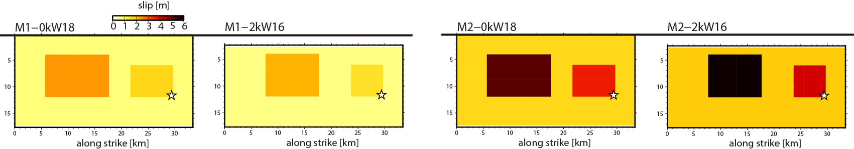
FIG. 1. Source models. Star represents the rupture starting point.

Strong-motion Simulation
In order to simulate strong-motion, we apply a hybrid approach that combines a 3D finite-difference method (FDM) and the stochastic Green’s function method (SGFM) for long- (>1 s) and short-period (<1 s) ranges, respectively. The time series of strong-motion on the engineering bedrock whose shear wave velocity is 600 m/s is computed by using the hybrid approach. We use the 3D FDM using discontinuous grids [13] and the SGFM by Dan and Sato [14]. A 3D velocity structure model constructed by Fujiwara et al. [15] is used to compute time series on the engineering bedrock. The long- and short-period components are superpositioned in the time domain to create a time series of a ground motion at crossover period (1 s) after applying a pair of high- and low-cut filters. The target area in this study is shown in FIG.2. We use Vs30 distribution map estimated from the 250-m-mesh Japan engineering geomorphological classification map [16] as the subsurface structure shallower than the engineering bedrock.
The observed and simulated peak ground velocities (PGVs) are compared in FIG.3. The simulated PGV is calculated from peak velocity on the engineering bedrock by multiplying the amplification factor. The amplification factor is obtained from Vs30 by using an empirical relationship [17]. The simulated PGVs for source models with smaller seismic moment (M1-0kW18 and M1-2kW16) are underestimated with observed PGVs. On the other hand, simulated PGVs for source models given appropriate seismic moment 4.5×10¹⁹ N·m (M2-0kW18 and M2-2kW16) are well matched with observations. The difference in the simulation results between M2-0kW18 and M2-2kW16 is small and the distribution of PGVs in the wide region can be well reproduced in the both models. This indicates that it is not bad to assume that the effective stress is zero at the source fault shallower than the seismogenic layer.
An example of the observed and simulated velocity waveforms on the engineering bedrock are compared in FIG.4. The simulated waveform at the site distant from the source fault (e.g. KMM009) is in good agreement with the observed one, but at site which is very close to the source fault (93048), a pulse-like wave with a period of about 3 s cannot be reproduced. FIG.5 shows a comparison of observed and simulated displacement waveforms on the engineering bedrock at the site 93048. The underestimation of peak displacement is remarkable, but the model M2-0kW18 is better. In order to examine the characteristics of long-period component of strong-motion at sites very close to the source fault, we calculate waveforms on the engineering bedrock every 1 km grid. The distribution of the simulated peak horizontal displacements is shown in FIG.6. At sites where the shortest distance to the source fault trace is 2 km or more indicated by blue diamonds or black crosses in the figure, the difference in peak horizontal displacement between two models, M2-0kW18 and M2-2kW16, is small. However, the difference at sites where the shortest distance to the source fault trace within 1 km is very large between the two models. This indicates that the long-period component of strong-motion at sites very close to the source fault, where shortest distance to the source fault trace within 1km, varies greatly due to the difference in observation site location of several hundred meters.

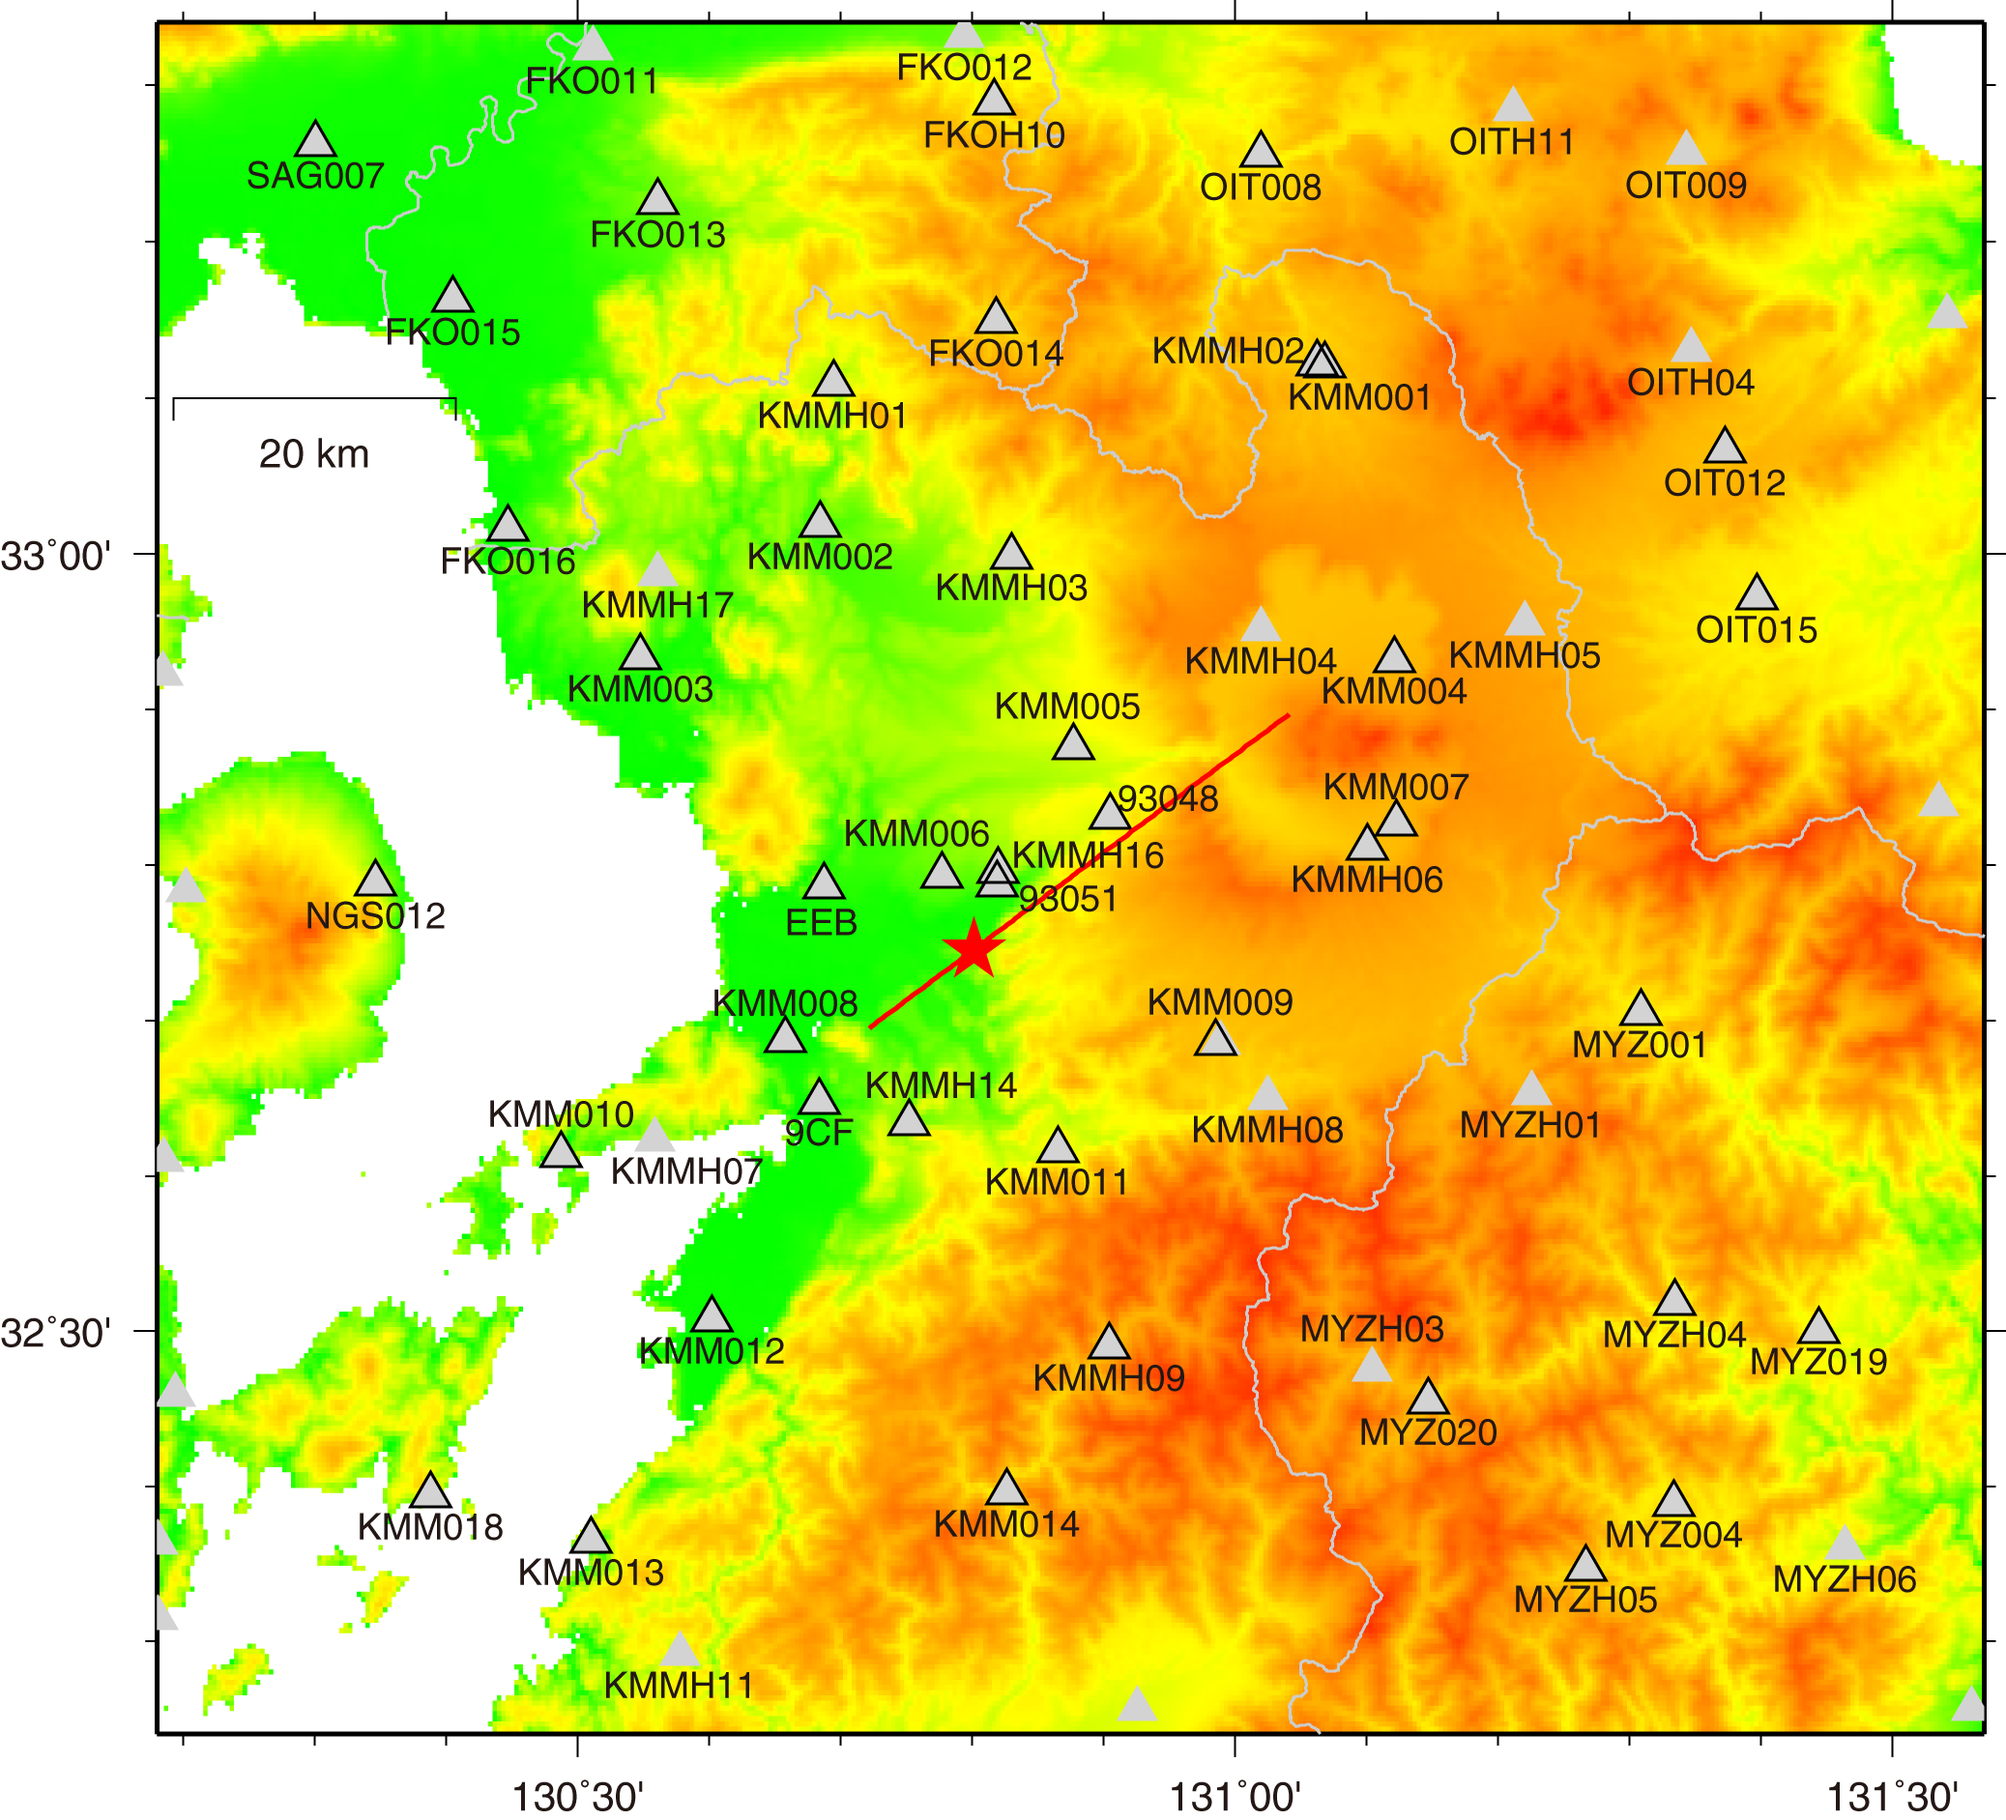
FIG. 2. Target area in this study.

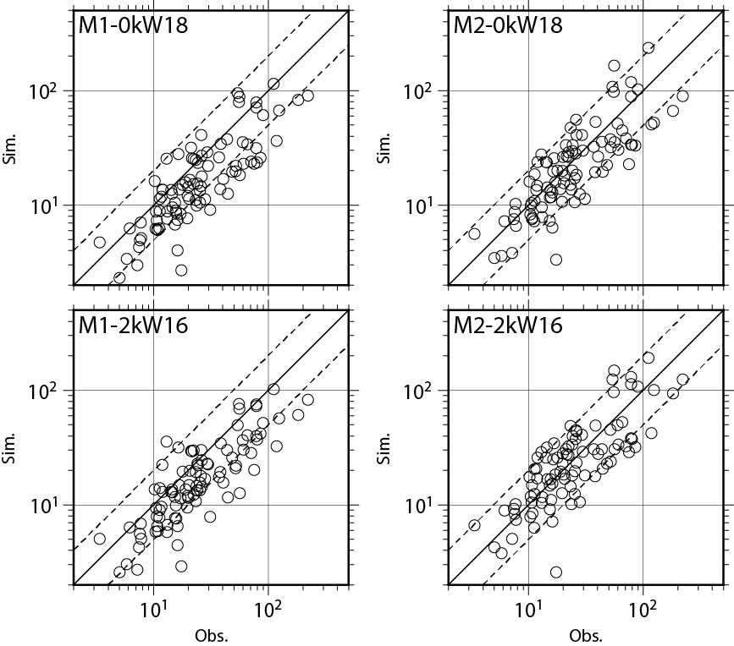
FIG. 3. Comparison of observed and simulated horizontal peak ground velocities.
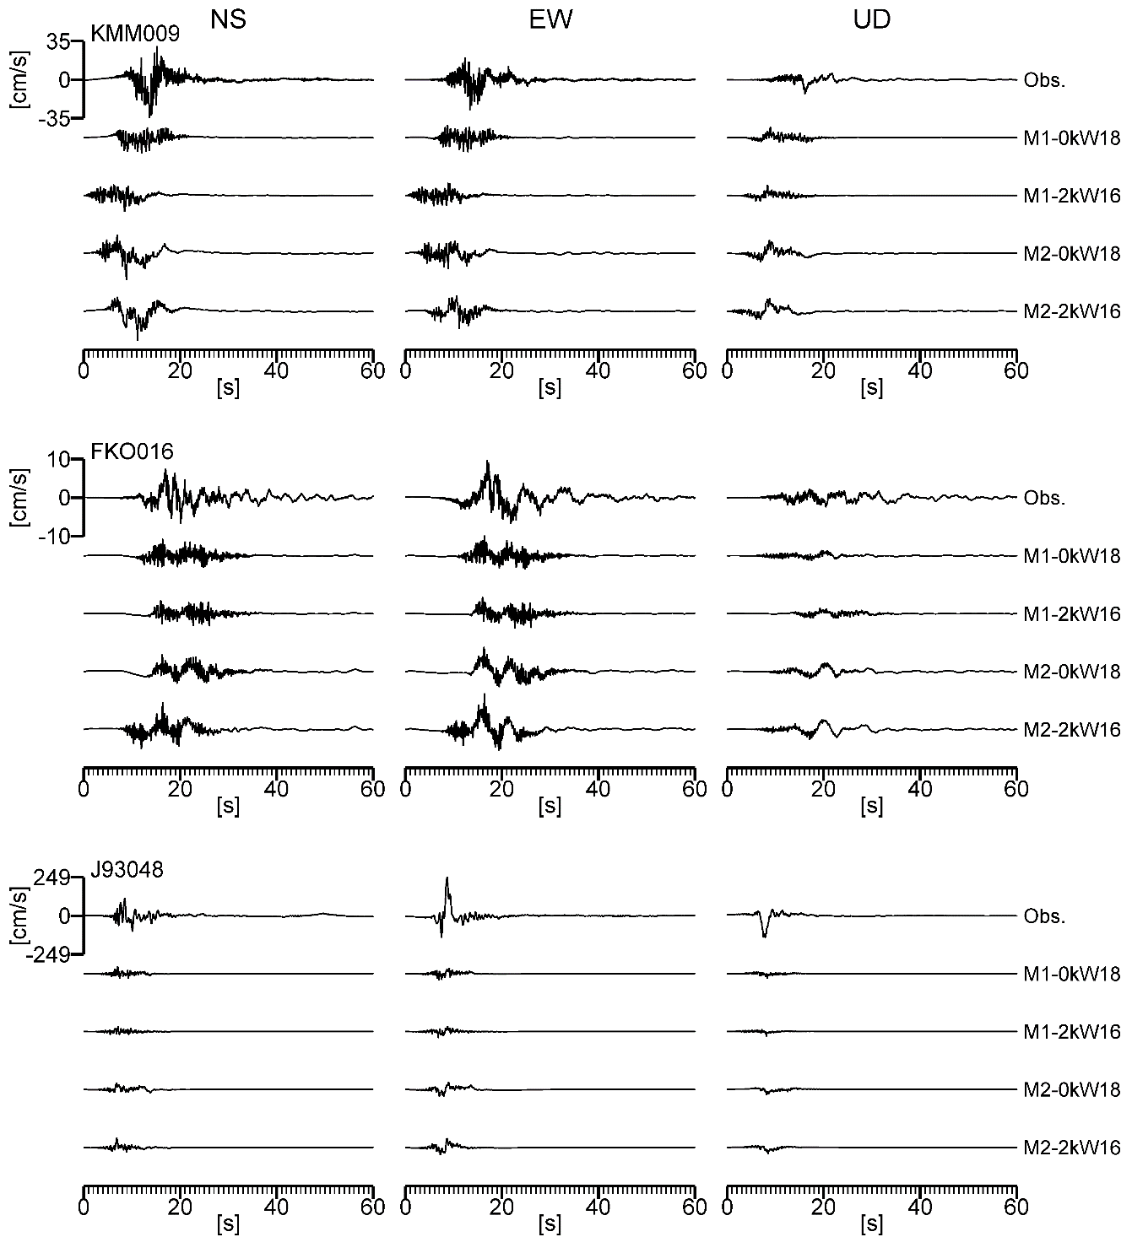
FIG. 4. An example of comparison of observed and simulated velocity waveforms.

NS EW UD
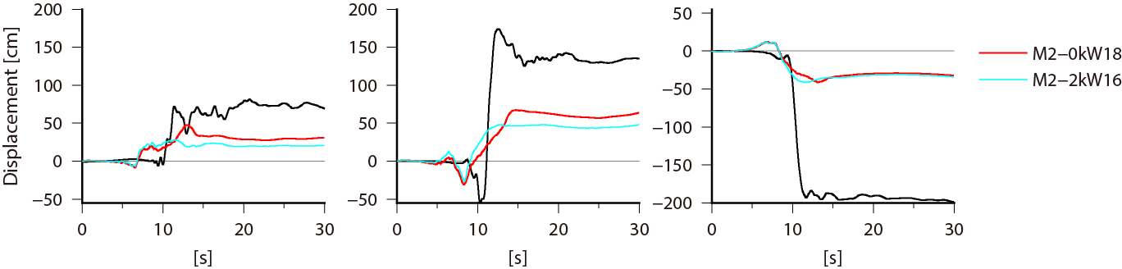
FIG. 5. Comparison of observed and simulated displacement waveforms at a site very close to the source fault.

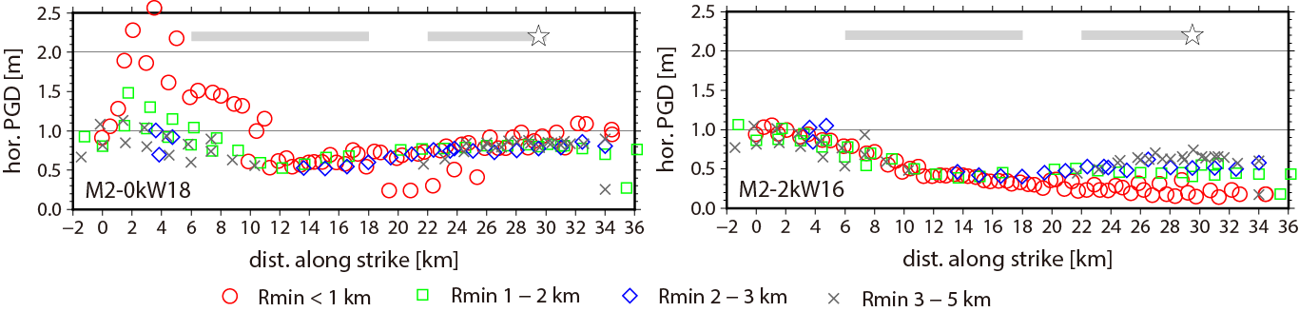
FIG. 6. Comparison of horizontal peak displacement on the engineering bedrock between source models with and without surface rupture. Star and gray bold lines represent a rupture starting point and locations of asperities, respectively.

Simulation Results
The seismic moment evaluated for the 2016 Kumamoto mainshock based on the recipe using the length of surface rupture was underestimated. However, the relationship between the seismic moment and entire source area for M2-0kW18 and M2-2kW16 is included in the range of variation in the Irikura and Miyake’s relationship. In the current strong-motion evaluation based on the recipe, only the source model that considers the value of the empirical equation itself is to be set. Our results show that by considering variations in empirical equations, we can set up a source model that can reproduce the strong-motion distribution of the Kumamoto mainshock. Another possible cause of underestimation of the seismic moment is that the source fault length is longer than the surface fault length.
In this study, the lower depth of the source fault was set as 18 km with reference to aftershock distribution, but it was deeper than the depth of about 13 km which was evaluated from the hypocenter distribution before the earthquake. On the other hand, the dip angle of the source fault was set as 90 degrees based on the evaluation before the earthquake is slightly different from 60-70 degrees applied in the source inversion analysis.
The strong-motion simulation for the fault model with the upper depth of the fault as 0 km shows that the variation of strong-motion is large very close to the surface fault whose shortest distance is within 1 km (see FIG.6). In order to reproduce the waveform at site 93048, the distance from surface fault to the site should be within 1 km, although it is about 2 km in our model (see FIG.2). In addition, it is reported that the heavy damage such as the collapse of wooden house was concentrated in small regions which are very close to the surface fault [18]. These facts imply that the location and shape of the source fault in detail is extremely important for strong-motion evaluation at sites very close to the source fault. In the model of this study, the slip shallower than the seismogenic layer is assumed uniform, but actually inhomogeneous. Construction of source modeling method shallower than seismogenic layer in detail is a future problem.

Discussion
The Kumamoto earthquakes were earthquakes that were long-term evaluated by the headquarters of earthquake research promotion of Japan. The earthquakes occurred in a part of the Futagawa fault zone and the Hinagu fault zone where the seismic hazard maps with specified seismic source fault were published. Based on the knowledge obtained from the analysis of the Kumamoto earthquake, we consider problems in strong-motion prediction and seismic hazard analysis, especially handling of uncertainty in prediction of future events.

(1) Modeling of uncertainties in parameters of source fault model
We classify the uncertainty in assessment into aleatory variability and epistemic uncertainty. The aleatory variability is evaluated as a random variable, and the epistemic uncertainty is evaluated using a logic tree. Considering the epistemic uncertainty with respect to the setting of the size of source fault, it is necessary to consider the following model in addition to the basic model according to the current ‘recipe’, 1) model assuming that the source fault length is longer than the surface fault length, 2) model assuming that depth of lower end of fault slightly deeper than the lower limit of the seismogenic layer, 3) model with the top of the source fault at 0 km (ground), and 4) model considering uncertainty in setting dip angle.
It is important to properly consider the epistemic uncertainty accompanying the selection of the equation and the aleatory variability included in the prediction in parameter setting of the source fault model using the empirical formula, such as, 1) epistemic uncertainty on selection of empirical formula in L-Mo relation and Mj-Mw relation, and 2) aleatory variability in Mo-S relation and Mo-A relation.
In the strong-motion prediction by simulation using the fault model, it is necessary to evaluate both "average ground motion level" and "variation of ground motion due to model uncertainty". For that purpose, it is necessary to consider the uncertainty in the inner parameters of source fault model. It is important to consider the uncertainty concerning starting point of rupture, asperity position, inhomogeneity of effective stress of asperity, the setting of slip velocity time function in the shallower part than the seismogenic layer. In the prediction using simulation, it is necessary to clarify relationship between the reproduction model of the past earthquake and the model for prediction.

(2) Construction of strong-motion evaluation method for sites very close to source faults.
It is reported that the heavy damage such as the collapse of wooden house was concentrated in small regions which are very close to the surface fault of the Kumamoto earthquake. These facts imply that the location and shape of the source fault in detail is extremely important for strong-motion evaluation at sites very close to the source fault. In order to predict the strong ground motion in the very vicinity of the fault, detailed modeling of the location and shape of the source fault with the top end depth of 0 km is necessary. Construction of source modeling method shallower than seismogenic layer in detail is an important problem.

(3) Modeling of earthquakes occurring on active faults whose magnitudes are smaller than 6.8.
The earthquake on April 14 (M6.5), which is thought to be a smaller earthquake than the characteristic one, but the maximum seismic intensity 7 is observed. In the seismic hazard analysis, it is extremely important to model smaller earthquakes that occur frequently than the characteristic one. Modeling of magnitude and occurrence frequency for one size smaller earthquakes than the characteristic one is an important issue.

4. Conclusions
The 2016 Kumamoto earthquake sequence occurred on active faults where strong-motion evaluation was executed based on the long-term evaluation and strong-motion prediction method ‘Recipe’ by Headquarters for Earthquake Research Promotion (HERP). The magnitude of first large earthquake occurred on April 14 (M6.5) at a part of the Hinagu fault zone was smaller than that evaluated by HERP (about M6.8) before the earthquake. On the other hand, the largest earthquake occurred on April 16 (M7.3) at a part of the Futagawa fault zone was larger than that by HERP (about M7.0).
Here we examined whether strong-motion evaluation results based on the ’Recipe’ could predict observations if the fault length on the ground surface, the fault area and the seismic moment of the target earthquake were evaluated appropriately before the earthquake. As a result, we found the following things.
・Distribution of calculated strong-motion parameter, such as peak velocity or JMA seismic intensity, was comparable with observed one if an appropriate seismic moment was given.
・However, the large amplitude of ground motion observed at sites very close to the source fault cannot simulate even if the appropriate seismic moment was given.
・The seismic moment of M7.3 event was underestimated if we use a mean value calculated from empirical relationships in the ‘Recipe’.
Based on the above results, we suggest tentative plans to improve strong-motion evaluation method for earthquakes occurring on active faults as follows:
1) Modeling of uncertainties in magnitude for earthquakes occurring on active faults.
2) Construction of strong-motion evaluation method for sites very close to source faults.
3) Modeling of earthquakes occurring on active faults whose magnitudes are smaller than 6.8.

Acknowledgements
This study was performed under the direction of the Earthquake Research Committee, the subcommittee for long-term evaluations and the subcommittee for evaluations of strong ground motion. This study was conducted as a part of the Research Project on hazard and risk assessment for natural disasters by NIED.

REFERENCES
- HEADQUARTERS FOR EARTHQUAKE RESEARCH PROMOTION OF JAPAN, “National Seismic Hazard Maps for Japan”, (2009) (in Japanese).
- FUJIWARA, H., et al, “Technical reports on national seismic hazard maps for Japan”, Technical Note of the National Research Institute for Earth Science and Disaster Prevention, 336 (2009).
- FUJIWARA, H., et al., “Seismic hazard assessment for Japan: Reconsidrations after the 2011 Tohoku earthquake”, Journal of Disaster Research, 8 (2013) 848-860.
- HEADQUARTERS FOR EARTHQUAKE RESEARCH PROMOTION OF JAPAN, National Seismic Hazard Maps for Japan (2014) (in Japanese).
- MORIKAWA, N.，FUJIWARA, H., Updates of the Seismic Activity Models of Japan: Lessons from the Great Tohoku Earthquake，Seismological Research Letters，87 (2016) 1240-1253.
- IWAKI, A., et al., “Validation of the Recipe for Broadband Ground-Motion Simulations of Japanese Crustal Earthquakes”, Bull. Seism. Soc. Am. 106 (2016) 2214-2232.
- SHIRAHAMA, Y. et al., “Characteristics of the surface ruptures associated with the 2016 Kumamoto earthquake sequence, central Kyushu, Japan”, Earth Planets and Space 68 (2016) 191.
- HEADQUARTERS FOR EARTHQUAKE RESEARCH PROMOTION OF JAPAN, “Scenario Earthquake Shaking Maps”, National Seismic Hazard Maps for Japan (2014) (in Japanese), http://www.jishin.go.jp/main/chousa/14_yosokuchizu/bessatsu.pdf.
- IRIKURA, K., MIYAKE, H., “Prediction of strong ground motions for scenario earthquakes, J. Geor. 110 (2001) (in Japanese) 849-875.
- ASANO, K., IWATA, T., “Source rupture processes of the foreshock and mainshock in the 2016 Kumamoto earthquake sequence estimated from the kinematic waveform inversion of strong motion data, Earth Planets and Space 68 (2016) 147.
- FUJII, Y., MATSU’URA, M. “Regional Difference in Scaling Laws for Large Earthquakes and its Tectonic Implication”, PAGEOPH 157 (2000) 2283-2302.
- SOMERVILLE, P. G., et al., “Characterizing crustal earthquake slip models for the prediction of strong ground motion”, Seism. Res. Lett. 70 (1999) 59-80.
- AOI, S., FUJIWARA, H., “3D finite-difference method using discontinuous grids”, Bull. Seism. Soc. Am., 89 (1999) 918-930.
- DAN, K., SATO, T., “Strong-motion prediction by semi-empirical method based on variable-slip rupture model of earthquake fault”, J. Arch. Inst. Japan 509 (1998) (in Japanese) 49-60.
- FUJIWARA, H., et al., “A study on subsurface structure model for deep sedimentary layers of Japan for strong-motion evaluation”, Technical Note of the NIED 337 (2009) (in Japanese).
- WAKAMATSU, K., MATSUOKA, M., “Nationwide 7.5-arc-second Japan engineering geomorphologic classification map and Vs30 zoning”, J. Disast. Res. 8 (2013) 904-911.
- FUJIMOTO, K., MIDORIKAWA, S., “Relationship between average shear-wave velocity and site amplification inferred from strong motion records at nearby station pairs, J. Japan Assoc. Earthq. Eng. 6 (2006) (in Japanese) 11-22.
- MONMA, N., et al, “Distribution of building damage near the surface deformation associated with the Kumamoto earthquake, JAEE, proceedings (2016).

