# FRAMEWORK FOR NON-STRUCTURAL COMPONENT FRAGILITY CURVE ESTIMATION USING SYNTHETIC GROUND MOTIONS WITH CONDITIONAL SPECTRA

K. TREVLOPOULOS1, I. ZENTNER2

1Alternative Energies and Atomic Energy Commission (CEA), Cadarache, France

2EDF R&D Lab Paris-Saclay, Palaiseau, France

*E-mail contact of main author: k.trevlopoulos@gmail.com*

**Abstract**. Fragility curves are a key component in seismic risk assessment and fragility curve estimation using ground motions compatible with conditional spectra allows for consistency with the seismic hazard. However, natural ground motions might not be available when considering high return periods in low to moderate seismicity areas. The framework presented here is a practical alternative to existing procedures, as it generates synthetic ground motions in agreement with conditional spectra instead of selecting and scaling recorded signals. Here, the point probabilities of damage state exceedance at intensity measure levels are estimated with a lognormal model and the fragility curve is adjusted using a generalized linear model. Finally, we use this framework to investigate the effect of ground motion spatial variability on fragility curves of non-structural components in an industrial building. We see that the first has a favorable effect on the fragility curves, which showcases the usefulness of this framework.

**Key Words**: fragility curves, synthetic ground motions, curve fitting, spatial variability

### Introduction

In seismic risk analysis, the mean annual rate of exceedance of damage states of assets (e.g. buildings, non-structural components) is obtained by integration of the fragility curve with respect to the seismic hazard curve [1]. The fragility curve gives the probability of exceeding a damage state threshold conditioned on the ground motion Intensity Measure (IM) and results from analytical seismic vulnerability analysis, which consists of three steps: ground motion selection, computation of Engineering Demand Parameter (EDP) observations as a function of the IM (typically with time-history analyses), and fragility curve assessment. In fragility curve assessment robustness is required while ground motion selection should be consistent with the site-specific seismic hazard in site-specific seismic risk analysis. The selection of ground motions, which are compatible with Conditional Spectra (CS) [2] is considered consistent with the results of Probabilistic Seismic Hazard Analysis (PSHA). Based on seismic source data, PSHA estimates the probability of exceedance or observation of a level of ground shaking during a time-period. The Uniform Hazard Spectrum (UHS) together with seismic hazard disaggregation [3] is one of the main results of PSHA. The generation of CS requires the UHS, the magnitude and distance distribution from seismic hazard disaggregation and the corresponding Ground Motion Prediction Equation (GMPE). The CS are defined for a set of return periods, i.e. hazard levels. In practice, a few sets of ground motions compatible with CS are selected in order to cover the range of IM levels of interest, e.g. [4] selected site-specific sets of ground motions compatible with CS for six annual probability levels ranging from 10-3 to 10-7. Seismic ground motion databases are growing but they do not always contain recorded ground motions that fit both the seismic scenario and particular spectral shape, as defined by the CS, or excessive record scaling is required [5]. Therefore, the selection of synthetic ground motions is a practical alternative [6].

This paper presents a framework for site-specific fragility curve computation based on synthetic ground motions compatible with CS. The set of CS for each intensity level is computed using the procedure in [7] and the synthetic time histories compatible with the CS are generated with code_aster [8] following the procedure in [6]. Because of the use of synthetic motions, this framework does not require a database of real ground motion records compatible with the site-specific seismic hazard. Instead, it generates sets of 3D ground motions with correlated horizontal components, which is one of its original and practical aspects. With the generated synthetic ground motions, the corresponding EDP observations are computed with seismic response analyses and the point probabilities of exceeding a damage state threshold at the IM levels is estimated. Each exceedance point probability is estimated based on a lognormal distribution according to the EDP observations. Subsequently, a lognormal fragility curve is fitted to the point probabilities with a fit based on a generalized linear model, which is another original aspect of this paper. Finally, we apply the developed framework in a case study to demonstrate its usefulness. The framework is employed to study the effect of spatial ground motion variability on the fragility curves of non-structural components in industrial buildings. Monte-Carlo simulations are performed with and without spatial variation of the seismic ground motion its effect is discussed based on the estimated fragility curves.

### Synthetic input ground motions with conditional spectra

In this study synthetic ground motions are used, which are individually compatible with CS at different IM levels. Following the procedure in [7], the simulated CS fit the mean and plus one standard deviation target spectra. In consequence, the synthetic spectrum compatible ground motions also comply with these statistics, which is verified in the following. The generation process starts with defining the target CS using the procedure developed in [7]. The UHS at five return periods is used here in order to cover the range of IM required for the evaluation of the fragility curves. In this work, the GMPE by Campbell and Bozorgnia [9] is used to define the conditional spectra. For more consistency with the results of PSHA for a given site, all GMPEs used for the evaluation of the UHS should be considered (e.g. [10]). This is out of the scope of the demonstrative application herein and one GMPE is used for simplicity. Moreover, the correlation between the spectral accelerations at different periods has to be taken into account. Here, the correlation coefficients proposed by [11] are used. For our case study, deaggregation results in addition to the UHS given by USGS [12] for a hypothetical site in California are employed. Since we are evaluating fragility curves for non-structural components with a frequency of 10 Hz, Table 1 includes the conditioning spectral acceleration at 10 Hz (which is equal to the UHS at that frequency), the magnitude and the source distance resulting from the deaggregation of the hazard at 10 Hz.

TABLE 1: SEISMIC HAZARD DATA USED IN THE GENERATION OF THE SYNTHETIC GROUND MOTIONS.

|  |  |  |  |  |
| --- | --- | --- | --- | --- |
| Intensity Measure Level | Return Period (years) | UHS  Sa(10 Hz) (g) |  | (km) |
| IM1 | 949 | 1.22 | 7.09 | 14.3 |
| IM2 | 1950 | 1.57 | 7.11 | 13.9 |
| IM3 | 4950 | 2.08 | 7.12 | 13.4 |
| IM4 | 9950 | 2.45 | 7.11 | 13.1 |
| IM5 | 19900 | 2.87 | 7.10 | 12.6 |

Based on this data and Monte-Carlo simulations according to [7], five sets of thirty target CS for the horizontal components are simulated, corresponding to the 5 selected return periods (949, 1950, 4950, 9950 and 19900 years). For these target CS, individually spectrum-compatible synthetic ground motions are generated with the procedure described in [6], which models ground motions as stochastic processes with spectrum compatible power spectral densities. Each CS is used as the target geometric mean spectrum for the generation of two correlated horizontal components with a correlation coefficient of 0.2. The vertical ground motions are generated similarly as a single independent ground motion component and by applying a scaling factor of 2/3 to the simulated CS. Thus, three-dimensional synthetic ground motions in agreement with CS are generated and are used in the seismic soil-structure interaction analyses. The geometrically mean spectra of the horizontal components of the synthetic ground motions are shown in Figure 1a and fit well the target CS. The median and plus-minus one standard deviation spectra of the synthetic ground motions also fit well to the target values as shown in Figure 1b.

a) 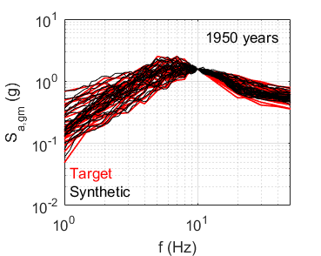b) 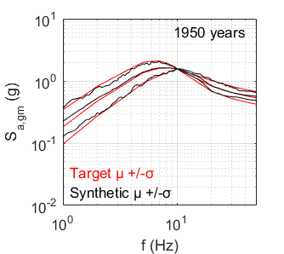

*FIG. 1. a) Target CS and spectra of the generated synthetic ground motions b) Median plus/minus one standard deviation (ln) of the target CS and the spectra of the synthetic ground motions for a return periods of 1950 years.*

### Models of the structure and the non-structural components

In what follows, we describe the building and models of non-structural components, which are used in order to illustrate the application of the methodology for fragility analysis developed here. We are interested in developing fragility curves for non-structural components in industrial buildings where the impact of soil-structure interaction can be significant and has to be accounted for, since the epistemic uncertainty of fragility curves depends not only on the uncertainty of the parameters of the non-structural components themselves, but also on the uncertainties in the soil-structure system hosting the non-structural components.

The substructuring approach is used in this study to model soil-structure interaction where the impedance matrix of the soil domain is determined by a boundary element code. The response of the soil-structure system is computed based on the combination of the modes of the structure and foundation interface [13-14] using the Finite Element Method (FEM). The building model used (Figure 2a) is a three-story simplified model representative of reinforced concrete industrial buildings in terms of seismic behavior. A distributed mass modelling scheme is employed, which accounts for high frequency local modes such as floor bending. The mass of the roof is uniformly distributed and includes 10 kN/m² live loads, while the mass distribution of the foundation and the floors are unsymmetrical. Their masses include 10 kN/m², 15 kN/m² and 20 kN/m² live loads in the building parts with coordinates x < 19 m, 19 m < x < 38 m and x > 38 m, respectively. Mass eccentricity has been introduced in analyses of industrial structures to emphasize rotations induced by ground motion incoherency [15]. The structure is considered to have elastic behavior and modeled with finite elements of approximately 2 m so that the seismic motion at high frequencies is not filtered due to the discretization [16].

The employed building model (Figure 2) is embedded in an elastic stratum of 30 m overlaying elastic bedrock of equal VS, which models the soil domain as a uniform elastic halfspace. The flexibility of the foundation is taken into account and it is modelled in full contact with the soil without uplift or sliding potential. Elastic frequency domain analyses of the building model are performed to compute structural 3D response for free-field excitation in direction x, y and z separately. The uncertainties of the parameters of the soil-structure system are taken into account by modelling them as random parameters with a lognormal distribution in Monte Carlo Simulations. The parameters, whose uncertainty is taken into account, are the concrete’s Young’s modulus (Ec), structural damping ratio, structural mass, the shear wave velocity VS and the damping of the soil (Table 2).

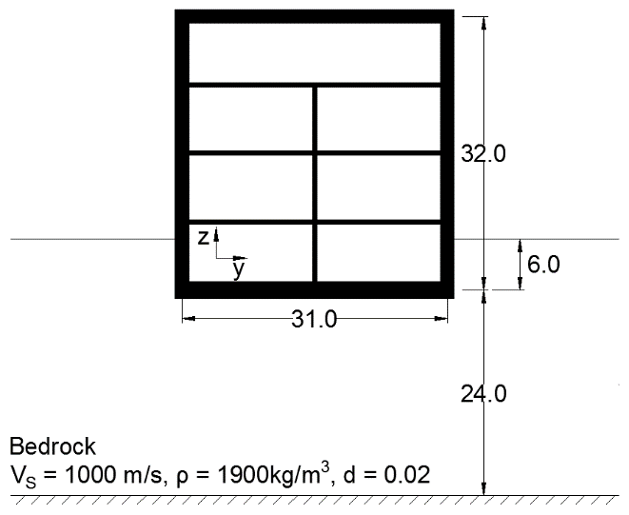

*FIG. 2. Simplified model of an industrial building.*

TABLE 1: MEDIAN AND DISPERSION OF THE RANDOM MODE PARAMETERS

|  |  |  |
| --- | --- | --- |
| Parameter | Median | C.O.V. |
| Concrete Young’s Modulus (Ec) | 30 GPa | 0.30 |
| Structure Damping | 0.07 | 0.35 |
| Structural Mass | 61,000 t | 0.10 |
| Soil Shear Wave Velocity (VS) | 1000 m/s | 0.20 |
| Soil Damping | 0.02 | 0.35 |

The non-structural components at the center of the foundation and at the center of the third floor of the building are modeled as identical linear elastic single-degree-of-freedom (SDOF) oscillators. Elastic oscillators are typically used to model acceleration sensitive non-structural components anchored to the floor. The employed elastic oscillators have a natural frequency of 10 Hz. The seismic response of the oscillator is computed using the computed in-building seismic motions.

### Fragility curve estimation

#### Damage state threshold exceedance point probabilities and seismic demand analysis

The seismic demands are computed for the sets of ground motion with a fixed intensity measure level. This is the common spectral value of the set of motions with CS at the conditioning frequency, i.e. the natural frequency of the non-structural components. In this framework, synthetic motions are used, which are generated with the procedure described above. The ground spectral acceleration at 10 Hz is the IM and the floor spectral acceleration the same frequency is the EDP in this case. The EDPs were computed at five IM levels, which are given by the UHS at five return periods. For each IM level, the probability of exceedance of a damage state threshold may be computed with a lognormal cumulative distribution function. In [17], the damage-state exceedance point probability at an IM level is computed using the binomial distribution. Here, this probability is computed with the lognormal model, whose parameters are computed based on the seismic demands (EDPi) for one IM level with Equations 1-2. The lognormal cumulative distribution function for one IM level and the probability of exceeding an EDP equal to α are given by Equations 3 and 4, respectively.

(1)

(2)

(3)

(4)

Where αi is the i-th seismic demand computed for the IM level, and are the estimators for the median and the dispersion of the lognormal model, Pc(α) is the cumulative distribution function as a function of the value α, Φ is the cumulative distribution function of the standard normal distribution and Pf(a) is the probability of exceeding an EDP threshold equal to α.

### Lognormal CDF fit to point probabilities of damage state threshold exceedance

Based on the estimated point probabilities at the IM levels, which are evaluated with a lognormal model or a kernel density function, a lognormal fragility curve may be determined using a Generalized Linear Model (GLM) with a Probit link function. Equation 5 gives the probability of exceeding a damage state threshold α given by a lognormal fragility curve with estimated median and dispersion and , respectively. After the change of variables in Equation 6, we obtain Equation 7, which is the Probit link function. Subsequently, the linear model in Equation 8 may be fitted to the points with coordinates *(lnαi, Φ-1(Pf(αi)))*, where αi and Pf(αi) are the IM and the probability of exceeding the damage state threshold at the i-th IM level, respectively. The coefficients c0 and c1 may be estimated with any method for fitting a linear model to a cloud of points, like the Iteratively Reweighted Least Squares employed by MATLAB for GLM fitting. Weighted fits should be considered, if there are unequal numbers of EDP observations at the considered IM levels. Here, for simplicity, equal EDP observations at all IM levels are used and the GLM is fitted with Ordinary Least Squares (OLS). OLS has the matrix form in Equation 9, where ***Y*** is a vector computed based the probabilities of exceeding the damage state threshold at the n considered IM levels, ***A*** is the matrix with the logarithms of the IM values (αi), ***C*** is the vector with the coefficients of the GLM and ***R*** is the vector with the residuals between the GLM and the points to which it is fitted (Equation 13). The vector ***C***, which minimizes the sum of the squares of the residuals, is given by Equation 14. Having computed the coefficients of the GLM, the median and the dispersion of the fitted fragility curve are computed with Equation 6.

(5)

(6)

(7)

(8)

(9)

(10)

### Resultant lognormal fragility curve dispersion

The lognormal curve fitted to the point estimates of the probability of exceeding the damage state threshold is defined by a median and a dispersion βdem, the latter accounting for the uncertainties considered in the computation of the seismic demands, i.e. ground motion variability and uncertainty in the soil-structure model parameters. The dispersion of the final fragility curve (β) is however higher than βdem, since it includes two other components, which are not included in the numerical model, and is defined in Equation 11.

(11)

The component βmod is used to take into account the uncertainty in the modelling process. It is used, since the seismic demands are computed with best-estimate parameters of the non-structural component model. In this study, the uncertainty in the modelling of the non-structural component is taken into account by taking βmod = 0.20. The third component (βthr) accounts for the uncertainty of the damage state threshold. In the case of anchorages of non-structural components, βthr may be computed with Equation 12 [18-19]:

(12)

The threshold uncertainty is computed as the resultant of βD, βM, βc, and βinel which correspond to the uncertainty in the design, the material, the construction quality and additional uncertainty in the case of post-yield damage state thresholds respectively. The values of the first three components in Equation 12 are given by [18] according to behavior, construction quality and sensitivity to construction quality, while the fourth is taken equal to 0.16, if the damage state threshold is higher than the limit of elasticity and 0 otherwise. It is assumed that the anchorage has a ductile behavior during earthquake shaking, therefore βD is taken equal to 0.05. Anchorage steel is assumed conforming to ASTM 36 and thus βΜ equals 0.15. Construction quality is assumed to be high as well as sensitivity to the construction quality, which is typically the case for nonstructural components in industrial buildings. Therefore, βC is taken equal to 0.0 leading to βthr = 0.15 for the floor spectral acceleration damage state threshold.

### Application to the case study

In this case study, which has the goal to highlight the usefulness of the developed framework, we study the effect of the spatial variability of the seismic ground motion and the effect of the uncertainty of the shear wave velocity of the subsoil on the fragility curves of in-building non-structural components. Seismic ground motion may vary even over small distances (e.g. a few tens of meters). In the case of industrial buildings with large mat foundations it is required to model ground motion spatial variability. Spatial variation of the ground motion has been documented by field experiments such as the Argostoli array [20]. The natural spatial variability of the seismic ground motion may be modeled with coherency functions [21]. Such functions have been developed for different soil types and are available in numerical simulation software. In this study, we use the coherency function by Abrahamson [21] in Code_Aster to investigate the effect of the coherency model on in-building non-structural component fragility curves.

Using the maximum displacement of the oscillator and the floor Sa(10 Hz) as alternative EDPs, the fragility curves of the oscillators are computed for a damage state threshold of 2.0 g. The parameters of the estimated fragility curves (median and total resultant dispersion) for the different cases considered are given in Table 3.

Moreover, Figure 3 shows the fragility curves and their 95 % CI for the case of coherent and incoherent ground motion according to Abrahamson’s model. The 95 % CI are here estimated with boostrap resampling [22]. We observe in Figure 3 that modeling ground motion spatial variability with Abrahamson’s coherency function results in fragility curves with a higher median with respect to the fragility curves for coherent ground motion. This is true for the fragility curves at the center of the foundation and at the center of the third floor of the building model.

TABLE 3: MEDIAN AND DISPERSION OF THE RANDOM MODE PARAMETERS

|  |  |  |  |
| --- | --- | --- | --- |
| Control Point | Coherency function | Fragility Curve Parameters | |
| Median Sa(10 Hz) (g) | β |
| Foundation center | Abrahamson | 2.89 | 0.30 |
| Foundation center | None | 2.55 | 0.27 |
| 3rd floor center | Abrahamson | 1.59 | 0.33 |
| 3rd floor center | None | 1.50 | 0.32 |

a) 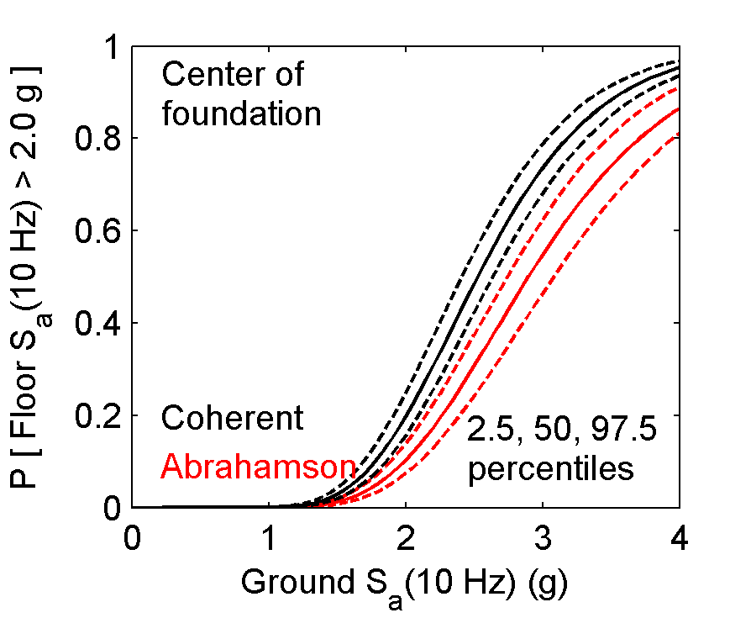b) 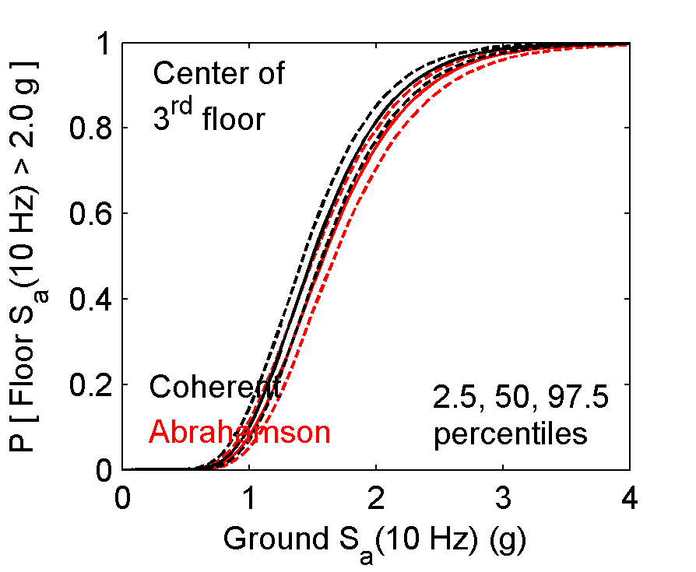

*FIG. 3. Fragility curves for coherent and incoherent ground motion with Abrahamson’s model for the non-structural component a) at the center of the foundation b) at the center of the third floor.*

### Conclusion

We have presented a framework for fragility curve estimation using synthetic ground motions in agreement with CS, so that the evaluated curves are consistent with information from PSHA. The synthetic ground motions are generated for a series of return periods (IM levels) based on PSHA data. The probability of exceeding damage state thresholds is computed with a lognormal model for the EDP observations. As far as fitting a lognormal curve to the point probabilities is concerned, in this framework, a fit based on a generalized linear model is proposed. The usefulness of the developed framework is demonstrated by applying it to study the effect of ground motion spatial variability on the fragility curves of in-building non-structural components. The non-structural components are modeled as elastic oscillators in a model of an industrial building in a soil-structure system. As anticipated, the effect ground motion spatial variability on the fragility curves is beneficial in the case study.

### AKNOWLEDGEMENTS

The authors thank Rainer Zinn (SPI) for kindly providing the details of the building model used in this study. This work was partially funded by Euratom’s FP7 through the research program NUGENIA+ and its pilot project LOSSVAR (grant agreement No 604965), and by the French National Research Agency through the research program SINAPS@ (ANR-11-RSNR-0022).

### REFERENCES

1. SILVA V, CROWLEY H, BAZZURRO P. Exploring Risk-Targeted Hazard Maps for Europe. Earthquake Spectra, 2015:32; 1165-1186. DOI: 10.1193/112514EQS198M
2. BAKER JW. The conditional mean spectrum: A tool for ground motion selection. Journal of Structural Engineering, 2011:35; 1077-1095. DOI: 10.1061/(ASCE)/ST.1943-541X.0000215
3. BAZZURRO P, CORNELL CA. Disaggregation of Seismic Hazard. Bulletin of the Seismological Society of America, 1999:89; 501-520
4. SWISSNUCLEAR. Probabilistic Seismic Hazard Analysis for Swiss Nuclear Power Plant Sites – PEGASOS Refinement Project. Final Report, 2016:6
5. AY BÖ, FOX MJ, SULLIVAN TJ. Technical Note: Practical Challenges Facing the Selection of Conditional Spectrum-Compatible Accelerograms. Journal of Earthquake Engineering, 2017:21; 169-180. DOI: 10.1080/13632469.2016.1157527
6. ZENTNER I. A procedure for simulating synthetic accelerograms compatible with correlated and conditional probabilistic response spectra. Soil Dynamics and Earthquake Engineering, 2014:63; 226-233. DOI: 10.1016/j.soildyn.2014.03.012
7. JAYARAM N, LIN T, BAKER JW. A computationally efficient ground-motion selection algorithm for matching a target response spectrum mean and variance. Earthquake Spectra, 2011:27; 797-815. DOI: 10.1193/1.3608002
8. Code_Aster, 2016, Version 13.2, [Computer Program], Available at: http://code-aster.org
9. CAMPBELL KW, BOZORGNIA Y. NGA Ground Motion Model for the Geometric Mean Horizontal Component of PGA, PGV, PGD and 5% Damped Linear Elastic Response Spectra for Periods Ranging from 0.01 to 10 s. Earthquake Spectra, 2008:24; 139-171. DOI: 10.1193/1.2857546
10. BERNIER C, MONTEIRO R, PAULTRE P. Using the Conditional Spectrum Method for Improved Fragility Assessment of Concrete Gravity Dams in Eastern Canada. Earthquake Spectra, 2016:32; 1449-1468. DOI: 10.1193/072015EQS116M
11. BAKER JW, JAYARAM N. Correlation of Spectral Acceleration Values from NGA Ground Motion Models. Earthquake Spectra, 2008:24; 299-317. DOI: 10.1193/1.2857544
12. UNITED STATES GEOLOGICAL SURVEY (USGS). 2008 PSHA Interactive Deaggregation. 2008; http://geohazards.usgs.gov/deaggint/2008/ (Accessed: 17 February 2017)
13. CLOUTEAU D, COTTEREAU R, LOMBAERT G. Dynamics of structures coupled with elastic media-A review of numerical models and methods. Journal of Sound and Vibration, 2013:332; 2415-2436, DOI: 10.1016/j.jsv.2012.10.011
14. LYSMER J, OSTADAN F, CHIN CC. SASSI 2000 Theoretical manual – A system of analysis of soil-structure interaction. University of California, Berkeley, 1999
15. SHORT S, HARDY G, MERZ K, JOHNSON J. Program on Technology Innovation: Validation of CLASSI and SASSI codes to treat seismic wave incoherence in soil-structure interaction (SSI) analysis of nuclear power plant structures. Electric Power Research Institute, 2007, Report 1015111
16. KUHLEMEYER RL and LYSMER J. Finite element method accuracy for wave propagation problems. Journal of Soil Mechanics & Foundations Div., 1973:99; 421-427
17. BAKER JW. Efficient analytical fragility function fitting using dynamic structural analysis. Earthquake Spectra, 2015:31; 579-599. DOI: 10.1193/021113EQS025M
18. FEMA. Seismic performance assessment of buildings, Volume 1-Methodology, FEMA P-58-1, prepared by the Applied Technology Council for the Federal Emergency Management Agency, Washington, DC; 2012
19. FEMA. Seismic performance assessment of buildings, Volume 1-Implementation Guide, FEMA P-58-2, prepared by the Applied Technology Council for the Federal Emergency Management Agency, Washington, DC; 2012
20. BERGE-THIERRY C, SVAY A, LAURENDEAU A et al.. Toward an integrated risk assessment for nuclear safety improving current French methodologies through the SINAPS@ research project. Nuclear Engineering and Design, 2017:323; 185-201. DOI: 10.1016/j.nucengdes.2016.07.004
21. ABRAHAMSON NA. Program on technology innovation: Effects of spatial Incoherence on Seismic Ground Motions, Electric Power Research Institute, Palo Alto, CA, 2007;1015110
22. IERVOLINO I. Assessing uncertainty in estimation of seismic response of PBEE. Earthquake Engineering & Structural Dynamics, 2017. Published online. DOI: 10.1002/eqe.2883