# Outline of the PFDHA Method and Recent Studies on PFDHA in Japan

Makoto TAKAO1, Toshimichi KANETO1, Tetsushi KURITA2

1Tokyo Electric Power Company Holdings, Inc. (TEPCO), Japan

2Tokyo Electric Power Services Company, Ltd. (TEPSCO), Japan

*E-mail contact of main author: takao.makoto@tepco.co.jp*

**Abstract**. A probabilistic fault displacement hazard analysis (PFDHA) is a methodology that assesses the annual rate at which an amount of displacement of a surface earthquake fault exceeds a certain quantity. Youngs et al. (2003) developed PFDHA and Takao et al. (2013) derived evaluation formulae based on data from surface earthquake faults generated in Japan. In addition, Takao et al. (2014) and Takao et al. (2016) proposed alternative evaluation formulae to improve the reliability of PFDHA. Since we experienced three large earthquakes accompanied with surface faults after our previous studies were published, we attempted to reflect these earthquakes in the PFDHA equations. As a result of this study, we found that there is no significant difference between the previously proposed formulae and the tentatively evaluated formulae reflecting the recent earthquakes. In addition, as for the occurrence probability of a distributed fault, the range (distance from the principal fault) to be considered when analyzing the occurrence probability of a distributed fault had previously not been studied at all. Therefore, we demonstrated parametric analyses which can clarify how the range, which is considered in the analysis of the occurrence probability of the distributed fault, impacts on the evaluation formulae. As a result of the study, we concluded that 15 km could be a rough indication to be considered as the range.

**Key Words**: PFDHA, probabilistic fault displacement hazard analysis, distributed fault

### Introduction

A probabilistic fault displacement hazard analysis (PFDHA) is a methodology that assesses the annual rate at which an amount of displacement of a surface earthquake fault exceeds a certain quantity. According to Safety Standard No. SSG-9 that was published by the International Atomic Energy Agency (IAEA) in 2010, it is recommended to perform a PFDHA for existing nuclear power plants in case there is a capable fault at the site.

Youngs et al. (2003) developed PFDHA methodology for normal faults. Petersen et al. (2011) proposed evaluation formulae for strike-slip faults and Takao et al. (2013) derived evaluation formulae based on data from surface earthquake faults generated by reverse and strike-slip faults in Japan. In addition, Takao et al. (2014) proposed alternative evaluation formulae by conducting model experiments and numerical analyses based on the discrete element method (DEM) in order to compensate for the lack of data regarding distributed faults, and Takao et al. (2016) improved probability distribution functions necessary for calculating the exceedance probability of distributed faults by using the maximum likelihood method.

After Takao et al. (2013) was published, we experienced three large earthquakes accompanied with surface earthquake faults beyond January 2010. In this paper, we tentatively attempted to reflect these earthquakes, which were not included in the previous database, to examine how they impact on the previous formulae established using earthquakes up to December 2009.

In addition, as for the occurrence probability of a distributed fault, the range (distance from the principal fault) to be considered when analyzing the occurrence probability of a distributed fault had previously not been studied at all. Therefore, we demonstrated parametric analyses which can clarify how the range, which is considered in the analysis of the occurrence probability of the distributed fault, impacts on the evaluation formulae.

### Outline of PFDHA

#### Definition of principal and distributed fault

In PFDHA, surface ruptures are to be divided into two categories on the basis of the hierarchy of faults. One is called a ‘principal fault’ and the other is a ‘distributed fault’.

According to Takao et al. (2013), a principal fault is defined as a surface earthquake fault which is closely related to the earthquake source fault. If it is obvious that a splay fault is connected to the earthquake source fault, the splay fault is to be categorized as a principal fault.

A distributed fault is defined as a surface earthquake fault which cannot be recognized to be closely related to the earthquake source fault and which appeared secondarily and subserviently at a certain distance from the principal fault. In this paper, we decided to use ‘distributed fault’ after the terminology of Youngs et al. (2003), but ‘secondary fault’ is used in some papers with the same meaning.

#### Probability related to the principal fault

The annual rate (annual frequency) *ν*(*d*)*p* that a displacement of a principal fault exceeds a certain value can be calculated as follows:

 (1)

where *ν*0 is annual rate of rupture of an earthquake source fault, *P*1*p* is conditional probability of occurrence of a principal fault on the surface when an earthquake source fault ruptures, *P*2*p* is conditional probability of occurrence of a fault displacement under the designated evaluation point when a principal fault has appeared on the surface and *P*3*p* is exceedance probability of a certain value when a principal fault displacement has appeared under the designated evaluation point. When actually performing a PFDHA, *Eq. (1)* in Takao et al. (2013) is to be used, since *Eq. (1)* in this paper is a conceptual expression.

#### Probability related to the distributed fault

The annual rate (annual frequency) *ν*(*d*)*d* that a displacement of a distributed fault exceeds a certain value can be calculated as follows.

 (2)

where *ν*0 is annual rate of rupture of an earthquake source fault, *P*1*p* is conditional probability of occurrence of a principal fault on the surface when an earthquake source fault ruptures, *P*2*d* is conditional probability of occurrence of a distributed fault displacement at a certain distance from a principal fault when a principal fault has appeared on the surface and *P*3*d* is exceedance probability of a certain value when a distributed fault displacement has appeared under the designated evaluation point.

### Previously proposed evaluation formulae

1. **Principal fault**

(1) *P*1*p*

Takao et al. (2013) proposed the *P*1*p* equation using Japanese data in terms of whether or not the surface earthquake fault appeared. Thisequation, which was determined based on the logistic regression model and the maximum likelihood method, is shown in *Eq. (3)*.

 (3)

, 

where *Mw* is moment magnitude of the earthquake.

(2) *P*2*p*

The length of the surface earthquake fault does not necessarily correspond to that of the earthquake source fault. Accordingly, Takao et al. (2013) introduced conditional probability *P*2*p*, which is related to rupture segments on the basis of the fact that the ratio of surface earthquake fault length to earthquake source fault length depends on the magnitude of the earthquake. *P*2*p* is an original idea by Takao et al. (2013), having not been proposed by other researchers. The detailed calculation method for *P*2*p* and necessary equation, such as the ratio of surface earthquake fault length to earthquake source fault length, are described in Takao et al. (2013).

(3) *P*3*p*

The modelled cumulative distribution functions necessary for calculation of *P*3*p* are described as follows:

1) Fault length equal to or longer than 10 km

For *D/MD*

  (4)

For *D/AD*

  (5)

2) Fault length shorter than 10 km

For *D/MD*

  (6)

For *D/AD*

  (7)

where  is a non-dimensional distance from the edge along the principal fault standardized by the fault length  when assuming that fault displacement is symmetric about .

The maximum displacement (*MD*) and the average displacement (*AD*) of the principal fault are necessary in order to calculate the displacement along the principal fault. In Takao et al. (2013), the inclination of *MD-Mw* or *AD-Mw* was set after Wells and Coppersmith (1994) and the intercept (constant term) was determined based on the least square method because there are not enough data in terms of both *MD* and *AD* in Japan. Consequently, as for *MD*, the relation between *MD* and *Mw* was obtained as shown in *Eq. (8)*, whose constant term is 0.3 greater than that of Wells and Coppersmith (1994) ().

 (8)

As for *AD*, the relation between *AD* and *Mw* shown in *Eq. (9)* was assumed to be the same as that of Wells and Coppersmith (1994) because the difference between the constant term obtained by the least square method and that of Wells and Coppersmith (1994) was less than 0.1.

 (9)

Lognormal distribution was assumed as dispersion around the *MD-Mw* and *AD-Mw* relation, and 0.42 for *MD* and 0.36 for *AD* are used as standard deviation after Wells and Coppersmith (1994) because of insufficient data in Japan.

Finally, *P*3*p* can be obtained by calculating an exceedance probability using the density function that will be derived from numerical integration of two probability density functions, which are the beta distribution (*Eq. (4)* or *Eq. (6)*) and lognormal distribution (sigma=0.42) in the case of *MD*. In the case of *AD*, *Eq. (5)* or *Eq. (7)* and lognormal distribution (sigma=0.36) are employed to calculate the *P*3*p*.

1. **Distributed fault**

**(1) *P*2*d* (500m cell size)**

Takao et al. (2013) derived the equation (*Eq. (10)*) for the occurrence probability of a distributed fault (*P*2*d*) using a 500m×500m cell size and logistic regression with the maximum likelihood method after Youngs et al. (2003).

 (10)

**(2) *P*2*d* (other cell sizes)**

Takao et al. (2013) proposed the *P2d* equation in consideration of *Mw* dependency as shown in *Eq. (10)*. For the sake of an actual application, Takao et al. (2014) provided the *P*2*d* equations (*Eq. (11)*) considering the cell size dependency characteristics after Petersen et al. (2011).

When evaluating the *P*2*d* with the cell size dependency, Takao et al. (2014) performed an analysis considering the type of the fault; however, there was no clear difference between reverse fault and strike-slip fault. In addition, it was found that the effect of magnitude *Mw* on *P*2*d* was much smaller than that of the change of cell size on *P*2*d*. Therefore, fault type and *Mw* were not taken into account in *Eq. (11)*.

 (11)

500m×500m: , , 

250m×250m: , , 

100m×100m: , , 

50m× 50m: , , 

(3) *P*3*d*

Two kinds of information are inevitably required to calculate the exceedance probability *P*3*d*. One is a distance attenuation equation for normalized displacement of the distributed fault (*DD/PMD* or *DD/PAD*) and the other is a probability distribution for the normalized displacement of the distributed fault (*DD/PMD* or *DD/PAD*) at each distance from the principal fault to the distributed fault, where *DD* is the displacement of the distributed fault, *PMD* is the maximum displacement of the principal fault, and *PAD* is the average displacement of the principal fault.

a) Distance attenuation equation

As per Takao et al. (2013) and Takao et al. (2016), an exponential function was adopted like Youngs et al. (2003) as an attenuation curve for distributed fault displacement standardized by the principal fault displacement, and 90% non-exceedance level curves in terms of *MD* and *AD* were obtained as shown in *Eq. (12)*, *Eq. (13)* and *Eq. (14)*.

 (12)

 (13)

 (14)

where *DD* is the displacement of the distributed fault, *PMD* is the maximum displacement of the principal fault, *PAD* is the average displacement of the principal fault, and *r* is the shortest distance (km) from the principal fault to the distributed fault.

In addition, *Eq. (12)* and *Eq. (13)* were derived exclusively on the basis of the field data, and *Eq. (14)* was obtained from not only field data but also model experiment and numerical calculation.

**b) Probability distribution**

Takao et al. (2013) embraced gamma distribution for *DD/PMD* and *DD/PAD* after Youngs et al. (2003). The gamma distribution equation expressed in *Eq. (15)* is the same form as *Eq. (5)* and *Eq. (7)*, and shape parameter *a* and scale parameter *b* are shown in:

 (15)

For *DD/PMD*

 (16)

For *DD/PAD*, Takao et al. (2016) proposed alternative parameters to those of Takao et al. (2013, 2014), using the maximum likelihood method to improve objectivity and reliability as described in *Eq. (17)*.

 (17)

1. **Study on the impact on equations by reflecting the latest earthquakes**

As described in the introduction, we experienced three large earthquakes accompanied with surface earthquake faults after Takao et al. (2013) was published. Therefore, we tentatively attempted to reflect these post-January 2010 earthquakes, namely the 2011 Fukushima-ken Hamadori earthquake, the 2014 Nagano-ken Hokubu earthquake and the 2016 Kumamoto earthquake, to examine how they impact on the previous formulae established using earthquakes up to December 2009.

1. **Screening of earthquakes**

At first, we investigated earthquakes that occurred after January 2010 which were not included in Takao et al. (2013). The screening conditions for choosing earthquakes to be employed in this study were identical to those in the previous study. Briefly, earthquakes which were *Mj* (Japan Meteorological Agency magnitude) 5.8 and over, and which occurred at a shallow depth (shallower than 40 km) in the inland crust, were chosen on the basis of a literature survey.

As a result of this screening, 14 earthquakes were chosen to be added to the database which was constructed in the previous study. *TABLE 1* shows the number of earthquakes selected through the screening as well as the number of earthquakes accompanied with surface ruptures.

1. **Tentative evaluation for PFDHA equations**

In this study, equations for the occurrence probability of a surface rupture for principal fault and distributed fault are considered as a tentative evaluation. In other words, *P*1*p* and *P*2*d* were examined in this paper. *TABLE 2* shows 22 earthquakes accompanied with surface ruptures. The appearance/non-appearance of surface ruptures is indicated as a circle/cross in the table. In addition, the three earthquakes from the top of the list were added to the previous database.

*TABLE 1: Number of earthquakes considered for analysis*

|  |  |  |  |  |  |  |
| --- | --- | --- | --- | --- | --- | --- |
| Fault type | Number of earthquakes through the screening conditions | | | Number of earthquakes accompanied with surface ruptures | | |
| up to 2009 | 2010 - 2016 | up to 2016 | up to 2009 | 2010 - 2016 | up to 2016 |
| Reverse | 37 | 4 | 41 | 7 | 1 | 8 |
| Strike-slip | 58 | 5 | 63 | 12 | 1 | 13 |
| Normal | 12 | 5 | 17 | 0 | 1 | 1 |
| Total | 107 | 14 | 121 | 19 | 3 | 22 |

*TABLE 2: List of earthquakes accompanied with surface ruptures*

|  |  |  |  |  |  |  |
| --- | --- | --- | --- | --- | --- | --- |
| Year | Earthquake Name | *Mj* | *Mw* | Principal Fault | Distributed Fault | Fault Type  R: Reverse  S: Strike-slip  N: Normal |
| 2016 | Kumamoto | 7.3 | 7.0 | ○ | ○ | S |
| 2014 | Nagano-ken Hokubu | 6.7 | 6.2 | ○ | ○ | R |
| 2011 | Fukushima-ken Hamadori | 7.0 | 6.7 | ○ | ○ | N |
| 2008 | Iwate-Miyagi nairiku | 7.2 | 6.9 | ○ | ○ | R |
| 2004 | Niigata-ken Chuetsu | 6.8 | 6.6 | ○ | ○ | R |
| 2000 | Tottori-ken seibu | 7.3 | 6.7 | ○ | ○ | S |
| 1998 | Iwate-ken nairiku hokubu | 6.2 | 5.8 | ○ | ○ | R |
| 1995 | Hyogo-ken nanbu | 7.3 | 6.9 | ○ | ○ | S |
| 1984 | Nagano-ken seibu | 6.8 | 6.2 | × | ○ | S |
| 1978 | Izuohshima kinkai | 7.0 | 6.6 | ○ | ○ | S |
| 1974 | Izuhanto-oki | 6.9 | 6.4 | ○ | ○ | S |
| 1959 | Teshikaga | 6.3 | 6.0 | ○ | × | S |
| 1945 | Mikawa | 6.8 | 6.7 | ○ | ○ | R |
| 1943 | Tottori | 7.2 | 7.0 | ○ | ○ | S |
| 1939 | Oga | 6.8 | 7.0 | × | ○ | R |
| 1938 | Kussyaro | 6.1 | 5.8 | ○ | ○ | S |
| 1930 | Kitaizu | 7.3 | 6.9 | ○ | ○ | S |
| 1927 | Kitatango | 7.3 | 7.1 | ○ | ○ | S |
| 1925 | Tajima | 6.8 | 6.4 | ○ | ○ | S |
| 1918 | Ohmachi | 6.5 | 6.4 | ○ | × | R |
| 1896 | Rikuu | 7.2 | 6.7 | ○ | ○ | R |
| 1891 | Nobi | 8.0 | 7.4 | ○ | ○ | S |

(1) *P*1*p*

The *P*1*p* equation was re-evaluated using the data listed in *TABLE 1* and *TABLE 2* on the basis of *Eq. (3)* and the maximum likelihood method. In this study, three kinds of examination were performed, using 1) all types of fault, 2) reverse faults, and 3) strike-slip faults.

*TABLE 3* displays the determined coefficients on the basis of the maximum likelihood method and *FIG. 1* illustrates the occurrence probability of principal fault (*P*1*p*) curves using the coefficients listed in *TABLE 3*. Although there is a slight difference between Takao et al. (2013) and the tentative evaluation in strike-slip faults, by and large, it can be said that no significant difference between the previously proposed equations and the tentatively evaluated equations was found.

*TABLE 3: List of earthquakes accompanied with surface rupture****s***

|  |  |  |  |  |
| --- | --- | --- | --- | --- |
|  | Takao et al. (2013) (up to 2009) | | Tentative evaluation (up to 2016) | |
| *a* | *b* | *a* | *b* |
| All types | -32.03 | 4.90 | -33.22 | 5.11 |
| Reverse | -35.54 | 5.48 | -34.18 | 5.29 |
| Strike-slip | -29.98 | 4.61 | -31.25 | 4.81 |



*FIG. 1 Results of logistic regression in terms of P1p*

**(2) *P*2*d***

As described in section 3.2 (2), four kinds of cell size, 500m, 250m, 100m and 50m, were employed for an analysis of the *P*2*d*. When analyzing the *P*2*d* in this study, 21 earthquakes listed in *TABLE 2* were used. The 2011 Fukushima-ken Hamadori earthquake was excluded, since its focal mechanism was a normal fault and we had the knowledge that there is no significant difference between reverse faults and strike-slip faults.

When distinguishing distributed faults from the principal fault, attention was paid to recognize any continuity of the trace of the surface rupture, as well as correspondence between the trace of the surface rupture and an extension of the earthquake source fault to the surface.

For the 2014 Nagano-ken Hokubu earthquake, Okada et al. (2015) was adopted as a reference for surface ruptures, and the earthquake source fault proposed by Hikima et al. (2015) was used. For the 2016 Kumamoto earthquake, the investigation results in terms of surface ruptures by Shirahama et al. (2016) and Toda et al. (2016) were embraced, and the earthquake source faults proposed by the Geospatial Information Authority of Japan (2016), Asano and Iwata (2016), Kubo et al. (2016), Ozawa et al. (2016), and Kawamoto et al. (2016) were referred to for the *P*2*d* analysis.

*FIG. 2* shows surface ruptures digitized by 500m cells as examples. The red line indicates the principal fault and blue dots signify the cells where distributed faults appeared. *FIG. 2 (a)* and *(b)* correspond to the 2014 Nagano-ken Hokubu earthquake and the 2016 Kumamoto earthquake respectively. It should be noted that further examination related to the recognition of surface ruptures in areas away from the principal fault is presently being conducted, especially for the 2016 Kumamoto earthquake, in research such as Aoyagi and Onuma (2017). Therefore, *FIG. 2 (b)* needs to be re-evaluated as relevant studies progress in the near future.

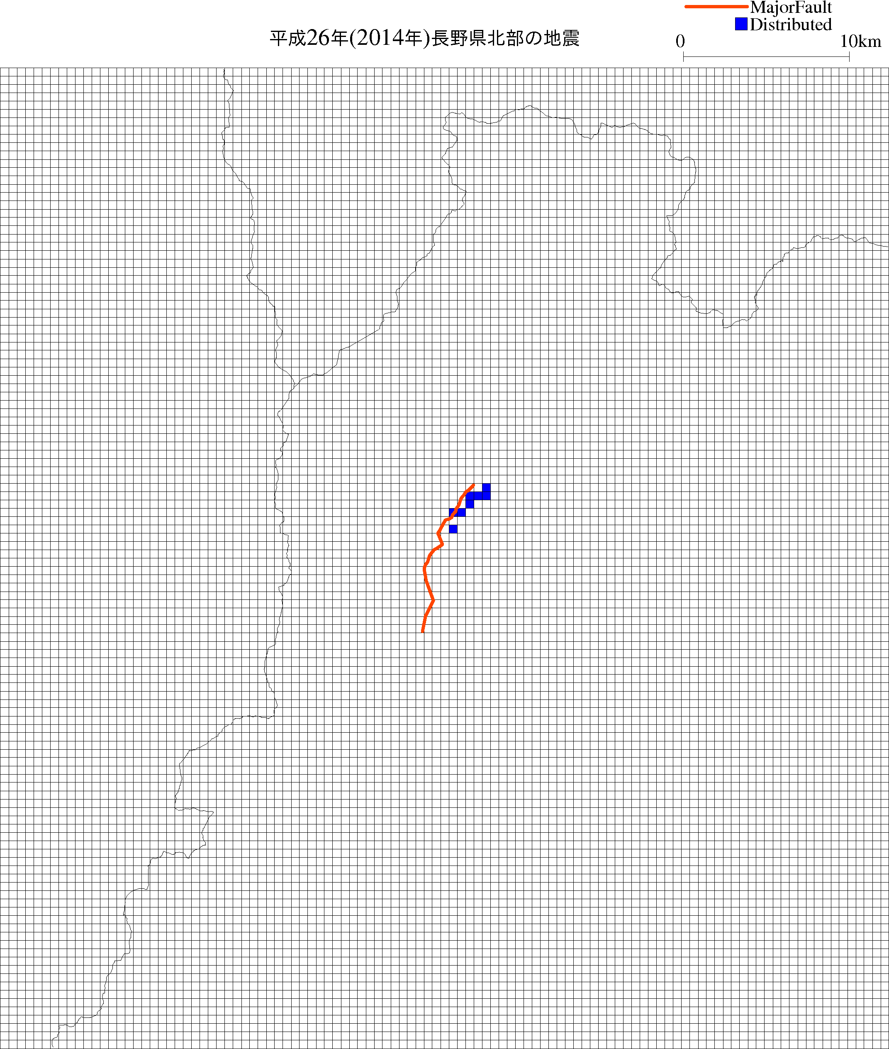 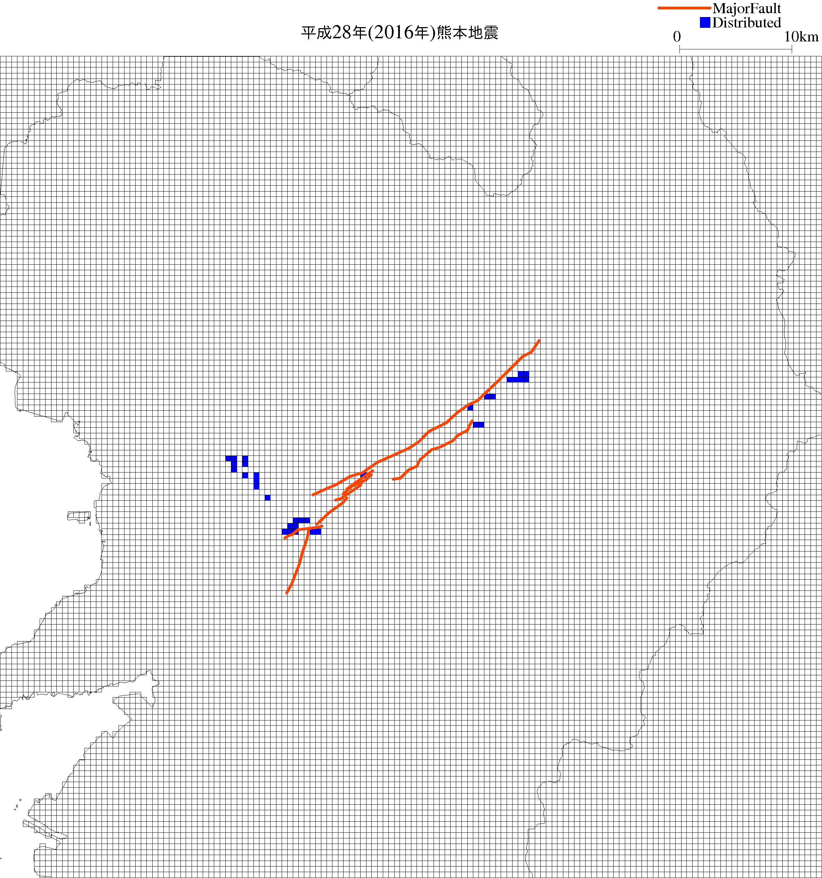

Principal

Principal

*(a) 2014 Nagano-ken Hokubu Eq. (b) 2016 Kumamoto Eq.*

*FIG. 2 Surface ruptures digitized by 500m cells*

*P*2*d* equations were evaluated in the same manner as described in section 3.2 (2) using *Eq. (11)* and the maximum likelihood method. *FIG. 3* shows the results of the logistic regression. *FIG. 3 (a)* demonstrates a comparison between the tentative evaluation and the previous evaluation and *FIG. 3 (b)* illustrates a comparison among fault types in terms of the tentatively determined equations. As understood from the figures, no significant difference was found in either *FIG. 3 (a)* or *FIG. 3 (b)*. According to the results of the tentative evaluation in terms of *P*1*p* and *P*2*d*, these equations will not significantly impact on the results of PFDHA.



*(a) Comparison between new and old*



*(b) Comparison among fault types*

*FIG. 3 Results of logistic regression in terms of P2d*

1. **Study on the range for analysis of distributed fault**

As for the occurrence probability of a distributed fault (*P*2*d*), the range (distance from the principal fault) to be considered when analyzing the occurrence probability of a distributed fault had previously not been studied at all. Therefore, we demonstrated parametric analyses which can clarify how the range, which is considered in the analysis of the occurrence probability of the distributed fault, impacts on the evaluation formulae.

1. **Analysis cases and conditions**

Before analyzing the *P*2*d*, the distributed fault data should be digitized by constructing a raster scan of each map using a certain cell size, e.g. 500m×500m, 250m×250m, 100m×100m, 50m×50m, as was done to derive the *P*2*d* equations written in the previous chapter. If there is/are a distributed fault/distributed faults in the cell, the flag of the cell is to be set to “1”. If there is no distributed fault in the cell, its flag is to be set to “0”.

In the next step, “1” and “0” are plotted in the distance-probability (1/0) space and then a logistic regression is performed by using *Eq. (11)* with the maximum likelihood method. *FIG. 4* indicates a schematic diagram explaining the procedure from digitizing the data to the logistic regression using the 1995 Hyogo-ken Nanbu earthquake case as an example.



**Principal**

*(a) Example of digitalization (b) Schematic diagram of logistic regression*

*FIG. 4 Procedure for logistic regression*

When conducting parametric studies, we considered the four cases shown in *TABLE 4* and *FIG. 5.* In Case 1, all of the “1” and “0” data within the range of the most distant “1” for each earthquake are used in the analysis. The location of the most distant “1”, which is the most distant distributed fault, depends on the earthquake. In other words, “0” information, which indicates non-appearance of a distributed fault in a remote area that is farther than the most distant “1”, is not considered in the analysis in Case 1.

In Case 2, all of the “1” and “0” data within 15 km for each earthquake are adopted in the analysis. In Case 2, “0” data farther than 15 km are not taken into consideration. For Case 3 and Case 4, data within 20 km and 25 km are taken into account respectively.

*TABLE 4: Analysis cases and conditions*

|  |  |  |
| --- | --- | --- |
|  | Data considered for the case | |
| Case 1 | “0” and “1” within the most distant “1” for each earthquake | (common condition)  data from 21 earthquakes that generated surface earthquake faults in Japan listed in *TABLE 2*, excluding the 2011 earthquake |
| Case 2 | “0” and “1” within 15 km |
| Case 3 | “0” and “1” within 20 km |
| Case 4 | “0” and “1” within 25 km |



*(a) Case 1*



*(b) Cases 2, 3 and 4*

*FIG. 5 Schematic diagrams of the cases*

1. **Analysis results**

*FIG. 6* is the result of the parametric study when employing the 500m×500m cell size. As shown in the figure, Case 1 is greatly different from the other cases. This result tells us that the assumption in Case 1 is not appropriate for *P*2*d* analysis. In other words, the information that there is no distributed fault in remote areas is rather important and this information should inevitably be considered for *P*2*d* analysis.

We also obtained another result - namely that there was no significant difference among Case 2, Case 3 and Case 4. This result indicates that the range to be considered in the *P*2*d* analysis is not particularly important as long as the information that there is no distributed fault in a remote area farther than the most distant distributed fault is taken into account. According to the results of this parametric study, it can be concluded that 15 km could be a rough indication to be considered as the range when analyzing the *P*2*d*.

Here, the following should be noted. If raw data were plotted, it would be impossible to understand goodness-of-fit because the raw data are “1” or “0” as mentioned earlier. Therefore, “Occurrence Ratio”, which is the ratio of the total number of “1”s to the total number of cells with respect to every 1 km, was plotted by red diamonds in *FIG. 6*.

The same conclusions mentioned above were derived when other cell sizes (namely 250m×250m, 100m×100m, and 50m×50m) were adopted, but we have omitted the illustrations of these other sizes due to lack of space in this paper.



*FIG. 6 Results of logistic regression*

1. **Concluding remarks**

In this paper, two kinds of recent study were described and the following conclusions could be obtained.

1. We attempted to reflect the recent earthquakes accompanied with surface ruptures in the PFDHA equations. As a result of the study, we found that there is no significant difference between the previously proposed formulae and the tentatively evaluated formulae reflecting the recent earthquakes.
2. We demonstrated parametric analyses which can clarify how the range, which is considered in the analysis of the occurrence probability of the distributed fault, impacts on the evaluation formulae. As a result of the study, we concluded that 15 km could be a rough indication to be considered as the range.

In recent years, remote sensing technology has been developed and a study on the applicability of the technology to the surface rupture issue has just begun. Aoyagi and Onuma (2017) attempted to detect surface ruptures accompanied with the 2016 Kumamoto earthquake using DInSAR, which is one of the remote sensing technologies, and evaluate the displacements of distributed faults. We understand that remote sensing technology could be a promising instrument for constructing a distance attenuation equation of distributed faults and we would like to address this problem as a challenging task.

**REFERENCES**

1. Youngs, R.R., et al. (2003), A methodology for probabilistic fault displacement hazard analysis (PFDHA), Earthquake Spectra, Vol. 19, No. 1, pp. 191-219.
2. Takao, M. et al. (2013), Application of Probabilistic Fault Displacement Hazard Analysis in Japan (in Japanese), *Journal of JAEE*, Vol. 13, No. 1, pp. 17-36
3. Takao, M. et al. (2014), Reliability Improvement of Probabilistic Fault Displacement Hazard Analysis (in Japanese), *Journal of JAEE*, Vol. 14, No. 2, pp. 16-36
4. Takao, M. et al. (2016), Maximum Likelihood Estimation of the Parameters regarding Displacement Evaluation of Distributed Fault in PFDHA (in Japanese), *Journal of JAEE*, Vol. 16, No. 2, pp. 96-101
5. INTERNATIONAL ATOMIC ENERGY AGENCY (2010), **Seismic Hazards in Site Evaluation for Nuclear Installations, Specific Safety Guide, *IAEA Safety Standards*, No.** SSG-9
6. Petersen, M.D., et al. (2011), Fault displacement hazard for strike-slip faults, Bull. Seismol. Soc. Am. 101, pp. 805-8257
7. Wells and Coppersmith (1994), New empirical relationships among magnitude, rupture length, rupture width, rupture area, and surface displacement, BSSA, 84, pp. 974-1002.
8. Okada et al. (2015), The First Surface-Rupturing Earthquake in 20 Years on a HERP Active Fault is Not Characteristic: The 2014 Mw6.2 Nagano Event along the Northern Itoigawa–Shizuoka Tectonic Line, Seismological Research Letters Vol. 86, No. 5, pp. 1287-1300
9. Hikima et al. (2015), Source process of the 2014 Nagano-ken Hokubu Earthquake (Mj6.7) - Analysis using the near-field Broadband Waveforms in the source region -, Seismological Society of Japan (SSJ), Fall Meeting, S15-14, p. 87
10. Shirahama et al. (2016), Characteristics of the surface ruptures associated with the 2016 Kumamoto earthquake sequence, central Kyushu, Japan, Earth, Planets and Space, 68:191, DOI 10.1186/s40623-016-0559-1
11. Toda et al. (2016), Slip-partitioned surface ruptures for the Mw 7.0 16 April 2016 Kumamoto, Japan, earthquake, Earth, Planets and Space, 68:188 , DOI 10.1186/s40623-016-0560-8
12. Geospatial Information Authority of Japan (2016), Earthquake source fault model of the 2016 Kumamoto earthquake (preliminary version), http://www.gsi.go.jp/common/000140781.pdf
13. Asano and Iwata (2016), Source rupture processes of the foreshock and mainshock in the 2016 Kumamoto earthquake sequence estimated from the kinematic waveform inversion of strong motion, Earth, Planets and Space, 68:147, DOI 10.1186/s40623-016-0519-9
14. Kubo et al. (2016), Source rupture processes of the 2016 Kumamoto, Japan, earthquakes estimated from strong‑motion waveforms, Earth, Planets and Space, 68:161, DOI 10.1186/s40623-016-0536-8
15. Ozawa et al. (2016), Crustal deformation associated with the 2016 Kumamoto Earthquake and its effect on the magma system of Aso volcano, Earth, Planets and Space, 68:186, DOI 10.1186/s40623-016-0563-5
16. Kawamoto et al. (2016), First result from the GEONET real‑time analysis system (REGARD): the case of the 2016 Kumamoto earthquakes, Earth, Planets and Space, 68:190, DOI 10.1186/s40623-016-0564-4
17. Aoyagi and Onuma (2017), Fault displacement of the 2016 Kumamoto earthquake deduced by DInSAR analysis, the annual meeting of Japanese Society for Active Fault Studies (JSAF), P-1, pp. 1-2