A PRELIMINARY STUDY TO INVESTIGATE THE REGIONAL EFFECTS ON GROUND MOTION PREDICTIVE MODELS FOR TURKEY

S. AKKAR¹, G. TANIRCAN¹, A. PINAR¹, E. YENIER² , Ö. KALE⁴

¹ Department of Earthquake Engineering, Boğazici University-Kandilli Observatory and Earthquake Research Institute, 34684 Istanbul, Turkey
² Nanometrics Inc. Ottawa, Canada
⁴ Department of Civil Engineering, TED University 06420 Ankara, Turkey

E-mail contact of main author: birgore@boun.edu.tr

Abstract. We investigated the regional effects by using the conventional residual analyses of strong-motion data compiled from the Marmara and Aegean regions in Turkey. The selected regions feature different seismo-tectonic regimes; Marmara region, being predominantly under transform tectonic movement, is dominated by strike-slip faults whereas the Aegean inland, being under extensional tectonic movement, is dominated by normal faults. The observed data were processed and were used together with the most recent local ground-motion predictive model by Kale et al. (2015) that is exclusively developed from the strong-motion accelerograms collected from entire Turkey. The between- and within-event residuals were computed separately for the above two regions and they suggest biased ground-motion estimates in terms of source and path. The biased ground-motion estimates at different oscillator frequencies change trends within different magnitude and distance intervals emphasizing the footprints of regional effects. Although the Kale et al. predictive model is specifically developed for Turkey, the biased trends in the residuals advocate a need to reassess the region-dependent source, anelastic attenuation and geometric spreading characteristics within the country. Essentially, further evaluation of these observations and more detailed studies in the next steps of this study will serve us to develop a region-dependent ground-motion predictive model for Turkey that will be a product of the “Updating and Extending the European Seismic Hazard Model” task in SERA project (Horizon 2020 - Seismology and Earthquake Engineering Research Infrastructure Alliance for Europe).
Key Words: Ground Motion Prediction Equation, Regional Effect, Turkey.

Introduction

The regional difference in earthquake ground motion amplitudes has been the subject of ground motion prediction related studies for more than a decade. Various studies showed the influence of region specific parameters such as focal depth, stress drop, high frequency attenuation characteristics, and shallow soil properties on ground motion amplitudes ([1] -[5]).
In their ground motion prediction equation (GMPE) study, Akkar and Çağnan (2010) [6] emphasized the significance of focal-depth on ground motion amplitude estimations, which might be attributed to the differences between the Turkish and Next Generation Attenuation (NGA) models. Atkinson and Morrison (2008) [7] and Mahani and Atkinson (2013) [8] showed that the regional amplitude differences across North America may stem from difference in frequency dependent attenuation characteristics. Oth et al (2017) [9] found a clear correlation between between-event residuals and stress drop.
In the light of previous studies on the regional variation of ground motion, Yenier and Atkinson, (2015) [10] developed a regionally adjustable generic GMPE based on equivalent point source simulation. The GMPE is applicable to different regions by modifying a few modeling parameters such as geometrical spreading and stress parameter. A more recent study by Hassani and Atkinson (2018) [11] improved the GMPE by Yenier and Atkinson model [10] by adding the effect of near surface attenuation factor.
In this research strong motion database of the Western Turkey is collected and major ground motion intensity measures (GMIMs) of the database are compared with the most recent GMPE model for Turkey developed by Kale et al (2015) (KAAH2015) [12] to see whether regional differences in ground motion exist. This is the first step toward generation of region specific ground motion characteristics of Turkey so as to be utilized with GMPE model of Yenier and Atkinson [10].

Study Area and Earthquake Database

In this study the strong ground-motion (SM) dataset is compiled from the earthquakes occurred between 1976 and 2017 in the Western Turkey. Two different sources are used in the compilation: data until 2009 is obtained from a project-specific dataset ([13]) whereas data from 2009-2017 are obtained from national ground-motion database (TR-NSMD), which is maintained and operated by Disaster and Emergency Management Authority (AFAD).

The lower magnitude limit of SM dataset is M_{L} 3.5 whereas epicentral distances of the recordings are within 300 km. The events are shallow crustal having hypocentral depths less than 30 km. Earthquakes with at least 5 recordings are included in the analysis.

A total of 5259 SM recordings from 255 earthquakes with complete Vs30 and style of faulting information (strike slip, normal or thrust) is considered in the analysis. Epicentral distance distribution of earthquakes, location of SM recording stations and active fault map of the area [14] are shown in FIG 1. (left panel). The right panel in this figure portrays the regional coverage of the surface projection of ray paths. 54% of the recordings have Vs30 values ranging between 180 m/s ≤ Vs30 < 360 m/s (classified as NEHRP D site class; FIG. 2) whereas Vs30 values range between 360 m/s ≤ Vs30 < 760 m/s (classified as NEHRP C site class; FIG 2) for about 37% of the dataset. Only 8% of the data has Vs30 > 760 m/s (NEHRP B or A site classes). Recordings from normal faulting (NF) earthquakes dominate the database.

As indicated previously, the area of interest is divided into two main regions based on their seismo-tectonics settings: the Marmara and Aegean region delineated by the black solid line in the left panel of FIG. 1. Active tectonic setting of the Marmara Region is characterized by strike-slip motions of western branches of the North Anatolian Fault Zone whereas the tectonic setting in the Aegean Region is dominated by extensional motions along Graben systems. The magnitude (Mw) vs Rjb distributions of these regions are given in FIG. 3. The earthquake recordings after 2009 particularly complement the SM database for both regions in small magnitudes ranging between 3.5 < Mw < 4.2. The 2017 M6+ earthquakes in the Aegean Region (Izmir earthquake, Mw6.4 and Bodrum-Kos earthquake, Mw6.6) significantly improve the pertaining data distribution in terms of magnitude and source-to-site distance. Indeed, the Bodrum-Kos Earthquake draws the upper bound magnitude for the Aegean SM database. The only distinguishable recent large-magnitude event in the Marmara region is the 2004 Gökçeada earthquake (Mw6.9).

FIG 1 (left) Distribution of SM stations and earthquakes together with active fault map [14]. (right) Ray coverage in the study area.

FIG 2 Mw, Vs30 and Repi histograms of the SM database

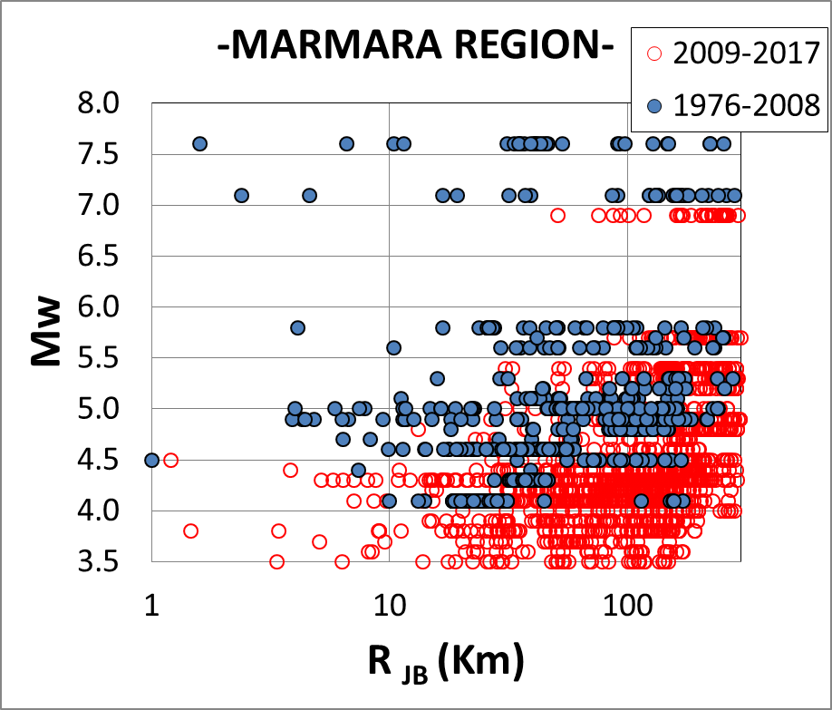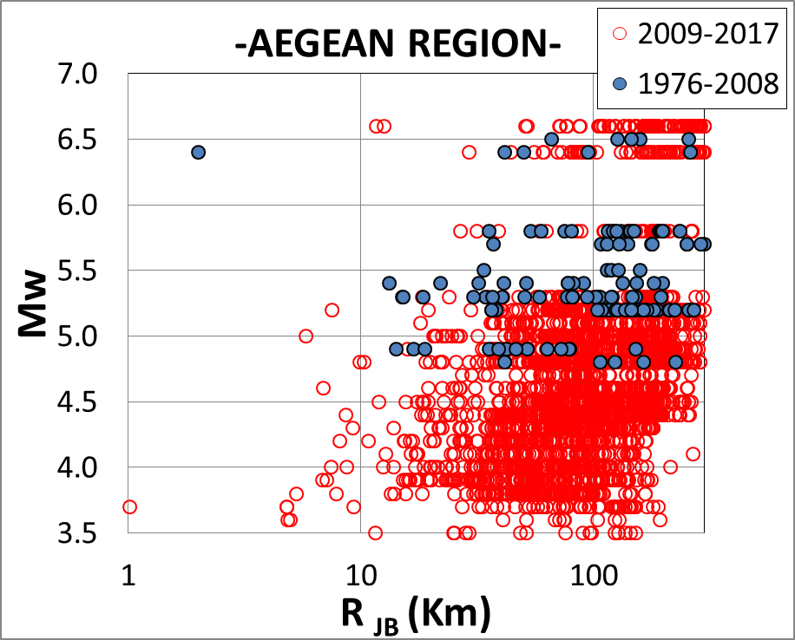
FIG3. Mw-Rjb distributions of Marmara and Aegean SM database

Data Analysis

Regarding SM data, the three component waveforms are baseline corrected which followed the visual selection of P-wave onsets. Arrival time between P and S waves for each recording is calculated by assuming Vp and Vs equal to 5.8 km/s and 3.4 km/s, respectively. Ground motion window is selected from the P-wave onset until three folds of the arrival time. 1 second-long buffer is added to beginning and end of the data. The selected portions of the waveforms are 10% cosine tapered and a 4th order phaseless band-pass filtering between 0.4- 40 Hz. is applied. The computed spectral accelerations and PGA values for regional residual analyses are not affected from the constant filter cut-offs (see discussions in the next paragraph). The Fourier amplitude spectra of raw and processed data are calculated for quality control of the processed data in frequency domain. The Nyquist frequencies of the SM dataset are either 50 Hz or 100 Hz. Signal-to-noise ratios (SNR) of SM data are not calculated due to insufficient pre-vent and/or post-event buffer at the majority of the dataset. Instead, a visual inspection of SM waveforms as well as variations in FAS are performed in order to exclude recordings containing high levels of noise.

The SM data processing results in a total of 2969 three-component records in the Aegean region. This number is 2290 for Marmara. Due to constant filter-cut off band-pass filtering, we only computed PGA, and T = 0.2s and T = 1.0s spectral accelerations from the compiled dataset. The geometric means of the horizontal components are computed for the above GMIMs because residual analyses are done by considering the ground-motion predictions of the KAAH2015model that is, to the best of authors’ knowledge, the most recent local model for Turkey. KAAH2015 is developed for estimating spectral ordinates for Rjb distances up to 200 km. The functional form of the model accounts for anelastic attenuation, magnitude dependent geometric spreading, a second-order polynomial magnitude scaling, style-of-faulting as well as Vs30-dependent linear/nonlinear soil behaviour for site amplification.

The between-event and within-event regional residuals are computed using KAAH2015 and the results are discussed in the following section. Since KAAH2015 predicts GMIMs for Rjb ≤ 200 km, residuals computed for larger distances represent model extrapolation.

Results and Discussions

FIG 4 shows the magnitude- and distance-dependent variations of PGA and spectral acceleration (SA) values at 0.2s and 1s periods. The first two columns in FIG 4 displays the PGA (first row), SA at T = 0.2s (middle row) and SA at T = 1.0s (bottom row) variations in terms of magnitude (first column) and source-to-site distance (second column). The last two columns present similar information for the Aegean region. The magnitude-dependent variations show different trends between Marmara and Aegean regions. The magnitude-dependent decay seems to be more gradual for ground motions recorded in the Aegean region. Similar differences also show themselves in distance-dependent variation. The gradients of distance dependent decay between Marmara and Aegean regions are different although some of the presented scatter diagrams show significant dispersion masking a clear understanding about distance dependent variation of the data (e.g., Marmara region, T = 0.2s and Aegean region T = 1.0s). The presented data variations for magnitude and distance should be considered as preliminary observations since we did not isolate the source and path effects in the data. The dispersive data behaviour stated above might be the consequential artefacts of the lack of path and source isolation.

FIG 4 PGA, Sa (T=0.2s) and Sa (T=1s) distributions with respect to Mw and Rjb for Marmara and Aegean database

FIG. 5- 7 show between-event and within-event residuals for PGA and SA at T = 0.2 s and T = 1.0 s as a function of distance and magnitude. Red open circles in the figures represent the average of evenly spaced magnitude and distance bins and the error bars represent the standard error about the average.

Different behaviour of between-event and within-event trends apparently advocates a regional variation. The between-event residuals of the Aegean region indicate that KAAH2015 tends to overestimate the subject GMIMs. As expected, the overestimations are more pronounced towards smaller magnitudes. The between-event residuals for Marmara indicate overestimation for small magnitudes but this tendency reverses and KAAH2015 predictions underestimate the ground-motion amplitudes towards larger magnitudes. The underesitmations are more notable for SA at T = 0.2s and T = 1.0s. The regional differences in stress drop that is disregarded in the KAAH2015 model can be one possible explanation to the observed differences between the two regions. Since the lower magnitude limit of KAAH2015 is Mw 4, between-event residuals below Mw 4 are computed by extrapolating the GMPE. Hence, observations on small-magnitude events should be evaluated with some reservation. Nevertheless, we believe that the major points addressed above do not change regardless of this limitation.

The within-event residual scatters of the Marmara and Aegean regions seems to draw more similar patterns although KAAH2015 estimations seem to display a more biased behaviour at long distances for the Aegean recordings. Once again, the distance limitation of KAAH2015 (Rjb ≤ 200 km) suggests some caution on these observations. Nevertheless, the model performance tends overestimation towards larger distances. KAAH2015 do not isolate path and source effects in their dataset used for developing the model, which may mask some of the crustal features between the regions (e.g., Moho boundary) and this can be reflected on to model estimations as discussed above.

In this preliminary analysis the source mechanism/geometry of earthquakes with M6+ occurred after 2009 are not taken into account, hence Repi is assumed to be equal to Rjb. This fact may lead to errors in the estimations in the near field recordings. In the further analysis, realistic Rjb values will be included into calculation.
FIG 5, Between-event and within-event residuals of PGA with respect to magnitude (Mw) and distance (Rjb). Residual calculation is performed utilizing KAAH201 [12] GMPE Upper and lower panels shows the residuals belong to Marmara and Aegean Regions, respectively. Red open circles represent the average values of selected Mw and Rjb bins. Error bars indicate the standard errors on the estimates of the mean residuals.
FIG 6, Between-event and within-event residuals of SA at 0.2 s structural period with respect to magnitude (Mw) and distance (Rjb). Residual calculation is performed utilizing KAAH201 [12] GMPE Upper and lower panels shows the residuals belong to Marmara and Aegean Regions, respectively. Red open circles represent the average values of selected Mw and Rjb bins. Error bars indicate the standard errors on the estimates of the mean residuals.
FIG 7 Between-event and within-event residuals of SA at 1.0 s structural period with respect to magnitude (Mw) and distance (Rjb). Residual calculation is performed utilizing KAAH201 [12] GMPE Upper and lower panels shows the residuals belong to Marmara and Aegean Regions, respectively. Red open circles represent the average values of selected Mw and Rjb bins. Error bars indicate the standard errors on the estimates of the mean residuals.

Conclusion

An updated SM data base is prepared for the Western Turkey. The database is compiled using high quality strong motion recordings as well as updated metadata information such as style of faulting and site characterization. GMIMs of the database are calculated and compared with those of estimated by the KAAH2015 [12] through conventional residual analyses. Results portrayed the apparent variations in Marmara and Aegean Regions.

In the further analysis a vast data base including strong motion and broadband data will be used and same analyses will be repeated to find the hints of possible regional differences between Marmara and Aegean Regions. The new database will form the basis for derivation of a GMPE compatible to Yenier and Atkinson [10] model.

REFERENCES
[1] WANG, G.-Q., et al., “Comparisons of ground motions from five aftershocks of the 1999 Chi Chi, Taiwan, earthquake with empirical predictions largely based on data from California”,Bull. Seismol. Soc. Am. 94, (2004),2198–2212.
[2] DOUGLAS, J., “An investigation of analysis of variance as a tool for exploring regional variability of ground motions”, J. Seism. 8, (2004),485 –496.
[3] DOUGLAS J.,”On the regional dependence of earthquake response spectra”. ISET J Earthq Technol 44(1): (2007), 71–99.
[4] STAFFORD, P., et al. “An evaluation of the applicability of the NGA models to ground-motion prediction in the Euro – Mediterranean region”, Bull. Earthq. Eng. 6, (2008), 149 –177.
[5] SCASSERA, G. et al.,” A Comparison of NGA Ground-Motion Prediction Equations to Italian Data ” Bulletin of the Seismological Society of America, Vol. 99, No. 5, (2009), pp. 2961–2978.
[6] AKKAR, S., ÇAĞNAN Z., “A Local GMPE for Turkey and Its Comparison with Other Local and Global GMPEs”. Bulletin of Seismological Society of America, Vol.100, Issue.6, (2010). pp.29782995.
[7] ATKINSON, G., MORRISON, M. “Observations on regional variability in ground-motion amplitudes for small-to-moderate earthquakes in North America”, Bull. Seismol. Soc. Am. 99, (2009). 2393 –2409.
[8] MAHANI A.B, ATKINSON G. “Regional differences in ground‐motion amplitudes of small‐to‐moderate earthquakes across North America” Bulletin of the Seismological Society of America 103 (5),(2013) 2604-2620
[9] OTH, A., et al, “On the relation of earthquake stress drop and ground motion variability” Journal of Geophysical Research, 122-7 (2017)pp 5474-5492.
[10] YENIER, E., ATKINSON, G. “Regionally Adjustable Generic Ground-Motion Prediction Equation Based on Equivalent Point-Source Simulations: Application to Central and Eastern North America”, Bulletin of the Seismological Society of America, 105(4) (2015) pp:1989.
[11] HASSANI, B., ATKINSON, G. “Adjustable Generic Ground-Motion Prediction Equation Based on Equaivalent Point-Source Simulations:Accounting for Kappa Effects”, Bulletin of the Seismological Society of America, 108(2) (2018) pp:913
[12] KALE, Ö. et al., “A Ground-Motion Predictive Model for Iran and Turkey for Horizontal PGA, PGV, and 5% Damped Response Spectrum: Investigation of Possible Regional Effects”, Bulletin of the Seismological Society of America, Vol. 105, No. 2A,(2015) pp. 963–980.
[13] AKKAR et al., “Updated Probabilistic Seismic Hazard Maps for Turkey” PSHA Workshop
At: Lenzburg Switzerland 2017
[14] EMRE Ö., et al., “Active fault database of Turkey”. Bull Earthq Eng. (2016):1–47.

