Evaluation of off-fault displacements during 2016 Kumamoto earthquake

N. INOUE¹, N. KITADA¹, N. SHIBUYA² , M. OMATA², M. TONAGI³, T. TAKAHAMA³ and K. IRIKURA⁴
¹Geo-research Institute (GRI), Osaka, Japan
²Pasco Corporation, Tokyo, Japan
³KOZO KEIKAKU ENGINEERING Inc., Tokyo, Japan
⁴Aichi Institute of Technology, Toyota, Japan

E-mail contact of main author: naoto@geor.or.jp

Abstract. Most of fault displacements of the 2016 Kumamoto earthquake were distributed within several hundred meters from the Futagawa and Hinagu active faults. Several ruptures were distributed away from main active faults. The off-fault displacement hazards are critical because the avoidance of construction is usually supposed as the first priority in the proximity to active faults. We updated the fault displacement data set by the 2016 Kumamoto earthquake and investigated the attenuation relation of the distributed fault displacement. The excavation surveys were performed at two sites (Fukuhara and Tsuchibayashi), where the off-fault displacement due to the 2016 earthquake was confirmed with the advanced InSAR technique and our field surveys. The fault displacements of these sites were not reported previously. The excavation survey at Fukuhara showed the evidence for the 2016 event and several prior paleoearthquakes. We performed a probabilistic fault hazard analysis (PFDHA) of excavation sites with the global strike-slip model and Japanese model. The annual rates of exceedence by the global strike-slip model at centimetres-order displacements are larger than that of the Japanese model. The annual rates of exceedence by the global strike-slip model rapidly decrease toward larger displacement compared to the Japanese model.
Key Words: the 2016 Kumamoto earthquake, distributed fault displacement, PFDHA.

INTRODUCTION
The Headquarters for Earthquake Research Promotion (HERP) have evaluated seismic hazard models of the Futagawa fault [1], which is one of the source faults in the 2016 Kumamoto earthquake. Immediately after the earthquake, various organizations and many researchers surveyed the distribution of the surface ruptures and fault displacements with the aid of results provided by geodetic observations (e.g., [2]). [3] published the compiled fault displacement data as shown in FIG. 1. Most of ruptures are distributed within several hundred meters from the main active faults: Futagawa and Hinagu faults. Several ruptures, which are denoted as secondary fault in FIG. 1, are distributed away from main active faults. The 2016 Kumamoto earthquake indicates the variability and complexity of distribution of fault displacements in detail.
The fault displacement hazards of off-fault displacement are critical, because the avoidance of construction is usually supposed as the first priority in the proximity to active faults. We have developed the procedure with the purpose evaluating fault displacements base on the both deterministic and probabilistic approaches [4, 5]. The deterministic approach consists of two processes: extraction of the displacement distribution from source fault model and the representation of fault displacements on the surface. With respect to the probabilistic approach, we have developed the fault displacement data and model based on the published Probabilistic Fault Displacement Hazard Analysis (PFDHA) works [6-9]. PFDHA evaluates the off-fault displacement as “distributed fault displacement”.
In this paper, we updated the fault displacement data set by the 2016 Kumamoto earthquake and investigated the developed PFDHA models for the distributed fault displacement. We also applied the advanced InSAR technique [10] to detect distributed fault displacement [11], and carried out the excavation survey in order to evaluate the distributed fault displacement. We performed the PFDHA of our excavation sites.

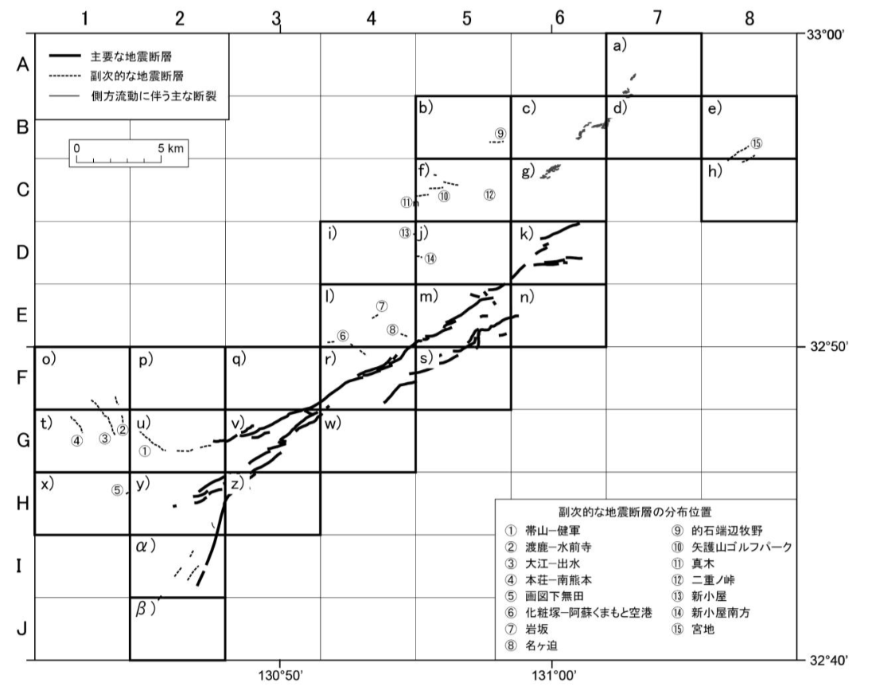
FIG. 1. Summary of the distribution of the surface ruptures of the 2016 Kumamoto earthquake [3]. Thick solid, dashed and solid lines in the figures denote main ruptures, secondary ruptures and fissures due to ground lateral flow, respectively.

Method and Result

PFDHA framework for distributed fault displacement
In a PFDHA (e.g.: [12]), the annual rates of exceedence of distributed fault displacement is calculated by:
$υ\left(d≥d_{0}\right)=αP\left(sr≠0 | m\right)\int_{r}{P(d≥d_{0}}\left|r,m,d≠0\right)f_{R}\left(r\right)dr$ (1)
where, $α$ is the annual rate of $m$, moment magnitude, $f_{R}(r)$ is fault location uncertainty, $P (sr≠0|m)$ is the probability of surface rupture given that a moment magnitude, $m$, earthquake occurs on the fault, $P (d≠0)$ is the probability of off fault surface rupture, $P (d≥ d_{0} |r, m, d≠0)$ is the conditional probability for non-zero displacement $d$ greater than or equal to a given value $d_{0}$, and is obtained by combining the attenuation relation of the distributed fault displacements with the lognormal distribution for AD or MD.
In this study, PFDHA calculations are based on models developed by [7], [9] and our attenuation relation. [7] and [9] are developed based on the global strike-slip data and Japanese data, respectively.

1. Probability of surface rupture
The probability of surface rupture is given by:
$P\left(sr≠0 | m\right)=\frac{e^{(a+bm)}}{1+e^{(a+bm)}}$ (2)
where $m$ is moment magnitude, $a$ and $b$ are $-12.51$ and $2.053$ for the global strike-slip model [7]. For Japanese model [9], $a$ and $b$ are $-32.03$ and $4.90$.

2. Conditional probability of off-fault surface rupture
In the global strike-slip model [7], the conditional probability of distributed fault is calculated by:
$\ln\left(P\left(d≠0 | r\right)\right)=-1.1538\ln\left(r\right)+4.2342$ (3)
where $r$ is the distance from the principal fault in meters. In the Japanese model [9], the probability is:
$P\left(d≠0 | m,r\right)=\frac{e^{z}}{1+e^{z}}$ (4)
where $z = -3.839 + (-3.866 + 0.350m) ln (r + 0.200)$. $r$ is the distance from the principal fault in kilometers.

3. Attenuation relation of distributed fault displacement
The distributed fault displacements normalized by the average displacement of the principal fault for the global strike-slip model [7] are modeled as:
$ln(d/AD) = -0.1826ln(r) - 1.5471$ (5)
where $AD$ is the average displacement of the principal fault, and $r$ is the distance from the principal fault in meters. Eq. 5 was derived from the regression analyses. $AD$ is calculated from [13]:
$AD = -6.32 + 0.90m$ (6)
The displacement normalized by the maximum displacement of the principal fault for Japanese model [9] is:
$d/MD = 0.55exp(-0.17r)$ (7)
where $MD$ is the maximum displacement of the principal fault, and $r$ is the distance from the principal fault in kilometers. Eq. 7 represents a 90th-percentile of the Japanese data set compiled by [9]. $MD$ is calculated from [9]:
$MD = -5.16 + 0.82m$ (8)
We have developed attenuation relations of distributed fault displacement of strike-slip and reverse slip in order to perform PFDHA of the Japanese earthquakes [6]. Eq. 9 is the attenuation relation of the strike-slip distributed fault displacement derived from the Japanese strike-slip data set compiled by [14]:
$d/MD = 0.55exp(-0.42r)$ (9)
where $r$ is distance from the principal fault in kilometers. Similar to Eq. 7, Eq. 9 is a 90th-percentile of data set compiled by [14], as shown in FIG.2. We digitized the displacement data of the 2016 Kumamoto earthquake reported by [3] and classified into principal and distributed faults as shown in FIG. 3. No significant difference was estimated in the attenuation relation based on data set updated by the 2016 Kumamoto earthquake (solid black circles in FIG. 2). We used the attenuation relations represented by Eqs. 5, 7 and 9 for PFDHA calculations.

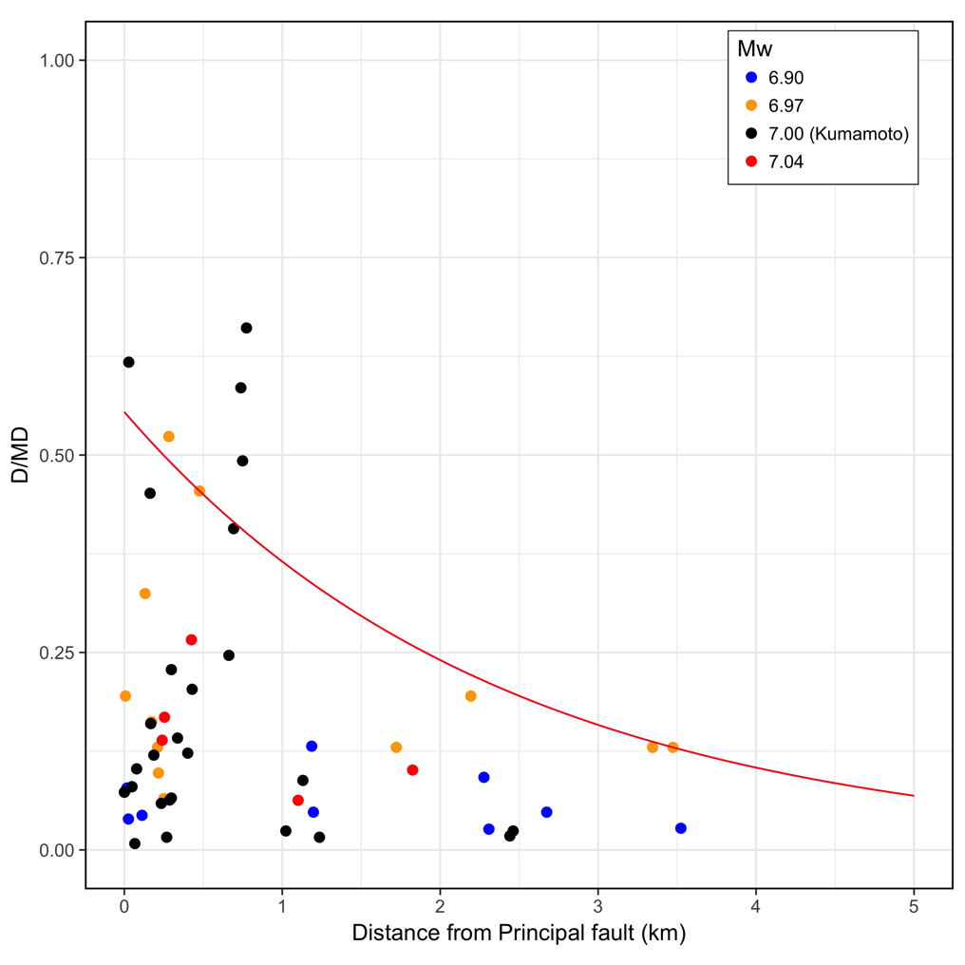
FIG. 2. Attenuation relation of distributed fault displacement. The displacement is normalized by the maximum displacement of the principal fault. Red curve in the figure corresponds to Eq. 9, which represents a 90th-percentile of the Japanese strike-slip data compiled by [14] and the 2016 Kumamoto earthquake data (solid black circles) shown in FIG. 3.

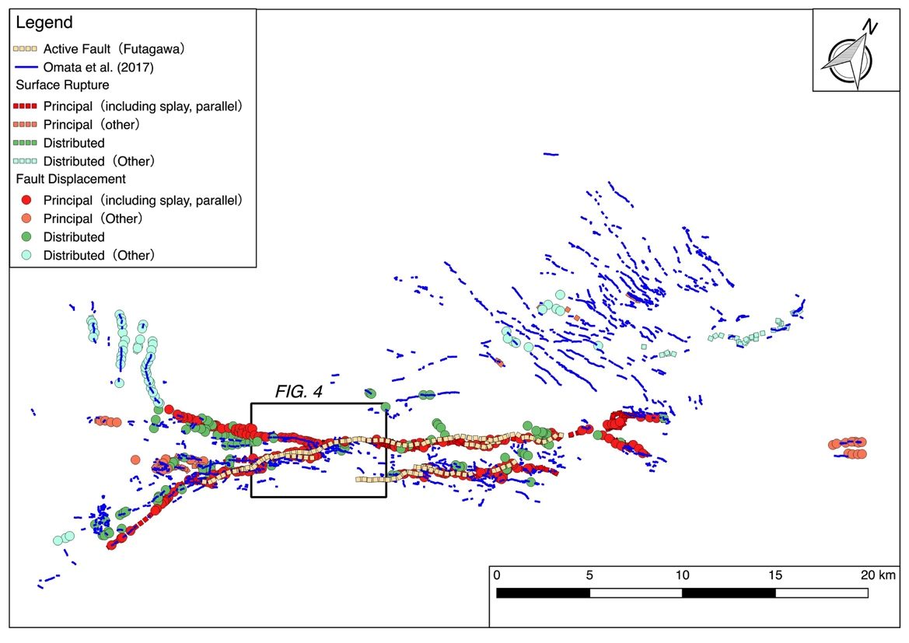
FIG. 3. Surface ruptures and fault displacement of the 2016 Kumamoto earthquake. The displacement data by [3] were classified into principal and distributed faults. Blue lines in the figure indicate the narrow low coherence zones of the InSAR interferogram [11]. The distributed fault displacements are shown in FIG. 2.

$P (d ≥ d_{0} |r, m, sr≠ 0)$ is calculated by Eq. 5, assuming lognormal distribution. The gamma distribution is applied to Eq. 7 and Eq. 9, which are 90th-percentile curve of distributed fault displacement data. Following [3] and [9], $a$ is 2.5, and $b$ is calculated from Eq. 7 or Eq. 9 divided by $4.617$, respectively.

Excavation survey of distributed fault
[10] has developed to detect small surface ruptures based on low coherence zones of the InSAR interferogram. In general, low coherence of the interferogram occurs when scatter of the InSAR image pixels moves randomly (pixel spacing is several meters or more). Narrow belts of low coherency are found along the linear surface ruptures for two reasons. One is the phase discontinuity of the interferogram, and the other is steep deformation along the linear surface rupture [15]. Blue lines in FIG. 3 are the extracted narrow low coherence zones of the 2016 Kumamoto earthquake by [11]. Excavation survey sites were selected as shown in FIG. 4, based on field investigations, which confirmed the several actual fault displacements induced by the earthquake. The fault displacements of these sites were not reported previously. The low coherence zones (blue solid lines in FIG. 4) around the Fukuhara are widely distributed and indicate complex form. The Fukuhara site was excavated on the small surface rupture, and indicated several events. On the contrary, the fault structure was not confirmed in the Tsuchibayashi site. This site indicated a flexure structure. Tsuchibayashi site was located on the end of the rupture. We did not excavate below the rupture due to the limitation of survey sites.

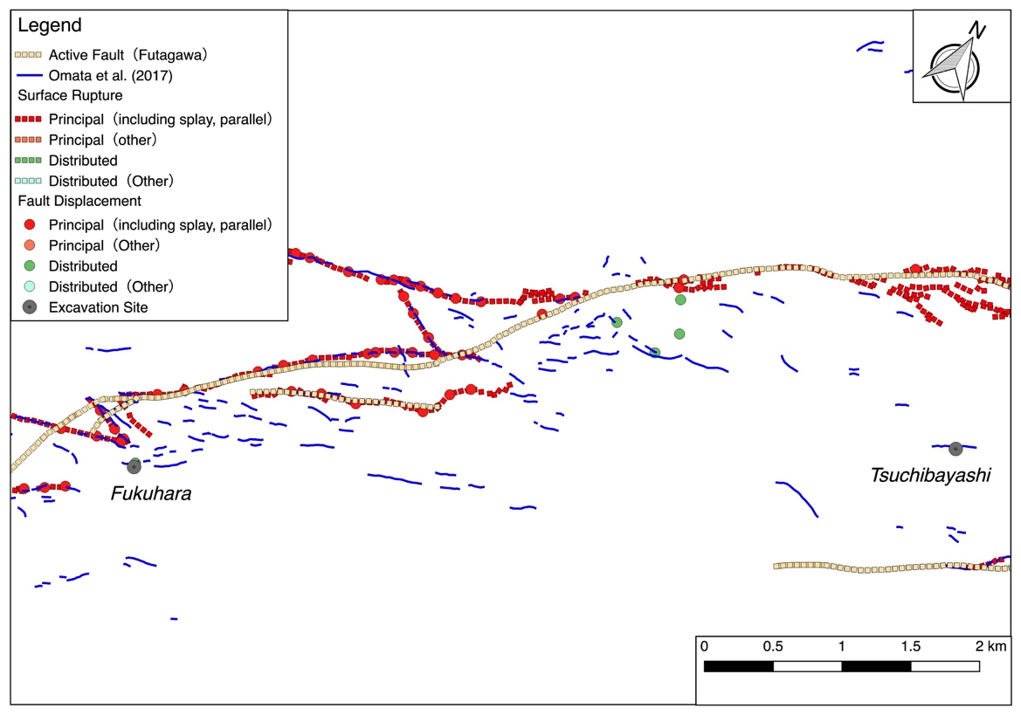
FIG. 4. Locations of surface ruptures and excavation survey locations (Fukuhara and Tsuchibayashi). Blue lines in the figure indicate the narrow low coherence zones of the InSAR interferogram [11].

Attenuation relation of distributed fault displacement around excavation sites
We show the attenuation relation described above at the two excavation sites based on the information before the 2016 Kumamoto earthquake. The moment magnitude m=6.5 was used from the J-SHIS 2014 model (http://www.j-shis.bosai.go.jp) and r was the distance from the active faults. FIG. 5 shows the 50th-percentile of the each attenuation relations (Eqs. 5, 7 and 9). MD of Eqs. 7 and 9 were calculated by Eq. 8. Eq. 5, red solid line in FIG. 5, shows rapid decreasing as far from the principal fault.
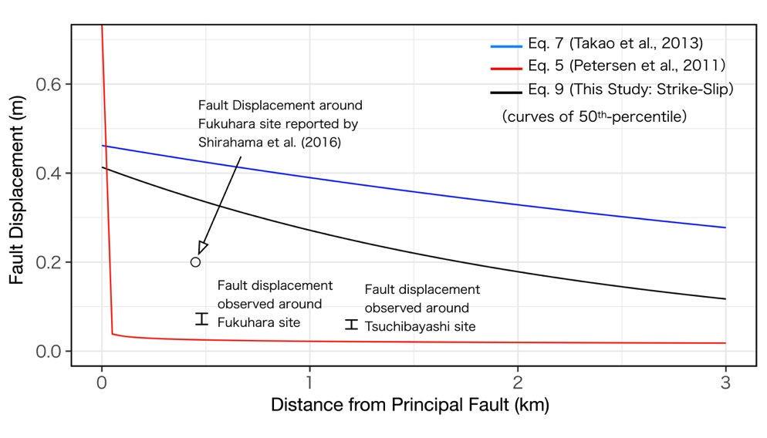
FIG. 5. 50th-percentile of each attenuation relation. Red, blue and black solid lines in the figure indicate the 50th-percentile of Eqs. 5, 7 and 9, respectively. Bars in the figure denote the displacement around the Fukuhara and Tsuchibayashi sites. Open circle denotes the displacement near the Fukuhara site observed by [16].

PFDHA of excavation sites
We performed PFDHA of two active fault survey sites. $α$ of Eq. 1 was used 1/8100 based on J-SHIS 2014 model (http://www.j-shis.bosai.go.jp), which have been evaluated by the HERP long-term active fault evaluation [1].
First, we show the annual rates of exceedence at the two excavation sites, based on the information before the 2016 Kumamoto earthquake. The moment magnitude m=6.5 was used from the J-SHIS 2014 model and r was the distance from the active faults. The annual rates of exceedence by global strike-slip model [7] (red lines in FIG. 6) rapidly decrease, compared to the Japanese models by [5, 9] (black and blue solid lines in FIG. 6). The annual rates of exceedence by the global strike-slip model at centimeters-order displacements are larger than that of the Japanese model. The annual rates of exceedence around the fault displacement around the excavation sites by the global strike-slip model are lower than the rates by Japanese models. The annual rates of exceednece at the Tsuchibayashi site show similar trend.
Next, we calculated the annual rates of exceednece based on the information after the earthquake in FIG. 7. The moment magnitude m=7.0 and distance from the surface ruptures were applied. The annual rates of exceedence are larger than rates (in FIG. 6) due to larger magnitude and shorter distance. The each hazard curve indicates similar trend as shown in FIG. 6. The annual rates of exceedence around the fault displacement around the excavation sites by the global strike-slip model are larger than the rates by Japanese models.
We calculated the several hazard curves at our excavation sites. The estimated hazard curves are affected by each component of PFDHA. [7] also evaluates the distance between active faults and surface ruptures as uncertainties of fault locations and complexity of fault distributions. These factors have a significant influence to evaluation near principal fault. The selection of the individual components within PFDHA should be carefully concerned in consideration of the individual effects as suggested by [17].
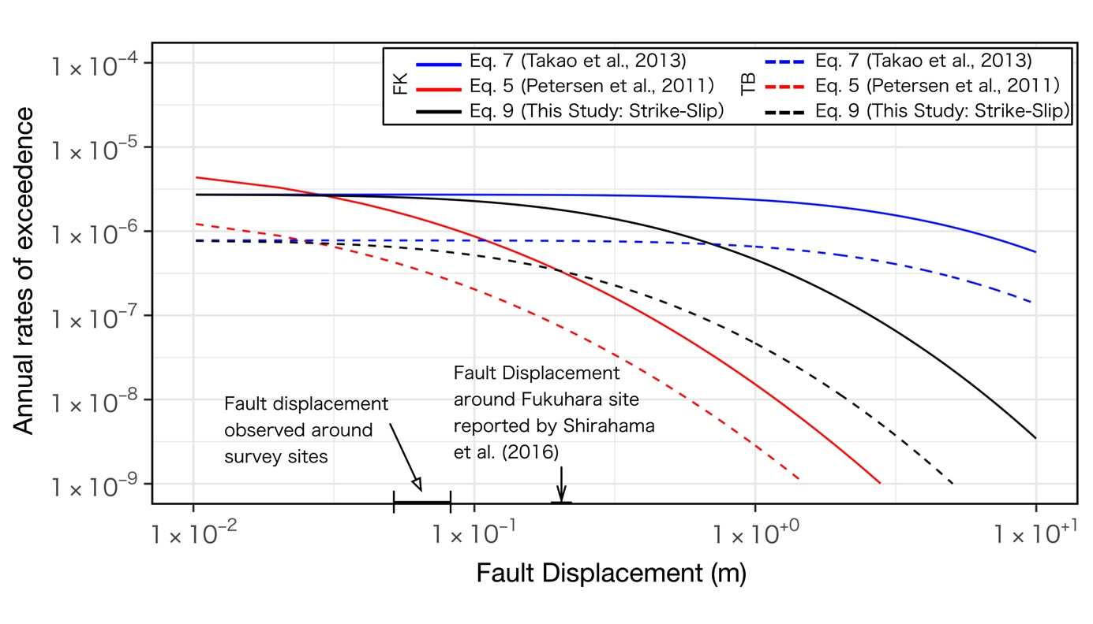
FIG. 6. Annual rates of exceedence of excavation sites, based on the information before the 2016 Kumamoto earthquake. Colored lines denote each attenuation relation. Solid and dashed lines represent each excavation site. FK and TB indicate the Fukuhara and Tsuchibayashi excavation sites, respectively.

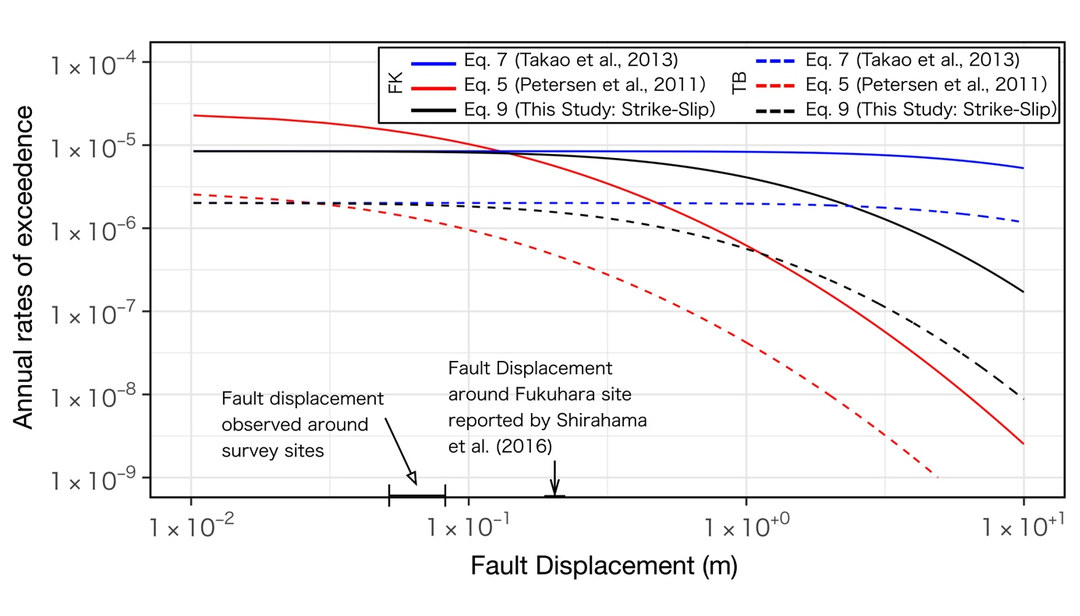
FIG.7. Annual rates of exceedence of excavation sites, based on the information after the 2016 Kumamoto earthquake. Colored lines denote each attenuation relation. Solid and dashed lines represent each excavation site. FK and TB indicate the Fukuhara and Tsuchibayashi excavation sites, respectively.

Concluding Remarks
The 2016 Kumamoto earthquake indicates the variability and complexity of distribution of fault displacements in detail. We updated the fault displacement data set by the 2016 Kumamoto earthquake and investigated the attenuation relation of for the distributed fault displacement. The distributed displacement sites detected by low coherence zones derived from InSAR analysis were investigated by excavation surveys and PFDHA. The excavation survey at Fukuhara indicates the evidence for the 2016 event and several prior paleoearthquakes. We performed a probabilistic fault hazard analysis (PFDHA) of excavation sites with several PFDHA components estimated by the global strike-slip model and Japanese model. The annual rates of exceedence by the global strike-slip model at centimeters-order displacements are larger than that of the Japanese model. The annual rates of exceedence derived by the global strike-slip model rapidly decrease toward larger displacement compared to the annual rates of exceedence estimated by Japanese model. The calculated annual rates of exceedence depend on the equations and data set of PFDHA components. The individual components within PFDHA should be carefully selected considering the individual effects.

ACKNOWLEDGMENT: This research was part of the 2017 research project ’Development of evaluating method for fault displacement’ by the Secretariat of Nuclear Regulation Authority (NRA), Japan.

REFERENCES
- THE HEADQUARTERS for EARTHQUAKE RESEARCH PROMOTION “Long-term evaluation of Futagawa-Hinagu Active Fault System (partially revised),” Vol. (http://www.jishin.go.jp/main/chousa/katsudansoupdf/93_futagawa_hinagu_2.pdf) (2013).
- GEOSPATIAL INFORMATION AUTHORITY of JAPAN “Surface earthquake faults associated with the 2016 Kumamoto earthquake,” https://www.gsj.jp/hazards/earth- quake/kumamoto2016/kumamoto20160513-1.html (2016). (in Japanese)
- MINISTRY OF EDUCATION, CULTURE, SPORTS SCIENCE AND TECHNOLOGY AND KYUSHU UNIVERSITY General active fault survey of 2016 Kumamoto earthquake, http://www.jishin.go.jp/database/project_report/kumamoto_sogochousa-h28/ (2017). (in Japanese)
- TONAGI, M., TAKAHAMA, T., MATSUMOTO, Y., WATANABE, T., KITADA, N., INOUE, N., IRIKURA, K. “Study on the evaluation method for fault displacement,” International Workshop on Best Practice in Physics-based Fault Rupture Models for Seismic Hazard Assessment of Nuclear Installations, P28 (2015).
- INOUE, N., KITADA, N., TONAGI, M., IRIKURA, K. “Study on the Evaluation Method for Fault Displacement: Probabilistic Approach Based on Japanese Earthquake Rupture Data,” International Workshop on Best Practice in Physics-based Fault Rupture Models for Seismic Hazard Assessment of Nuclear Installations, P20 (2015).
- YOUNGS, R. R., ARABASZ, W. J., ANDERSON, R. E., RAMELLI, A. R., AKE, J. P., SLEMMONS, D. B., MCCALPIN, J. P., DOSER, D. I., FRIDRICH, C. J., SWAN, F. H., ROGERS, A. M., YOUNT, J. C., ANDERSON, L. W., SMITH, K. D., BRUHN, R. L., KNUEPFER, P. L. K., SMITH, R. B., DEPOLO, C. M., O’LEARY, D. W., COPPERSMITH, K. J., PEZZOPANE, S. K., SCHWARTZ, D. P., WHITNEY, J. W., OLIG, S. S., TORO, G. R. “A Methodology for Probabilistic Fault Displacement Hazard Analysis (PFDHA),” Earthquake Spectra, Vol. 19, No. 1, pp. 191-219 (2003).
- PETERSEN, M. D., DAWSON, T. E., CHEN, R., CAO, T., WILLS, C. J., SCHWARTZ, D. P., FRANKEL, A. D. “Fault displacement hazard for strike-slip faults,” Bulletin of the Seismological Society of America, Vol. 101, No. 2, pp. 805-825 (2011).
- MOSS, R. E. S., ROSS, Z. E. “Probabilistic fault displacement hazard analysis for reverse faults,” Bulletin of the Seismological Society of America, Vol. 101, No. 4, pp. 1542-1553 (2011).
- Takao, M., Tsuchiyama, J., Annaka, T., Kurita, T. “Application of Probabilistic Fault Displacement Hazard Analysis in Japan,” Journal of Japan Association for Earthquake Engineering, Vol. 13, No. 1, pp. 17-32 (2013). (in Japanese with English abstract)
- OMATA, M., KOHRIYA, Y., SANGO, D. “New detection method of surface rapture by InSAR,” Japanese Society for Active Fault Studies 2016 annual meeting abstract, P-4 (2016). (in Japanese)
- OMATA, M., KOHRIYA, Y., SANGO, D., SHIBUYA, N., TANIGUCHI, K. “Small ground deformations of the 2016 Kumamoto earthquake detected by LC-InSAR analysis,” Japanese Society for Active Fault Studies 2017 annual meeting abstract, P-4 (2017).
- CHEN, R., PETERSEN, M. D. “Probabilistic Fault Displacement Hazards for the Southern San Andreas Fault Using Scenarios and Empirical Slips,” Earthquake Spectra, Vol. 27, No. 2, pp. 293-313 (2011).
- WELLS DONALD L., COPPERSMITH KEVIN J. “New Empirical Relationships among Magnitude, Rupture Length, Rupture Width, Rupture Area, and Surface Displacement,” Bulletin of the Seismological Society of America, 84, 4, pp. 974-1002 (1994).
- INOUE, N., TONAGI, M., TAKAHAMA, T., MATSUMOTO, Y., KITADA, N., DALGUER, L. A., IRIKURA, K. “Framework of probabilistic and deterministic methods for evaluating near-fault displacement,” in Fault Displacement Hazard Analysis Workshop (2016).
- HANSSEN, R. F. “Radar interferometry: data interpretation and error analysis”, Springer Science & Business Media, (2001). (in Japanese)
- SHIRAHAMA, Y., YOSHIMI, M., AWATA, Y., MARUYAMA, T., AZUMA, T., MIYASHITA, Y., MORI, H., IMANISHI, K., TAKEDA, N., OCHI, T., OTSUBO, M., ASAHINA, D., MIYAKAWA, A. “Characteristics of the surface ruptures associated with the 2016 Kumamoto earthquake sequence, central Kyushu, Japan,” Earth, Planets and Space, Vol. 68, No. 1, p. 191 (2016).
- PETERSEN M. D., CHEN R. “EMPIRICAL FAULT DISPLACEMENT HAZARD METHODS APPLIED IN THE UNITED STATES,” International Workshop on Best Practice in Physics-based Fault Rupture Models for Seismic Hazard Assessment of Nuclear Installations, P28 (2015).

