ANALYSIS OF THE SPATIAL CORRELATION OF EARTHQUAKE GROUND MOTION FROM PHYSICS-BASED NUMERICAL SIMULATIONS

M. INFANTINO¹, R. PAOLUCCI¹, C. SMERZINI¹

¹Department of Civil and Environmental Engineering, Politecnico di Milano, Italy

E-mail contact of main author: roberto.paolucci@polimi.it

Abstract. One of the key issues in the seismic risk assessment of large urban areas with spatially distributed portfolios is the modeling of the spatial correlation of ground motion intensity measures. In such conditions, standard tools for site-specific hazard assessment, based on the use of ground motion prediction equations, may not be suitable, as they do not account for the joint occurrence of IMs at multiple sites. On the other hand, physics-based numerical simulations of earthquake ground motion, including a 3D model of the fault rupture, the propagation path and near-surface geology, retains great potential for risk analyses at urban scale, owing to its superiority in reproducing the spatial variability of ground motion at regional scale.
In this contribution we aim at quantifying the spatial correlation of broadband physics-based simulated ground motions, generated through the spectral element code SPEED (http://speed.mox.polimi.it/). Broadband ground motions have been generated using an innovative approach based on Artificial Neural Network, trained on a database on strong motion recordings and applied to predict the short period spectral ordinates starting from the long period ones of synthetics. Geostatistical tools, based on the computation of the semi-variogram, have been used to estimate the correlation structure between spatially distributed response spectral accelerations at different vibration periods (range and sill parameters). The numerical dataset encompasses different areas worldwide (Po Plain, Italy; Istanbul, Turkey; Thessaloniki, Greece; Beijing, China) and severe earthquake scenarios (M=6-7+) in near-source conditions.
The results of this study point out that: (i) the structure of spatial correlation structure of broadband physics-based synthetics is in substantial agreement with the one from actual recordings as well as with other independent published studies in a broad range of periods; (ii) factors, such as near-source directivity/directionality and magnitude, may affect significantly the spatial correlation structure of IMs, leading to anistropy effects.
Key Words: spatial correlation of ground motion, seismic risk assessment, broad-band physics-based numerical simulation, semi-variogram

INTRODUCTION
Risk assessment of a spatially distributed portfolio of assets or infrastructure system, such as utility networks (e.g. water, electrical power, communications etc..), plays a key role in catastrophe modelling. When considering multiple buildings or lifelines, it is of primary importance to take into account the spatial correlation properties of the ground motion into the probabilistic seismic risk analyses. Indeed, if during the same earthquake all structures of a portfolio can be affected, it is not correct to treat the ground motion intensity measures (IMs) at all sites as independent variables, especially if they are located closely in space. As an example Weatherill et al. [1] considered the impact of spatial correlation upon the aggregated loss analysis for a homogeneous portfolio of a single type of buildings (masonry wall, mid-rise, pre-code type) for the Florence (Italy) Administrative Province, made of 2591 assets with the largest site-to-site distance of 100 km, compared to the Florence City District, made of 168 assets with the largest site-to-site distance of about 15 km. The authors concluded that considering spatial correlation produces greater losses at lower annual probabilities of exceedance on one side, and, on the other side, that such an impact is greater for the portfolio with the smaller ‘footprint’. Similar conclusions were drawn in further studies. Park et al. [2] evaluated the losses of two portfolios of different size in San Francisco Bay Area in Northern California considering six correlation assumptions: (1) no correlation, (2)-(3)-(4)-(5) spatially correlated ground motion field according different models and (6) perfect correlation. They demonstrated that, for large and small portfolios (FIG.1), the underestimation of losses starts at values of annual mean rate of exceedance (MRE) less than about 7×10⁻³ and 1×10⁻² (i.e., at return periods larger than about 100-150 years) respectively, and maximum differences of almost a factor of 2 can be found for smaller portfolios at very large return periods (10⁴ years). In a similar study, Goda and Atkinson [3] showed that the inclusion of the correlation structure of ground motion parameters may have a remarkable impact on the estimated seismic losses by a factor as high as 50%.
For this reason several spatial-correlations models have been proposed for different IMs using datasets of ground motion recordings (e.g., [4], [5], [6], [3], [7], [8], [9], [10]). However, it should be noted that ground motion correlation structure depends strongly on local geology and on the propagation path, therefore a single generalized spatial correlation model may not adequately represent large areas, as shown by Sokolov et al. [8] for the Taiwan case. Thus, the spatial correlation models proposed in literature, based on the analysis of large sets of strong motion recordings, can be hardly representative of the area under study and region-specific analyses are needed.
A powerful tool which allows to obtain detailed and region-specific estimates of earthquake ground shaking and of its spatial variability is represented by 3D Physics-Based Numerical Simulations (3D PBS). Such numerical simulations are based on physical models of the seismic source, the propagation path from the source to the site and local geologic irregularities, and allow one to investigate the dependence of spatial variability on factors, such as magnitude, wave propagation effects, local site conditions, for a variety of “virtual”, albeit realistic, conditions. In this work 3D PBS have been produced using the spectral element code SPEED (http://speed.mox.polimi.it/, [11]). To enrich the frequency content of numerical simulations, limited typically to about 1.5-2 Hz, broadband ground motions have been generated using an innovative approach based on Artificial Neural Network ( [12]).
The aim of this paper is two-fold: on one side, to verify the accuracy of the synthetics to reproduce the real spatial correlation structure, as inferred from the analysis of strong motion recordings, and, on the other side, to investigate the influence of physical parameters, such as source effects, magnitude and azimith, on spatial correlation features. Therefore, after having presented the entire methodology, from the setup of the numerical model up to the geostatistical analysis, the most significant results in response to the aforementioned objectives will be provided.

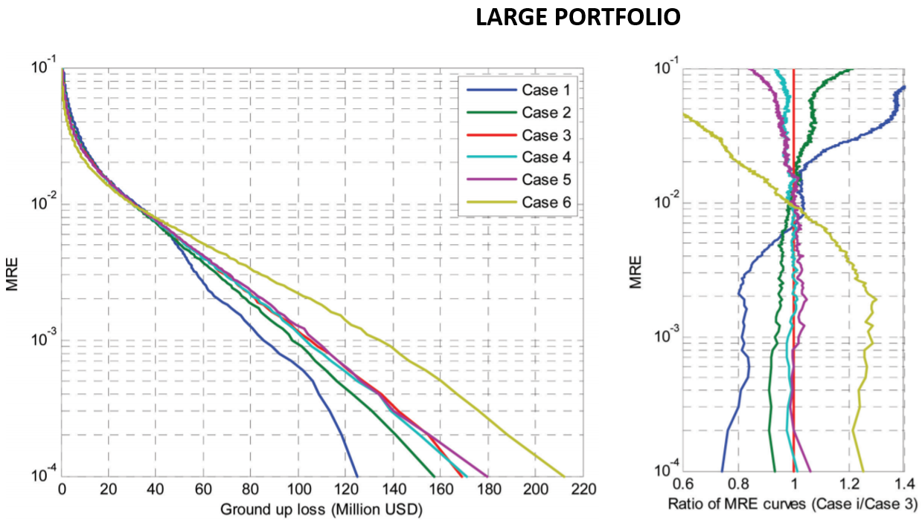
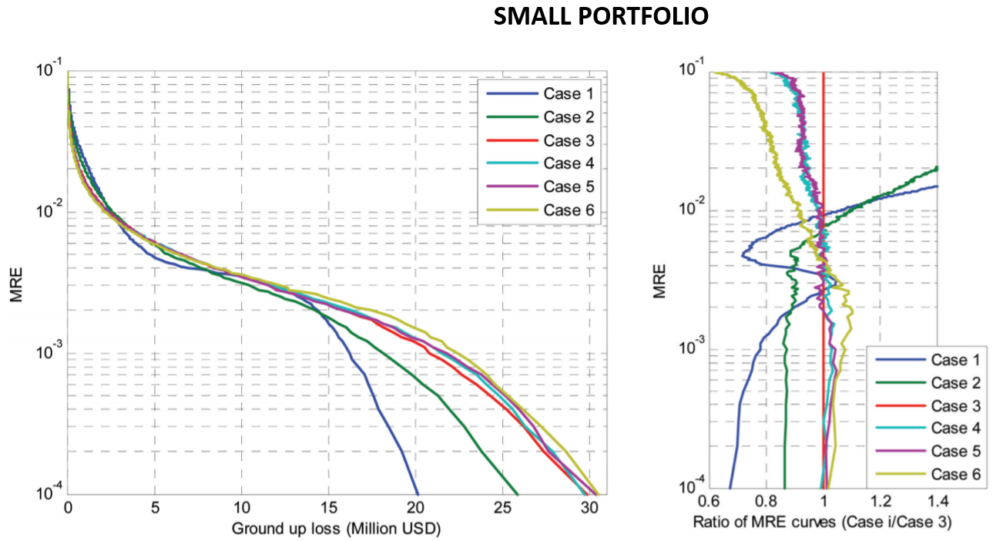
FIG.1 Left: mean rate of exceedance (MRE) curves for losses to the large portfolio (top) and small portfolio (bottom) computed using the six different correlation models. Right: ratio of MRE curves from Cases 1–6 to MRE curve for Case 3. (Adapted from [2])

ON THE ESTIMATION OF SPATIAL CORRELATION OF 3D PHYSICS-BASED BROADBAND GROUND MOTIONS
This section aims at describing the entire procedure followed to study the spatial correlation of 3D synthetics, from the setup of the 3D numerical model up to the geostatistical analysis. More specifically, for each case study considered herein, the whole procedure adopted can be summarized in the following steps:
- Setup of the 3D numerical model: collection of the input data, construction of the 3D geological model, definition of the source model (kinematic), execution of numerical simulations with SPEED code;
- Generation of broad-band synthetics from 3D PBSs through Artificial Neural Network (ANN2BB);
- Geostatistical analysis based on the computation of the semivariogram using the broad-band 3D PBSs.

  - 3D physics-based numerical simulations

Once that the topographical, geotechnical and geological information are collected, the 3D geological model can be constructed combining: (a) the digital elevation (and, if needed, bathymetry) model; (b) the crustal structure generally described in form of a layered model of S and P wave velocity, V_{S} and V_{P}, and (c) the local shallow geological structure with a model of V_{S} and V_{P} variable both in the horizontal and vertical direction, and possibly including the corresponding models for internal soil damping and local variation of shear modulus and damping as a function of shear strain (or, in 3D, of the second invariant of the strain tensor). Such a model is then combined with the source one based on seismotectonic knowledge. For the case studies discussed in the present work, a kinematic source model has been used applying along the fault a heterogenous co-seismic slip distribution combined with a slip source function, typically a sigmoid one, with initiation time and length depending on the local rupture velocity and rise-time. In the present version of SPEED two kinematic models are implemented. The first one is the model proposed by Herrero and Bernard [13] where the heterogeneities of the slip distribution are assumed to present a k⁻² spectral decay in the wavenumber domain, while the second one is the Crempien and Archuleta [14] model complying with the SCEC validation criteria ( [15]).
The source and velocity models obtained are then condensed into a spectral element numerical model consisting of hexahedral elements (see bottom left FIG.2) with a spectral degree selected in order to propagate a maximum reliable frequency typically of about 1.5 Hz.

  - ANN2BB: estimating broadband ground motions

Starting from the low frequency PBSs, broad-band synthetics have to be produced to enrich their frequency content and, hence, make them usable for earthquake engineering applications. In this study, broadband ground motions have been obtained through an approach based on Artificial Neural Network (ANN), referred to as ANN2BB, presented and validated against real case studies in Paolucci et al. [12]. While we refer the reader to the relevant publication for a detailed description of such a methodology and verification tests, we limit herein to describe the main feature of the approach.
The basic steps of the procedure can be summarized as follows: (1) the ANN is trained on a strong motion dataset, namely SIMBAD [16], to correlate short-period (T≤T*) spectral ordinates with the long period ones (T>T*), being T* the threshold period beyond which results of the PBS are supposed to be accurate; (2) the trained ANN is used to obtain the short period spectral ordinates of the physics-based earthquake ground motion for periods below T*; (3) the PBS long period time histories are enriched at high frequencies with an iterative spectral matching approach, until the response spectrum matches the short period part obtained by the ANN. In Paolucci et al. [12] it has been demonstrated that this approach allows on one side to obtain realistic waveforms and peak ground values and, on the other side, to preserve the spatial correlation structure of ground motion at short periods.

  - Geostatistical analysis

Once that the broad-band synthetics are generated, it is possible to evaluate the spatial correlation of the peak values of ground motion. The geostatistical tool commonly used to this end is the semivariogram γ(h) (see e.g. [5], [9], [10], [17]). It provides a measure of the average dissimilarity of two random variables (Z_{xi}, Z_{xj}) separated by an inter-site distance h, as follows:

$$γ\left(Z_{xi},Z_{xj}\right)=\frac{1}{2}E\left[{\left\{Z_{xi}-Z_{xj}\right\}}^{2}\right] (1)$$

In seismology applications Z_{xi} denotes the residual term computed as the logarithm (log₁₀) misfit between the ground motion (recorded or simulated) Y_{xi} at the site x_{i} with respect to an average trend ${\overline{Y}}_{xi}$. In the present study, the average trend is defined on the synthetic dataset itself as follows:

$$\log_{10}{\overline{Y}}_{xi}=c1+\log_{10}\left(R_{line}+c2\right) (2)$$

where c1 and c2 are model parameters, while R_{line} is the closest distance from the surface fault projection of the segment at the top edge of the rupture plan (see definition in [18]).
$γ\left(Z_{xi},Z_{xj}\right)$ in Equation 1 can be evaluated through the following steps: (i) computing the sample semivariogram by the method of moments ( [19]) by means of Equation (3) under the hypothesis of second order stationarity; (ii) selecting the theoretical model of the semivariogram among those generally used to this end (i.e. exponential, gaussian or spherical models [20]); (iii) estimating the parameters of the model, referred to as sill (i.e., the variance of the random process) and range (i.e., the inter-station distance at which γ(h) tends to the sill, indicating the distance at which motions are uncorrelated), by fitting the computed sample semivariogram values with the functional form chosen at the previous point.

$$\hat{γ}\left(h\right)=\frac{1}{2N\left(h\right)} \sum_{j=1}^{N\left(h\right)}{{\left\{z_{x_{j}}-z_{x_{j}+h}\right\}}^{2}} \left(3\right)$$

Finally, starting from the semivariogram it is possible to define the spatial correlation coefficient defined as the complementary to the semivariogram normalized by the sill ($σ^{2}$):

$$ρ\left(h\right)=1-\frac{γ(h)}{σ^{2}} (4)$$

CASE STUDIES
In the present study four different urban areas in earthquake-prone regions have been investigated. More specific, the locations selected, shown in FIG.1, are: Po Plain (Northern Italy), Thessaloniki (Greece), Beijing (China) and Istanbul (Turkey). Although such locations are characterized by different features in terms of geological and seismotectonic context, fault mechanism and geometry, all share: (i) the proximity to a well-known mapped fault capable to trigger a severe earthquake and (ii) a relatively good description of the geotechnical characterization of the soil.
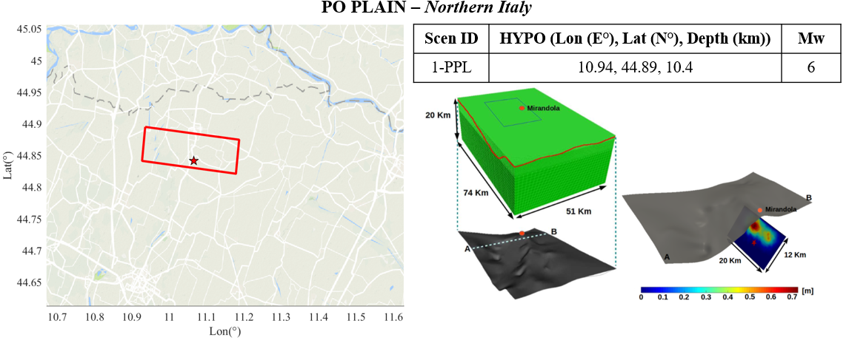
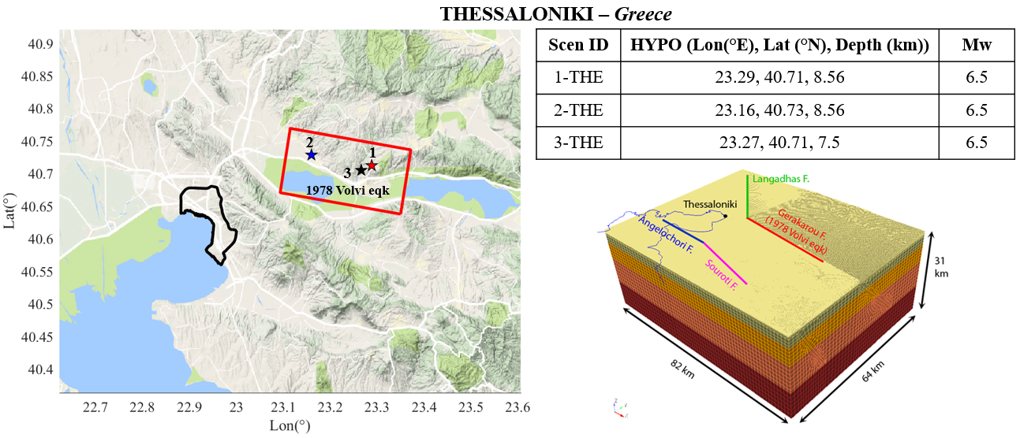
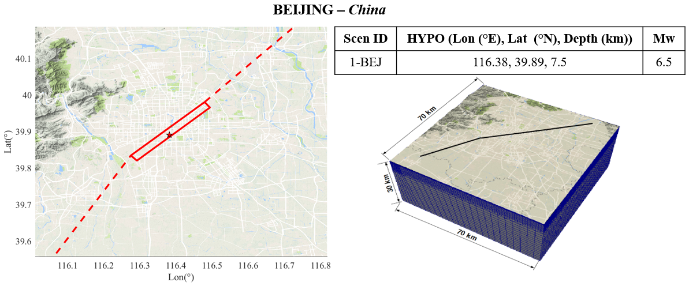
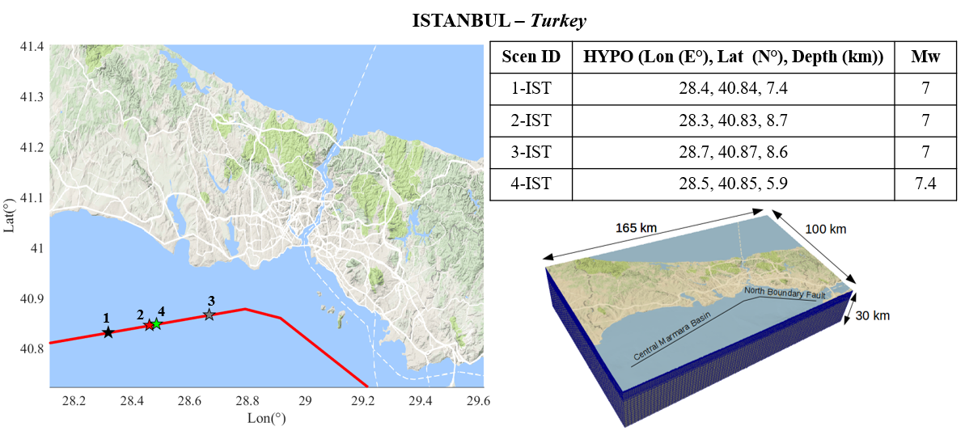
FIG.2 Overview of case studies of 3D numerical simulations in large urban areas worldwide. For each case studies the following information are provided: the google map along with the surface projection of the fault and epicenter position(s) (right), hypocenter coordinates and magnitude for each rupture scenario (top left) and numerical model (bottom left).

RESULTS
In the present section the main results obtained following the procedure described at Section 2 for the case studies presented at Section 3 are discussed. First, the spatial correlation structure of the ANN2BB results is compared with that observed on recording, for the Po Plain case study. Second, the dependence of spatial correlation estimates on period, source-related effects, magnitude and distance are investigated.
4.1 Comparison against records
Comparing the spatial correlation structure of the broadband synthetics with the observed one is crucial to test the ability of the ANN2BB procedure to reproduce the actual correlation of ground motion. To this purpose the Mw 6 earthquake occurred in Po Plain (Northern Italy) on 29 May 2012 is an excellent case owing to the availability of more than 30 near-source recordings at epicentral distances less than 30 km. Furthermore, for this case study, a comprehensive comparison between synthetics and observations both in terms of peak values and time histories of ground motion has been addressed, see [21]. Hence, the semivariogram and the spatial correlation coefficient have been computed at the available accelerometric stations both for records and synthetics. As an example, FIG.3 shows the semi-variograms obtained for both records (green) and synthetics (ANN2BB, red) for short period and intermediate periods (PGA and Spectral Acceleration at 1.0s on the left and right hand side, respectively). The horizontal NS component is considered. It is worth noting that PGA has been obtained with ANN2BB procedure (applied for T <0.75s) while SA at 1.0s is the output of 3D PBSs. A good agreement is found between observations and synthetics, with range values of approximately 19-25 km, demonstrating the capability of 3D PBS to reproduce the real correlation structure of ground motion in a broad range of periods.
FIG. 3 Top: Semivariograms obtained using records REC (triangles) and the ANN2BB approach (diamonds) for PGA (left) and SA(1.0s) (right). The corresponding best-fitting exponential models are denoted by continuous lines. Bottom: Spatial correlation coefficient for PGA (left) and SA 1.0s (right). (Modified after [12]).

  - Dependence on period
In this section the dependence of spatial correlation estimates on period is studied. To this end, in FIG.4 we show the trend of range versus periods. For each case study a single scenario (namely 1-PPL, 3-THE, 1-BEJ and 2-IST, see FIG. 1) has been considered for which the ranges have been computed for four spectral ordinates: PGA, SA 0.2s, SA 1.0s and SA 3.5s. For the simulations 3-THE, 1-BEJ and 2-IST about 400 monitors were randomly selected and consequently about 79800 pairs were used to estimate correlation of the geometric mean of the horizontal components for different spectral ordinates. Differently, for the 1-PPL the statistical analysis has been carried out on the NS component using the set of about 30 receivers corresponding to the stations that recorded the 29 May 2018 earthquake. The ranges estimated in this work generally increase with period, similarly to other studies (e.g. [5], [9],[10]).
As highlighted by Jayaram and Baker [5] and Esposito and Iervolino [10], this is consistent with past studies on spatial coherency of ground motion (e.g. [22]). Given that the coherency is a measure of similarity between two recordings, the aforementioned studies prove that coherency decreases at increasing distance between two points and at higher frequencies. In fact, high-frequency waves are more affected by small-scale heterogeneities and therefore they turn out to be less coherent, compared to low-frequency waves ( [23]). Regarding FIG.4, the results reveal a rather strong variability of range estimates, which turn out to be case- and period- dependent. However, the high variability of the range values is comparable with that found in literature works. The differences of the correlation structures among the different locations are mainly related to the frequency content of ground motion (e.g. [24] or [6]) and to peculiarities of the local geology and of the propagation path ( [8]). Observing FIG.4, it can be noted that the ranges estimated for Po Plain, Istanbul and Beijing at short period (i.e. T = 0s and 0.2s) are similar (i.e. between 20-30 km) while in Thessaloniki the range turns out to be much higher (about 55 km). This may be a consequence of the local site conditions: most of the monitors selected in Thessaloniki are located on homogeneous hard rock where the ground motion is expected to be more coherent. On the other hand, most monitors considered for the other three cases are located on highly variable ground conditions (Istanbul) or deep soft soil (Po Plain and Beijing). It can also be noted that the ranges obtained from the Po Plain simulation at long periods are rather small compared to the other three locations, most likely because receivers in the Po Plain are all located at very short distances from the fault, where near-source effects are predominant, increasing the variability of ground shaking.

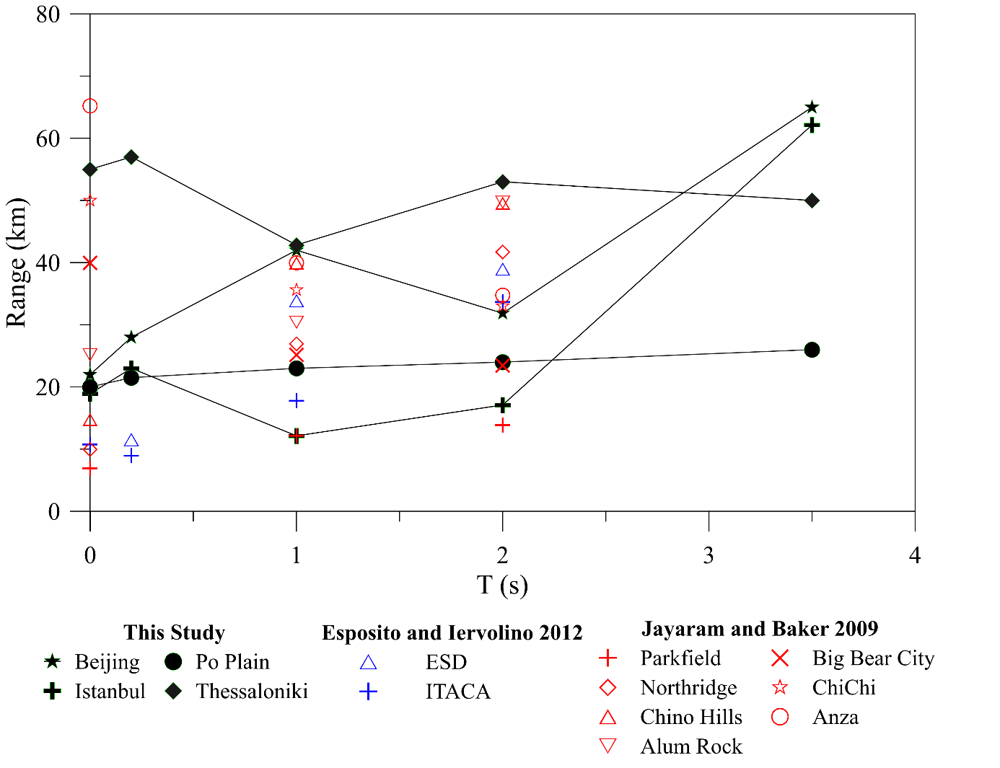
FIG. 4 Comparison of the ranges estimated by using 3DPBSs against the results of Esposito and Iervolino [10] and Jayaram and Baker [5]) based on recordings. (Adapted from [25])

  - Source and Propagation effects
The aim of this section is to investigate the influence of source propagation effects on the semivariogram and, therefore, on the correlation structure. For this purpose, the Istanbul and Thessaloniki applications, for which more than one simulation are available, have been considered.
The peculiar position of the megacity of Istanbul with respect of North Anatolian Fault NAF (FIG.2) offers us the chance to deepen some aspects. As shown in FIG.2, the portion of NAF at south of Istanbul can be sketched with 3 vertical segments with a convex shape with respect Istanbul itself. Such a configuration leads to level of ground motions different depending on the hypocenter position and slip distribution. By way of example, in FIG.5 the SA 2.0s maps of the geometric mean of the horizontal components are shown for three different rupture scenarios (i.e. 1-IST, 2-IST, 3-IST) classified as ‘directive’, ‘neutral’ and ’antidirective’ respect Istanbul, respectively. It is evident that the ‘directive’ one (i.e. 1-IST) produces the highest level of ground shaking due to propagation of the rupture front toward Istanbul (see slip distribution at bottom of FIG.5) while, on the contrary, the lowest peak ground values occur in the ‘antidirective’ 3-IST scenario, where the rupture front propagates in the opposite direction.
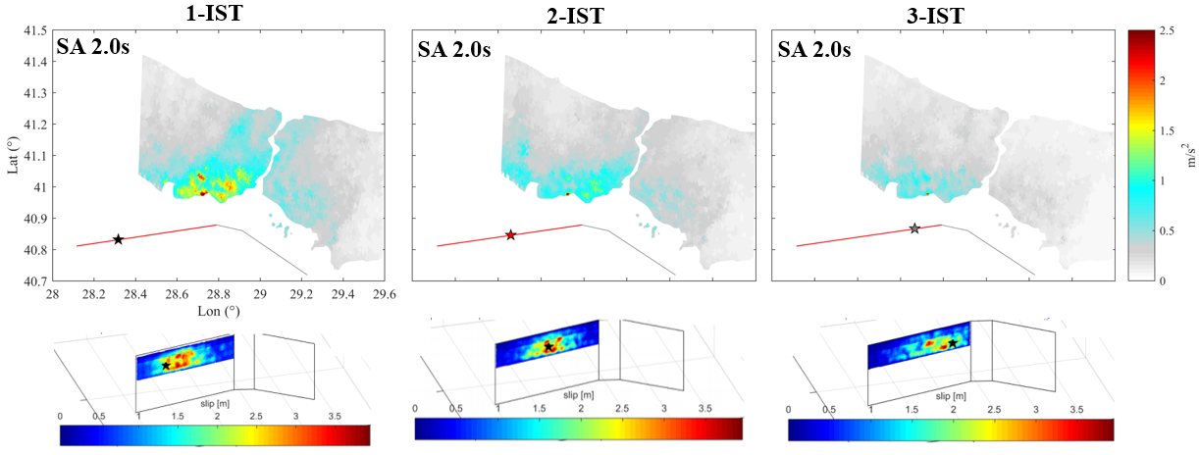
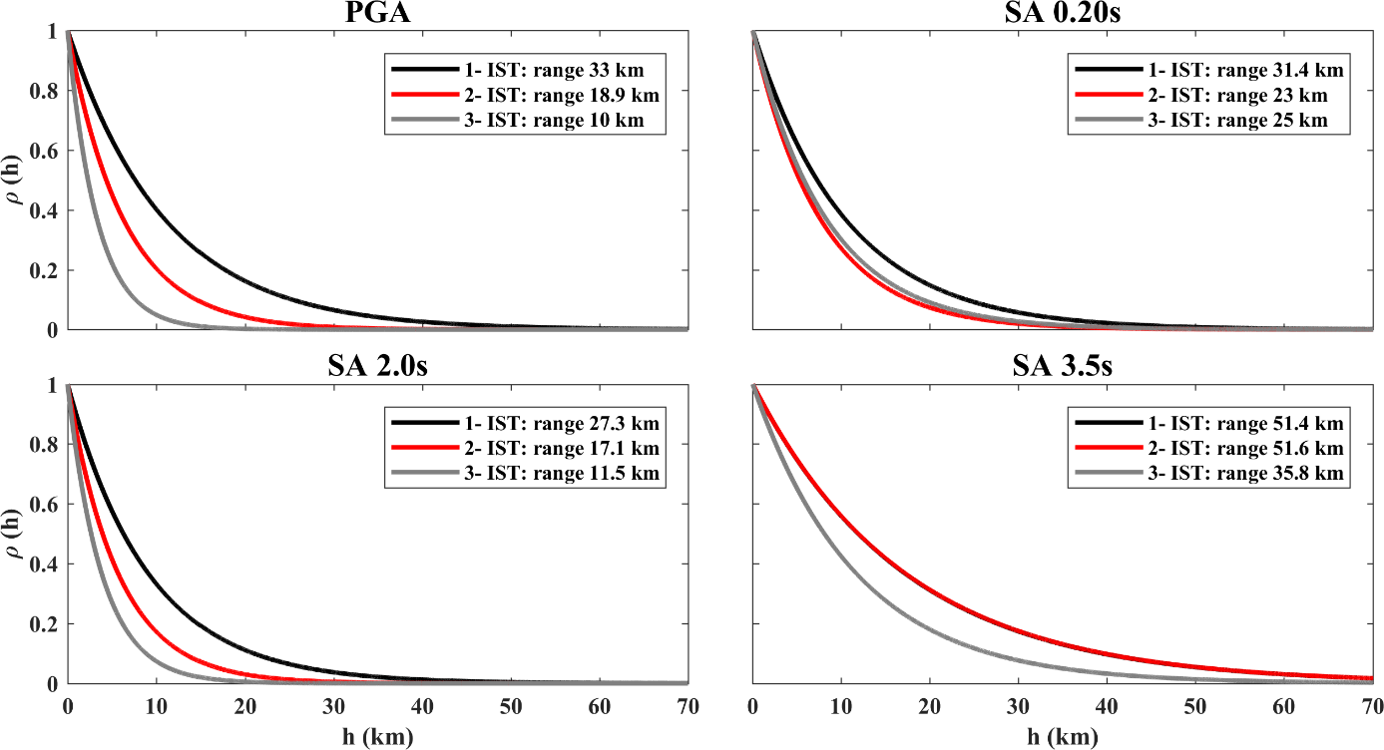
FIG. 5 Top: SA 2.0s Maps and slip distribution for Scenarios 1-IST, 2-IST and 3-IST. Bottom: Spatial Correlation coefficients for PGA, SA 0.2s, SA 2.0s and SA 3.5 s for the directive (1-IST, black), neutral (2-IST, red) and antidirective (3-IST, grey) scenarios referred to the Istanbul case
FIG.5 shows the spatial correlation coefficients obtained for the three aforementioned scenarios at 4 spectral ordinates (i.e. PGA, SA 0.2s, SA 2.0s and SA 3.5s). It is evident that the ranges increase from the antidirective to the directive conditions, implying a higher correlation length for the 1-IST scenario which produces higher and more coherent levels of ground shaking on a more extended area.
The second case study that offers us the opportunity to investigate the effects of source and propagation conditions is the Thessaloniki case ( [26]). Two different scenarios, 1-THE and 2-THE (FIG.2), characterized by different hypocenter positions and by the same slip distribution, have been considered. FIG.6 shows the impact of the hypocenter position on the peak ground maps (left) and on the correlation structure (left) considering the spectral ordinate SA 1.0s. It is evident that the 2-THE scenario produces higher maximum peak shaking values concentrated in a narrower area while, the 1-THE leads to maximum peaks lower than 2-THE but affecting a more extended portion. Such different ground shaking distributions allow to explain the semivariograms and spatial correlation coefficients showed on the right side of FIG.6: (i) 2-THE is characterized by an higher sill (or variance), which means an higher variability, due to the higher misfit between the maximum and minimum peak values, and (ii) 1-THE is characterized by an higher range meaning a more correlated ground shaking (i.e. a ground shaking correlated on longer distances), that is consequence of a more homogeneous maximum peak values on a more extended area.
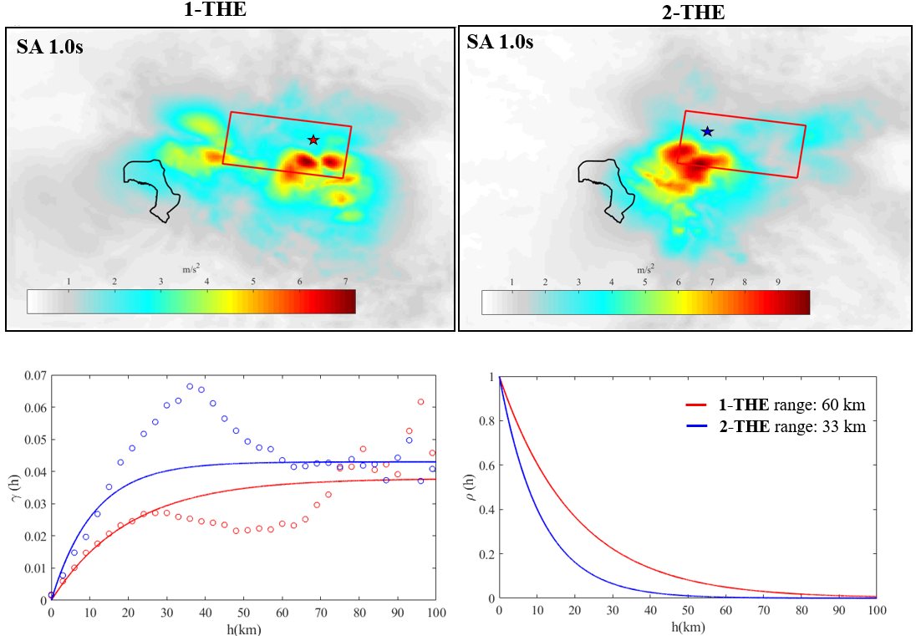
FIG. 6 Top: SA 1.0s Maps for Scenarios 1-THE (left) and 2-THE (right). Bottom: Semivariograms (left) and Spatial Correlation coefficients (right) for SA 1.0s for both scenarios (1-THE, red and 2-THE blue)
One of the main of advantages of numerical simulations is to study possible spatial anisotropies by grouping the receivers in classes of distance thanks to their large number, this is opposite to the case of real earthquakes where the number of stations is generally limited. Possible anisotropy patterns have been studied for the 1-THE scenario by considering a large set (~ 400) of synthetics receivers located in 4 near field sectors in the Northern and Southern with respect to the epicenter (right panel of FIG.7). For each sector the semivariogram model and the parameters (sill and range) have been estimated (right panel of FIG.7). This figure points out some interesting features summarized in Table 1: (i) the Southern sectors (i.e. 1S and 2S), characterized by a higher directivity and higher values of a peak shaking on a more extended area than the Northern ones (1N and 2N), show higher sills (i.e. variability) and ranges (i.e. correlation lengths); (ii) The model parameters (sills and ranges) are higher for the sectors nearest to the epicenter (1S and 1N).
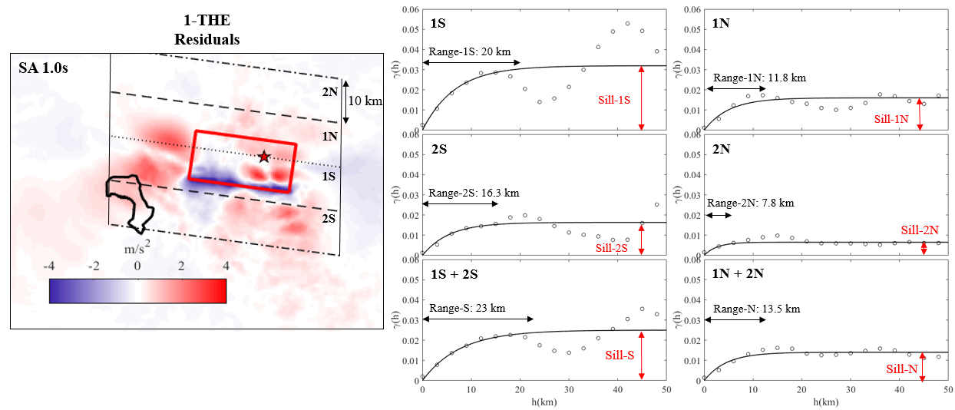FIG. 7 Left: Residual (SA 1.0s – Median, where Median is computed with equation 2) Map for Scenarios 1-THE with indicated the four (1S, 1N, 2S, 2N) sectors considered for the analysis. Right: Semivariograms for each sector.

TABLE 1: SUMMARY OF THE MAIN RESULTS OF FIG.7 REFERRED TO 1-THE CASE

 | Sill | Range | Reference to FIG.7
Effect of distance | Increase for decreasing distance | Increase for decreasing distance | Sill-1S > Sill-2S Range-1S > Range-2S  Sill-1N > Sill-2N Range-1N > Range-2N
Effect of fault directivity | Increase for areas characterized by directivity phenomena | Increase for areas characterized by directivity phenomena | Sill-1S > Sill-1N Range-1S > Range-1N  Sill-2S > Sill-2N Range-2S > Range-2N  Sill-1S+2S > Sill-1N+2N  Range-1S+2S > Range-1N+2N

  - Effects of Magnitude
In this section the possible dependence of correlation on magnitude is investigated. To this end, the Istanbul case study has been considered. To this end, in FIG.8 the ranges estimated of two scenarios with Mw 7.0 and Mw 7.4 for different spectral ordinates are compared. In order to make a consistent comparison, two scenarios with a similar position of hypocenter (2-IST, 4-IST) have been selected (left of FIG.8). Observing right panel of FIG.8, it is evident that the ranges are almost comparable at short – intermediate periods, up to 3 s, while they differ remarkably at long period where the influence of magnitude is higher. More specifically, for T > 3s the ranges of the Mw 7 (2-IST) earthquake scenario turn out to be much higher than ranges of Mw 7.4 (4-IST), implying a ground motion less correlated at long period for high magnitude. Such a result could be explained considering that the higher is magnitude, the larger is rupture area as well as the near source region: this is expected to widen the area where the heterogeneity of the fault surface reduces the coherency of motion. Therefore, a reduction of correlation in near-field is expected with respect to small magnitude events owing to the increase of the variability of wave paths involving different portions of the heterogeneous fault rupture.
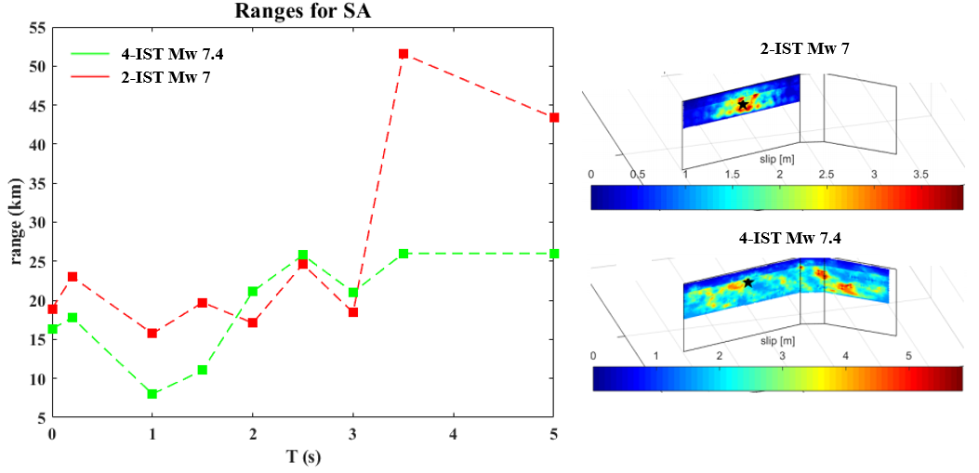
FIG. 8 (Right) Ranges for the different spectral components for the scenarios Mw 7.0, 2-IST (red) and the Mw 7.4, 4-IST (green) and (left) slip distribution.

CONCLUSIONS
This work investigated the spatial correlation structure of 3D broadband physics-based numerical simulations, obtained with the approach described in Section 2. Four applications worldwide, namely, Po Plain (Northern Italy), Thessaloniki (Northern Greece), Beijing (China) and Istanbul (Turkey)), have been considered. The most relevant conclusions can be summarized as follows:
- the Po Plain application demonstrates that the 3D PBSs can reproduce accurately the actual spatial correlation structure of ground motion with ranges consistent with recordings both at short and long periods (section 4.1);
- the estimates of ranges from PBSs for the four case studies under consideration turn out to be comparable with the available literature studies on the topic (section 4.2);
- spatial correlation estimates show a marked variability, especially at short periods, suggesting that spatial variability of ground motion is region- and scenario- specific, owing to its strong dependence on local geology and source effects in near conditions; the influence of source and wave propagation effects, including directivity, and of magnitude have been investigated. Such comparisons, even if preliminary, reveal that: (i) higher ranges, i.e. larger correlation distances ofground shaking, are obtained for the more ‘directive’ scenarios that produce high levels of ground shaking on a more extended area (section 4.3); (ii) a marked dependence on azimuth is found (section 4.3) as a consequence of directionality induced by fault rupture propagation; (iii) the impact of magnitude is relevant especially at long periods (about T ≥ 3s) with lower ranges for larger magnitude (section 4.4);
Further studies will aim at extending these analyses above to further scenarios to confirm the trends identified in this work.

REFERENCES

[1] | WEATHERILL, G., et al., "Exploring the impact of spatial correlations and uncertainties for portfolio analysis in probabilistic seismic loss estimation", Bull Earthquake Eng, vol. 13, pp. 957-981, 2015.
[2] | PARK, J., et al., «Modeling spatial correlation of ground motion Intensity Measures for regional seismic hazard and portfolio loss estimation», In: Kanada,Takada,Furuta (eds) Applications of Statistics and Probability in Civil Engineering. Taylor and Francis Group, London, 2007.
[3] | GODA, K., and ATKINSON, G., «Probabilistic characterisation of spatial correlated response spectra for earthquakes id Japan», Bull Seismol Soc Am, vol. 99, n. 5, pp. 3003-3020, 2009.
[4] | WANG, M., and TAKADA, T., «Macrospatial correlation model of seismic ground motions», Earthq. Spectra, vol. 21, n. 4, pp. 1137-1156, 2005.
[5] | JAYARAM, N., and J. BAKER, «Correlation model for spatially distributed ground motion intensities,» Earthq. Eng. Struct. Dynam., vol. 38, n. 15, pp. 1687-1708, 2009.
[6] | GODA, K., and HONG, H. «Spatial correlation of peak ground motions and response spectra», Bull. Seismol. Soc. Am., vol. 98, n. 1, pp. 354-365, 2008a.
[7] | GODA, K., and ATKINSON, G.M., «Intraevent spatial correlation of ground-motion parameters using SK-net data», Bull. Seismol. Soc. Am., vol. 100, n. 6, pp. 3055-3067, 2010.
[8] | SOKOLOV, V., et al., «Uncertainty and spatial correlation of earthquake ground motion in Taiwan,» Terr. Atmos.Ocean.Sci., vol. 21, n. 6, pp. 905-921, 2010.
[9] | ESPOSITO, S., and IERVOLINO, I., «PGA and PGV Spatial Correlation Models Based on European Multievent Datasets,» Bull. Seismol. Soc. Am., vol. 101, n. 5, pp. 2532-2541, 2011.
[10] | ESPOSITO, S. and IERVOLINO, I., «Spatial Correlation of Spectral Acceleration in European Data,» Bull. Seismol. Soc. Am., vol. 102, n. 6, pp. 2781-2788, 2012.
[11] | MAZZIERI, I. et al., «SPEED: SPectral Elemnts in Elastodynamics with Discontinuous Galerkin: a non conforming approach for 3D multi-scale problems», Int. J. Numer. Meth. Eng., vol. 95, n. 12, pp. 991-1010, 2013.
[12] | PAOLUCCI, R., et al., «Broad-band gound motions from 3D physics-based numerical simulations using artificial neural networks», Bull. Seimol. Soc. Am. (accepted fot submission), 2018.
[13] | HERRERO, A. and Bernard, P., «A kinematic self-similar rupture process for earthquakes», Bull. Seismol. Soc. Am., vol. 84, n. 4, pp. 1216-1228, 1994.
[14] | CREMPIEN, J., and ARCHULETA, R., «UCSB method for simulation of broadband ground motion from kinematic earthquake sources», Seismol. Res. Lett., vol. 86, n. 1, pp. 61-67, 2015.
[15] | GOULET, C., et al., «The SCEC broadband platform validation exercise: methodology for code validation in the context of seismic-hazard analyses», Seismol. Res. Lett., vol. 86, n. 1, pp. 17-26, 2015.
[16] | SMERZINI, C. et al., «Ground motion record selection based on broadband spactral compatibility », Earthq. Spectra, vol. 30, n. 4, pp. 1427-1448, 2014.
[17] | LOTH, C. and BAKER, J., «A spatial cross-correlation model of ground motion spectral accelerations at multiple periods», Earthq. Eng. Struct. Dyn., vol. 42, n. 3, pp. 397-417, 2013.
[18] | HASHEMI, K. et al., «Spatial variability of near-source seismic ground motion with respect to different distance metrics, with special emphasis on May 29 2012 Po Plain Earthquake», in 7th International Conference on Seismology and Earthquake Engineering, Tehran, Iran, 2015.
[19] | MATHERON, G., Les variables régionalisées et leur estimation, Paris: Masson, 1965.
[20] | CRESSIE, N., and HAWKINS, D., «Robust estimationof variogram,» Math. Geol. , vol. 12, n. 2, pp. 115-125, 1980.
[21] | PAOLUCCI, R. et al., «Anatomy of strong ground motion: near-source records and 3D physics-based numerical simulations of the Mw 6.0 May 29 2012 Po Plain earthquake, Italy», Geophys. J. Int., vol. 203, n. 3, pp. 2001-2020.
[22] | INFANTINO, M. et al., «Study of the spatial correlation of earthquake ground motion by means of physics-based numerical scenarios», Thessaloniki, Greece, 2018.
[23] | ZERVA, A. and ZERVA, V., «Spatial variation of dridmic ground motion», App. Mech. Rev., vol. 55, n. 3, pp. 271-297.
[24] | DER KIUREGHISN, A., «A coherency model for spatially vsrying ground motions», Earthq. Eng. Struct. Dyn., vol. 25, pp. 99-111, 1996.
[25] | BAKER, J. W. and JAYARAM, N., «Correlation of spectral acceleration values from NGA ground motion models,» Earthq. Spectra, vol. 24, n. 1, pp. 299-317, 2008.
[26] | SMERZINI, C. et al., «Evaluation of earthquake ground motion and site effects in the Thessaloniki urban area by 3D finite-fault numerical simulations», Bull. Earthq. Eng., vol. 15, n. 3, pp. 787-812, 2017.
[27] | PAOLUCCI, R. et al., «Anatomy of dtrong ground motion: near-source records and 3D physics-based numerical simulations of the Mw 6.0 May 29 1012 Po Plain earthquake, Italy», Gephys. J. Int., vol. 203, n. 3, pp. 2001-2020, 2015.

