# DYNAMIC RUPTURE SIMULATIONS TO INVESTIGATE THE BEHAVIOR OF THE M7-M8 CLASS EARTHQUAKES DEDUCED FROM THE TOHOKU EARTHQUAKE

K.TSUDA1, A. SAMANEH1, S. OGAWA1, T. WATANABE1, J. MIYAKOSHI1,

S. IWASE2, T.SASAKI2, S. HARADA2, J.P. AMPUERO3

1Ohsaki Research Institute, Tokyo, Japan

2Chubu Electric Power Company, Nagoya, Japan

3California Institute of Technology, Pasadena, USA

*E-mail contact of main author: kenichi.tsuda@shimz.co.jp*

**Abstract**. We build upon our previous dynamic rupture simulations based on the characterized source model (Tsuda *et al*., 2017 [1]) in order to investigate the fault behavior of the 2011 Mw 9.0 Tohoku earthquake. The original model included a large shallow asperity with high stress drop and multiple small and deep asperities with large strength drop. Despite its simplifying assumptions, such as planar fault and homogenous medium, the model was able to reproduce the basic features of the Tohoku earthquake. In order to understand the behavior of the deep asperities, which radiate short-period ground motions and also host M7-M8 class earthquakes, here we conducted a set of dynamic rupture simulations varying the properties of the deep asperities, such as their stress drop, strength drop, number and location. We examine the slip distribution and source scaling properties of the resulting earthquake models, and compare them to empirical scaling relations. Our simulation results are also useful to understand the behavior of the past M7-M8 class earthquakes that occurred around the Miyagi-Oki area, such as the 1978 Miyagi-Oki earthquake (M7.5).

**Key Words**: Tohoku Earthquake, Dynamic Rupture Propagation, M7-M8 Class Earthquakes, Deep Asperity

### INTRODUCTION

The fault rupture of the 2011 Off the Pacific Coast of Tohoku earthquake (Tohoku earthquake, Mw 9.0) extended over a very broad area, about 500 km long in the strike direction and 200 km wide in the dip direction. The rupture area included the area close to the trench, where large slip was detected, as well as the Miyagi-Oki area around 30 km deep, which also hosts M7-M8 class earthquakes with recurrence interval of around 30 years. The Tohoku earthquake also featured smooth rupture and large slip on the shallow parts of the inter-plate mega-thrust fault, close to the trench, and radiated strong short-period ground motions from the Miyagi-Oki area.

We previously carried out dynamic rupture simulations to investigate the fault behaviour of the Tohoku earthquake based on the characterized source model (Tsuda *et al.,* 2017 [1], FIGURE 1). This model comprises a large area with high stress drop (about 6 MPa) on the shallow part of the fault, called shallow asperity, and several small areas with large strength drop (= stress drop + strength excess) on the deep part of the fault, called deep asperities. These model features are derived from results of source inversion studies based on various types of observed data (e.g., Bleterly *et al.,* 2014 [2]). The model reproduced the basic features of the Tohoku earthquake, even under simplified assumptions such as a planar fault and homogeneous medium.

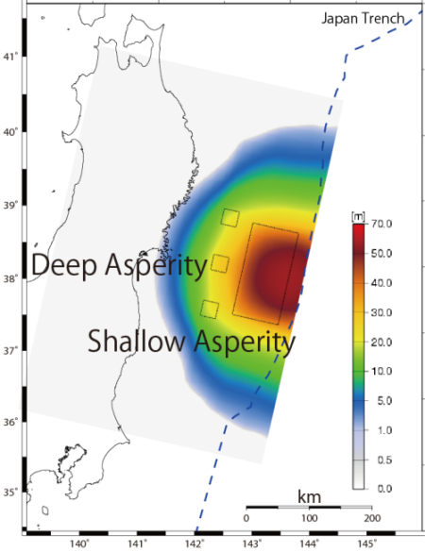Here, we focus on the deep asperities, which radiate short-period ground motions in the model of Tsuda *et al.* (2017) [1]. A simulation with a single deep asperity resulted in the Mw 7.7 rupture and a maximum slip of about 15 m. These results coincide with the M7-M8 class earthquakes that occur deep in the Miyagi-Oki area. We then investigated the slip distribution and source scaling properties of inter-plate earthquakes based on dynamic rupture simulations in which we varied the properties of deep asperities, including their stress drop, strength drop, their number and location.

*FIGURE 1: Slip distribution resulting from the characterized source model by Tsuda et al. (2017) [1]. Black rectangles indicate the location of the asperities.*

### SIMULATION MODEL

We used the spectral element method [3] to simulate the dynamic rupture propagation. We adopted the linear slip-weakening law (e.g., Ida, 1972 [4], FIGURE 2), in which the frictional strength is prescribed as a function of slip. The simplifying assumptions of the model include a homogeneous medium (VS=3.54 km/s, VP=6.3 km/s, and ρ=2.76 g/cm3) and a planar fault.

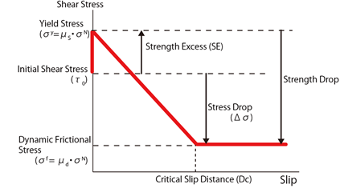

*FIGURE 2: Slip-weakening model (e.g., Ida 1972)*

In order to investigate the fault behavior of M7-8 class earthquakes, we set our basic reference model, Model 0, with a single, deep asperity, the central deep asperity from Tsuda *et al.* (2017) [1]. This model generated relatively large maximum slip, about 15 m. To reduce the maximum slip we modified two parameters, stress drop on the asperity and strength drop on the background area. This modified model is called Model 1.

By taking Model 1 as the base point, we changed some parameters. For Model 2, we added two more asperities in the same depth as the Model 1, with an interval of 20 km. For Model 3 and Model 4, we shifted the along-dip position of the asperity of Model 1 to the shallow side by 50 km and 100 km, respectively. For Model 5, we shifted the along-dip position of the asperities of Model 2 to the shallow side by 100 km. We summarize the features of each model in TABLE 2 and provide a schematic illustration in FIGURE 3.

*TABLE 1: Detail description of simulated models*



**Asperity**

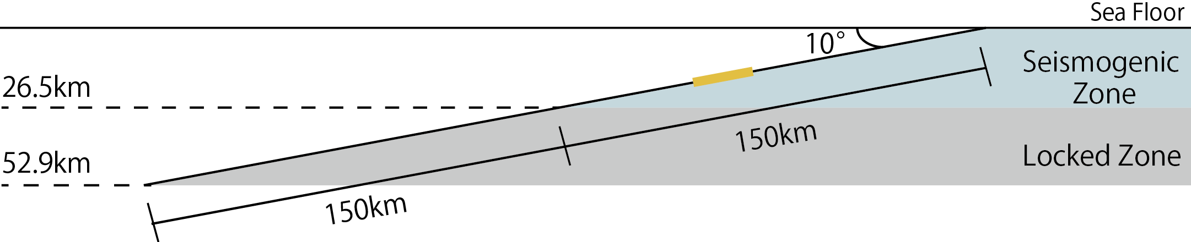

(Depth)

(Along Dip)

(Depth)

(1) Cross Section of the Model 1

25km

75km

125km

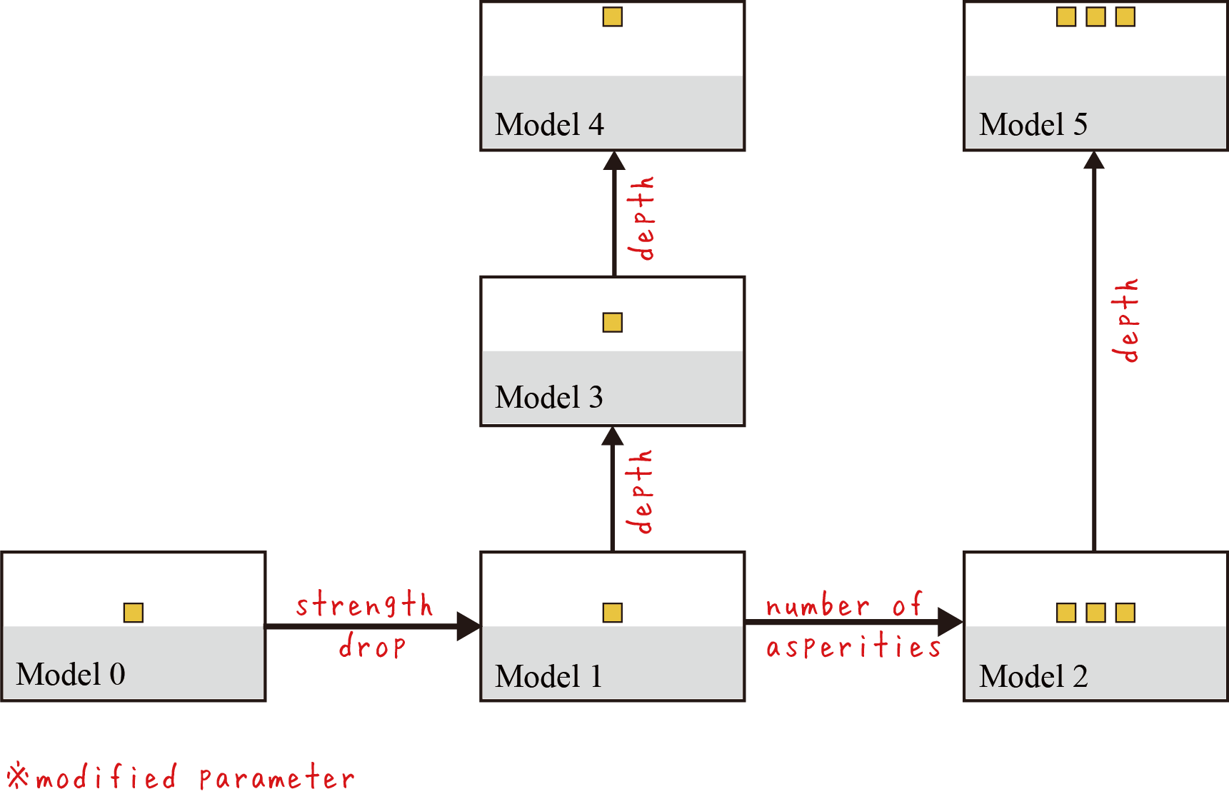

(Along Dip)

(Along Dip)

(Along Dip)

(2) Relations for Each Model

*FIGURE 3: Schematic illustration for simulation models*

For all models, the size of each asperity is the same, i.e. 25 km x 25 km with a constant Dc=0.5m (1.6 m for other areas). The rupture is nucleated in a 16 km x 16 km zone in the middle of the upper side of the asperity. A stress-strengthening zone (negative stress drop) is set beyond 150 km along-dip distance to the trench, representing the lower limit of the seismogenic zone. The stress drop is zero in the rest of the fault.

### RESULTS

#### 3.1. Simulation Results

The simulated slip distributions of Model 0 to Model 5 are shown in Figure 3. Based on the comparison between Model 1 - Model 2 and Model 4 - Model 5, increasing the number of asperities increased the maximum slip of the models by about 50%. In contrast, according to the results of Model 1 and Model 3, the depth of the asperities did not generate significant differences of maximum slip. The effect of breaking the surface on the maximum slip is large, based on the results of Model 4 and Model 5.

Using the simulation results, we have estimated the source parameters, such as the fault area, the resultant seismic moment, etc., based on the following the procedure:

1. Compute the area (S0.001) with slip ≧0.001 m
2. Compute the average slip (D2) within the area S0.001
3. Compute the area (Sfault) with slip ≧30 % of D2, following Somerville *et al.* (1999) [5]
4. Compute the average slip D within the fault area Sfault
5. Compute the seismic moment M0 based on D and Sfault.

We also estimated the average stress drop () based on the following equation:

. (1)

The estimated source properties are summarized in TABLE 2, including the seismic moment M0, the fault area Sfault, the average slip D, etc. Comparisons with empirical scaling laws relating M0 and Sfault, M0 and D, etc. are discussed in the next section.

We examine the ratio of asperity area to fault area, considering the following two definitions of the asperity area: (1) 25 km x 25 km times the number of asperities (Sasperity) and (2) following Sommerville *et al*., 1999 [5], the area with slip at least two times larger than the average slip over the whole fault area (Sarea with slip≧2D). Hence we calculated two surface ratios, S-Ratio 1 = Sasperity / Sfault and S-ratio 2 = Sarea with slip≧2D / Sfault. The results are also shown in TABLE 2. Because of the contrast of stress drop between asperities (15 MPa) and background (0 MPa), the slip diminished right after propagating into the background. This leads to a small value of S-Ratio 1. On the other hand, S-Ratio 2 gives a result generally consistent with previous studies in which the asperity area is about 22% of the fault area (Sommerville *et al.*, 1999 [5]).

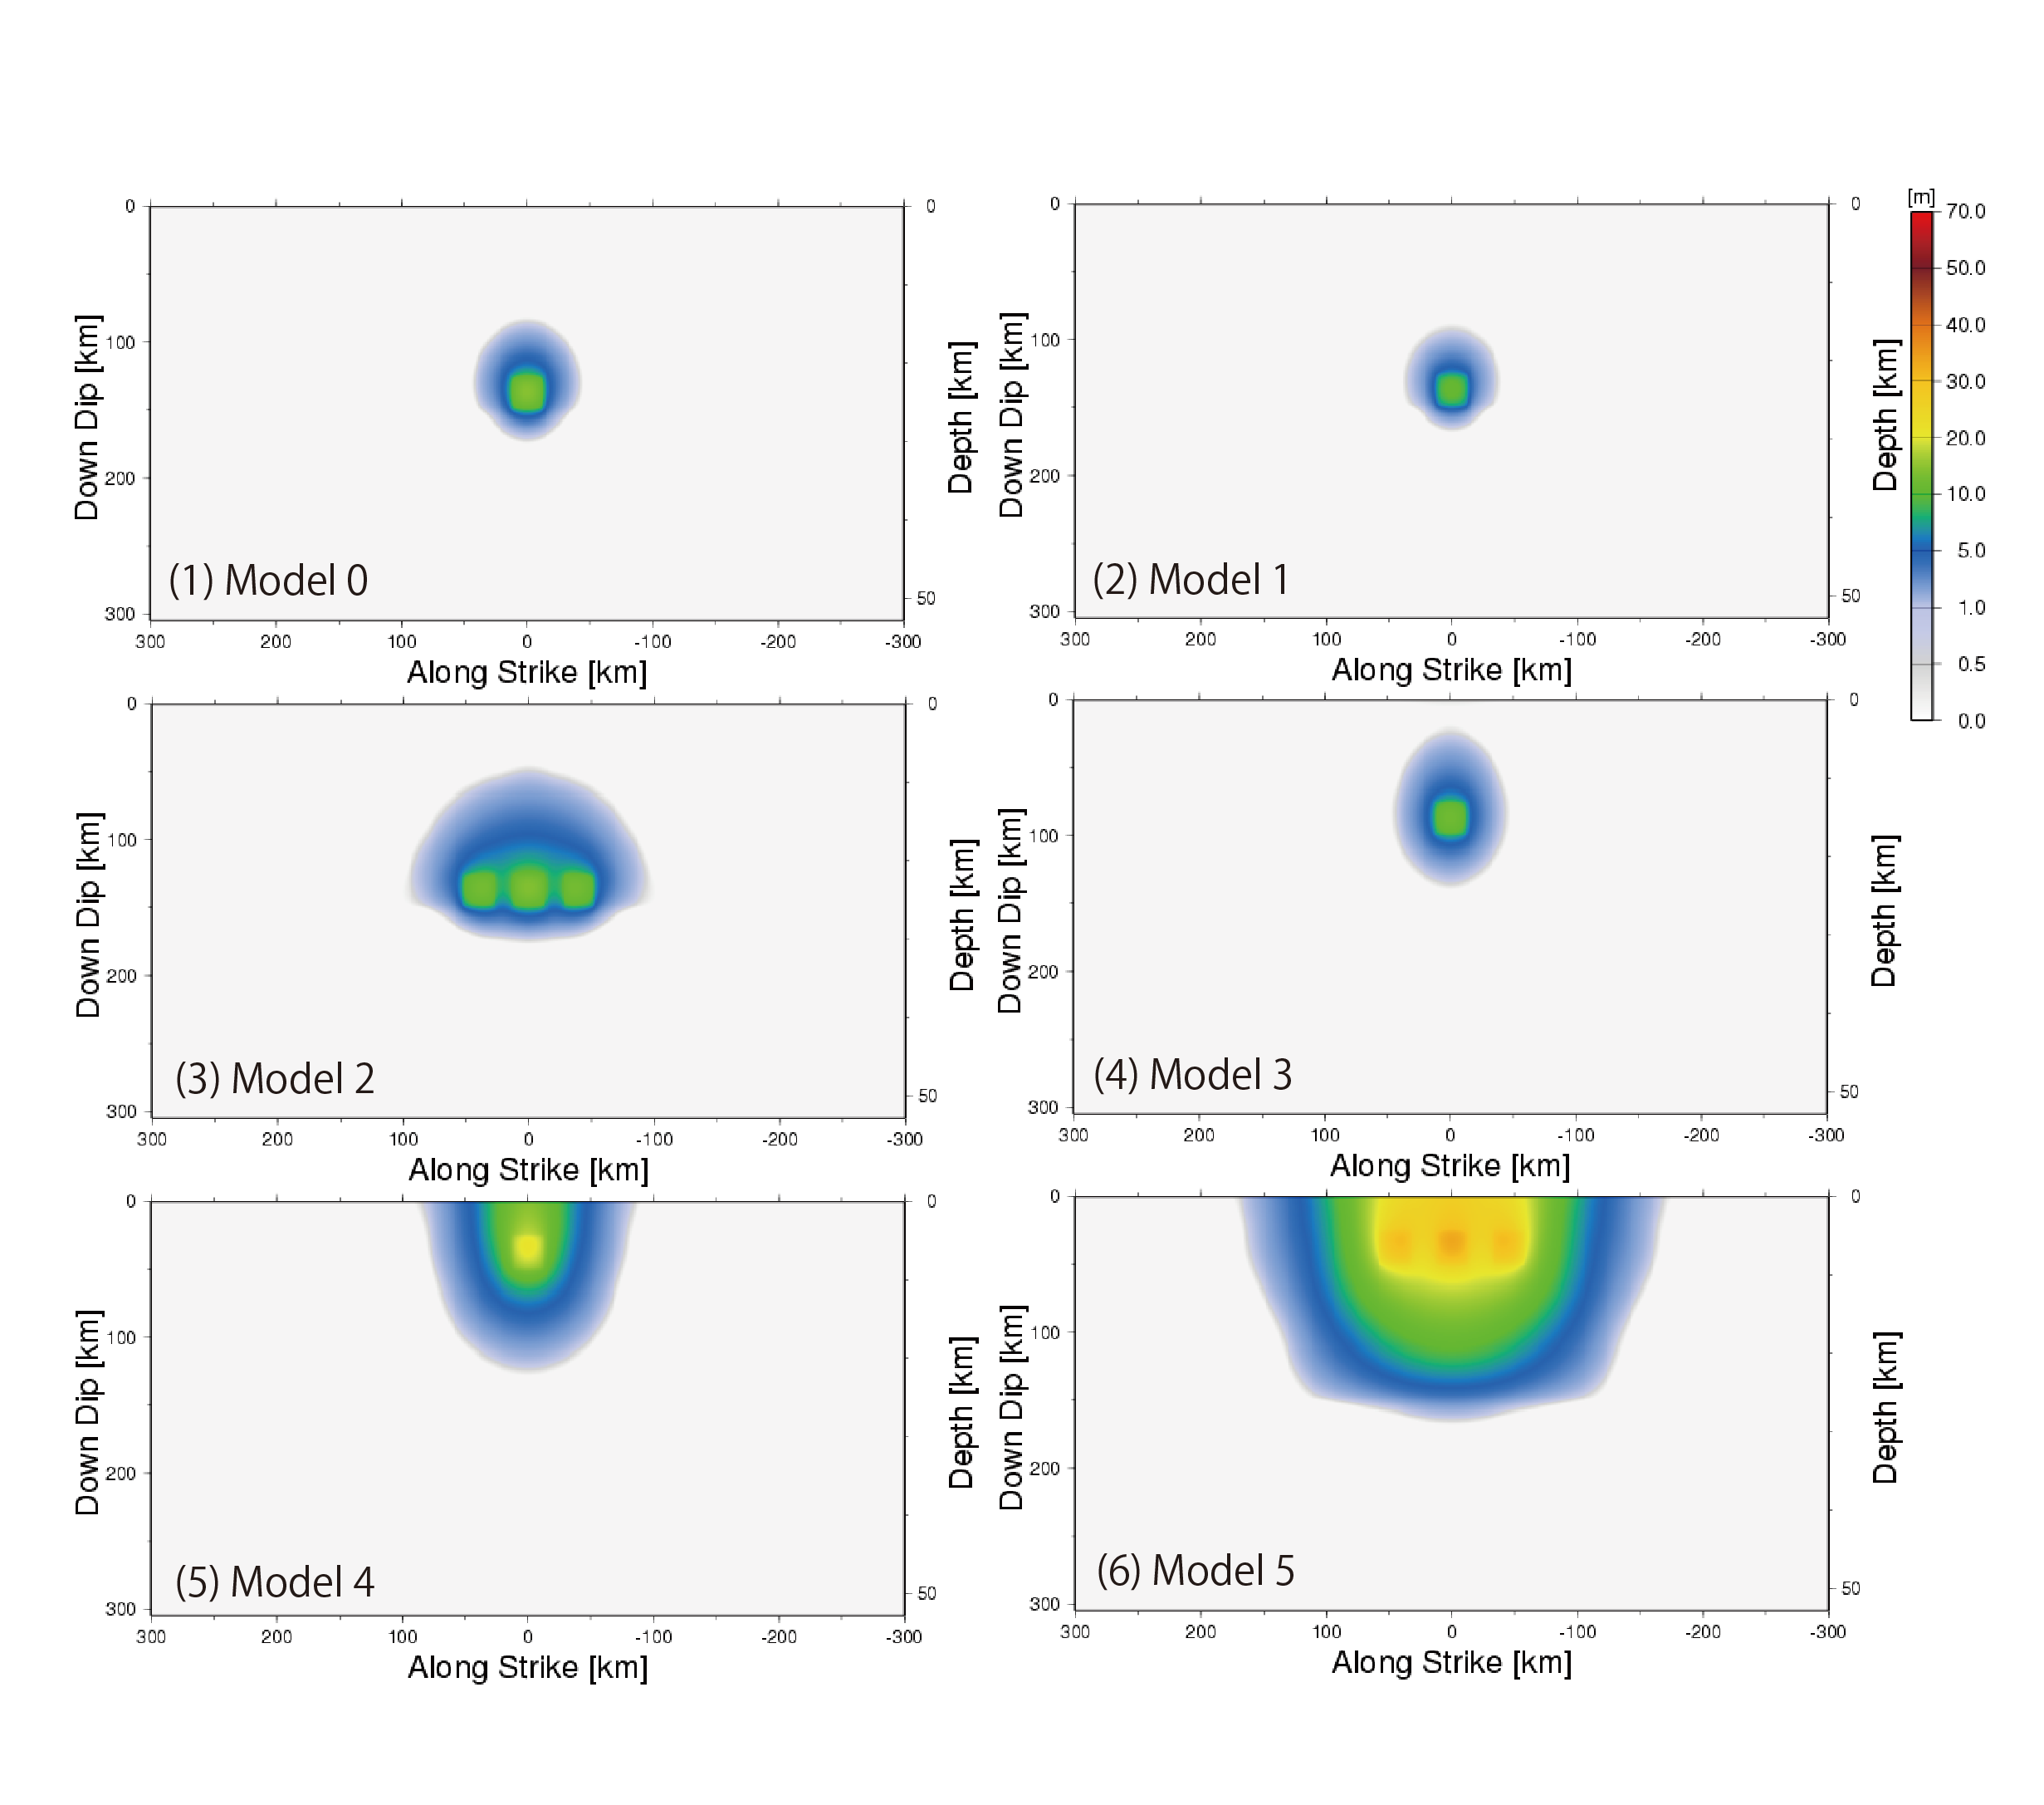

*FIGURE 3: Final slip distributions of Model 0 to Model 5*

*TABLE 2: Analysis results of Model 0 to Model 5*



**3.2. Comparison with empirical scaling laws**

We compare our simulation results with the proposed scaling laws based on source inversion analysis of past subduction earthquakes (Tajima *et al.,* 2013 [6]). The comparison results are shown in FIGURE 4, where FIG.4 (a) shows the effect of the number of asperities (Model 1 and Model 2), FIG.4 (b) shows the effect of the depth of a single asperity (Model 1, Model 3, and Model 4), and finally FIG.4 (c) illustrates the effect of the depth of multiple asperities (Model 2 and Model 5). The fault area, maximum slip and average slip from the simulation results are biased relative to the empirical data, indicating the need for future studies. However, in terms of the slope of the scaling laws, our results are fairly consistent with the empirical data. This may indicate that our simulation results are reasonable and useful to understand the behavior of the M7-M8 class earthquakes that occurred around the Miyagi-Oki area, such as the 1978 Miyagi-Oki earthquake (M7.5).

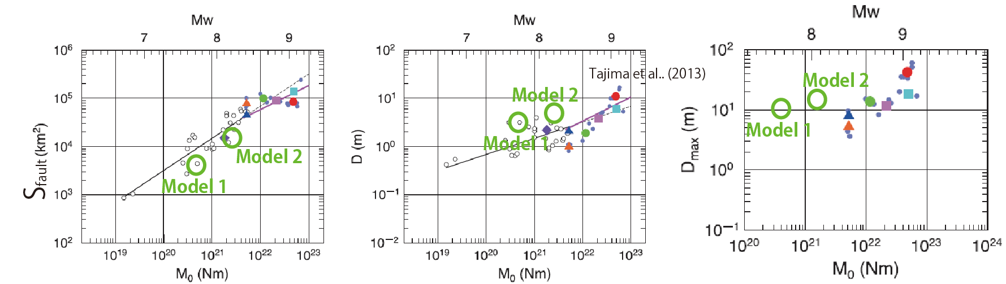

*(a) Models with different numbers of asperity (Model 1 and Model 2)*

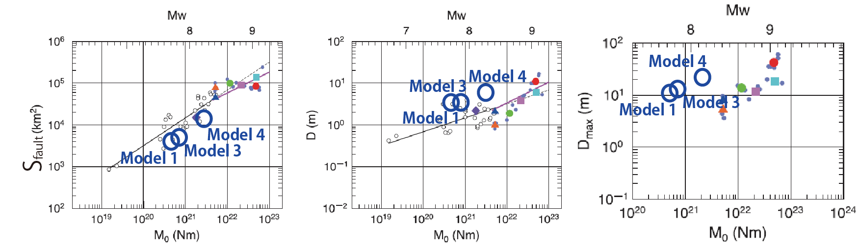

*(b) Models with different depth of single asperity (Model 1, model 3, and Model 4)*

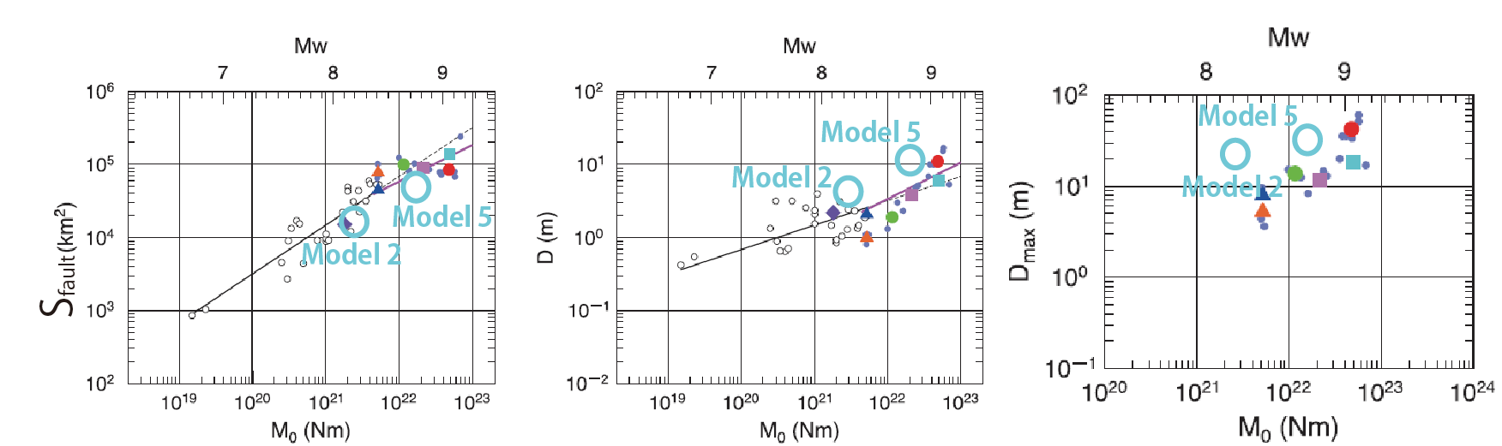

*(c) Models with different depth of multiple asperities (Model 2 and Model 5)*

*FIGURE 4: Comparison of simulation results with empirical scaling laws (Tajima et al，2013 [6])*

### SUMMARY

We simulated dynamic rupture propagation on a subduction megathrust by varying the properties of deep asperities, such as their stress drop, strength drop, number and location, based on the characterized source model for the Tohoku earthquake.

Based on source inversion analysis of past events and compared to previous studies, our simulations generated larger maximum and average slip at a given seismic moment. However, in terms of the slope of the scaling laws of source parameters, our results were fairly consistent. It may indicate that our simulation is useful to understand the behavior of the M7-M8 class earthquakes that occurred around the Miyagi-Oki area, such as the 1978 Miyagi-Oki earthquake (M7.5).

As for the next step, we will reexamine the boundary conditions of the lower limit of the seismogenic zone, where we will impose slip-strengthening condition to allow the rupture penetration to the deeper parts of the fault to expand the fault area and reduce the average slip.

**REFERENCES**

1. Tsuda, K. S. Iwase, Hiroaki. Uratani, S. Ogawa, T. Watanabe, J. Miyakoshi and J. P. Ampuero (2017), Dynamic rupture simulations based on the characterized source model of the 2011 Tohoku earthquake, Pure and Applied Geophysics, 174 (9), 3357–3368.
2. Bletery, Q., Sladen, A., Delouis, B., Vallée, M., Nocquet, J. M., Rolland, L., and Jiang, J. (2014), A detailed source model for the Mw9.0 Tohoku-Oki earthquake reconciling geodesy, seismology and tsunami records, J. Geophys. Res., 119, 7636–7653.
3. Galvez, P., Ampuero, J. P., Dalguer, L. A., Somala, S. N., and Nissen-Meyer, T. F. (2014), Dynamic earthquake rupture modelled with an unstructured 3-D spectral element method applied to the 2011 M9 Tohoku earthquake, Geophys. J. Int., 198 (2), 1222-1240.
4. Ida, Y. (1972), Cohesive force across the tip of a longitudinal-shear crack and Griffith‟s specific surface energy, J. Geophys. Res., 77, 3796-3805.
5. Somerville, P. G., K. Irikura, R. Graves, S. Sawada, D. Wald, N. Abrahamson, Y. Iwasaki, T. Kagawa, N. Smith, A. Kowada (1999), Characterizing crustal earthquake slip models for the prediction of strong ground motion, Seism. Res. Lett., 70, 59-80.
6. Tajima, R., Matsumoto, Y., Si, H., and Irikura, K (2013), Comparative Study on Scaling Relations on Source Parameters for Great Earthquakes in Inland Crusts and on Subducting Plate-Boundaries, Jishin, V2, 66, 3145. (Japanese with English Abstract)