1. **Introduction**

The aim of seismic risk analysis of nuclear power plants is to ensure that the chances of safety goals not being met in case of a severe earthquake are extremely small. It requires performing the fragility estimates of a large list of components which are mandatory to ensure these safety goals during and after an earthquake event. In practice, it is known that some classes of equipment and components very often appear as major contributors to the seismic risk, irrespectively of the nuclear power plant under consideration. It happens that some of these components need hardware modifications in order to improve their robustness in case of severe earthquake. It also occurs that the engineering methods used to evaluate their ultimate capacity are too conservative, leading to an overestimation of their real contribution to the seismic risk.

R&D efforts of the industry practitioners should then focus on the improvement of the understanding and modelling of the ultimate capacity of those generic high contributors to the seismic risk. The aim is to be able to determine if equipment needs reinforcement at the earlier stage of the seismic re-assessment.

Rigorous identification of those generic high contributors to the seismic risk is not an easy task. In this article, we present the approach retained by Framatome to define this generic seismic equipment list (GSEL). Its characteristic feature is to take advantage of the existing database of Seismic Margin Assessments and Seismic Probabilistic Safety Assessments.

Critical analyses of the engineering methods used to evaluate the fragility of GSEL shows that there is place for improvements in order to better assess their seismic risk.

In this paper, we focus on the improvement of modeling of energy dissipation of elastic structures supported by non-linear supports, and on the improvement of the prediction of fragility of electrical and instrumentation and control cabinets.

1. **Identification of major generic contributors to the seismic risk – GSEL**
   1. ***Identification from available results of SPSA and SMA studies***

The purpose of the Seismic Margin Assessment (SMA) is to show that the systems, structures and components (SSCs) critical to achieve a safe shutdown state following an earthquake are designed with large safety margins so that they have a low probability of failure in the Seismic Margin Earthquake (SME)[1].

The Seismic Probabilistic Safety Assessment (SPSA) of a nuclear power plant has the purpose to demonstrate that the contribution of seismic events to overall risk is not excessive.

Both approaches rely on the definition and analysis of a Seismic Equipment List (SEL), collecting the SSC contributing to meet the safety goals. The results of SMA or SPSA give then valuable information on the seismic performance and risk of the components of the SEL like: their dominant failure mode, their High Confidence of Low Probability of Failure (HCLPF) and fragility parameters, their PSA importance metrics (such as the Fussel-Vesely importance). It is noted that these metrics are conditional on the way it the fragility has been determined (with generic or specific method), as well as on the assumptions adopted in the PSA with respect to the dependence between seismic-induced failures and to the fragility of distributed systems.

In order to identify the generic high contributors to the seismic risk, the available data for several projects are gathered in a common database. Several metrics are built in order to rank the component of the SEL in terms of seismic risk. The different metrics are then weighted to reach a unique criterion, which is normalized. Hence, the most penalizing component is attributed a value of 100%. At the end, the components for which the indicator exceeds a given threshold are considered to be part of the GSEL (generic seismic equipment list).

Thanks to this method, the classes of components that often drive the seismic vulnerability are rigorously identified. The outcome of this work is that HVAC systems, cable trays, electrical equipment and I&C panels are significant generic contributors to the seismic risk.

* 1. ***From experience of seismic re-assessment***

In order to get a complete overview of the generic contributors to the seismic risk, it is also interesting to review the experience of seismic re-assessment for different industrial sites. It appears that the following issues often lead to a need for in-depth studies in order to achieve justification:

-Justification of reinforced concrete building when damages appear,

-Sliding and rocking structures or components (unanchored equipment, handling cranes and machinery),

-Structures and systems on nonlinear supports (seismically isolated buildings, yielding supports),

-Immersed components with high fluid-structure interaction effects.

Hence those components should be added to the GSEL.

1. **Critical analysis of the engineering methods**

Once the major generic contributors to the seismic risk are known, it is important to evaluate and, if necessary, improve the analysis methodologies that have led to identify those components as critical. Hence, if the fragilities estimates of those components are based on too conservative methods, then their seismic vulnerability is overestimated, which is not the goal of a SMA or SPSA.

The present paper follows up on the observation that the modelling of the dissipation of linear structures on nonlinear supports can be improved in order to better assess the seismic demand on those structures.

Furthermore, the paper elaborates on improvements in predicting the fragility of electrical cabinets.

1. **Improvement of damping modeling in case of sliding or yielding structures**

This section sums up a work presented in detail in [1].

***4.1 State of the art***

The sources of energy dissipation in structures are multiple and potentially rather complex to model. For elastic structures, it is common practice to model damping forces thanks to a linear viscous damping model. Usually this damping is introduced considering the proportional damping model, called Rayleigh damping.

The Rayleigh damping model is based on two coefficients that define the viscous damping matrix as a combination of terms proportional to the mass matrix,  [M], and the stiffness matrix,  [K].

While the stiffness matrix proportional term induces damping proportional to the deformations of the structures, the mass matrix proportional term induces damping when rigid motions are applied, which is not acceptable.

As a consequence, in presence of rigid body motion, cautious engineers only use the  [K] part, leading to a conservative modeling of the damping of the lower frequency modes.

***4.2 Development of the “GHOST” methodology***

The “ghost” methodology aims at producing damping forces on the linear structure which are only proportional to the structure deformation velocities. To achieve this goal, the velocity corresponding to the rigid body motion of the linear part of the model is subtracted from the overall velocity when constructing the damping force vectors, as presented in equation (1).

(1)

The rigid body motion is evaluated thanks to a rigid model of the structure that follows the displacements and rotations of the structure, defined as a function of the kinematics of some key nodes. Thanks to this technique, full Rayleigh damping can be introduced.

***4.3 Improvements in seismic demand assessment***

In order to show the benefit of such an improvement of modeling, the case of a building on a seismic isolation system is considered. In that situation, the building remains linear whereas isolators undergo significant deformation. Hence the isolated building belongs to the category of nonlinearly supported linear structures. Figure 1 shows the building model, supported at its bottom.

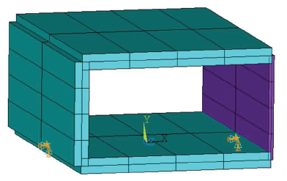

Figure 1. Overview of the building model

Figure 2 compares results obtained using only  [K] part and using the ghost methodology, both with a target of 7% reduced damping.

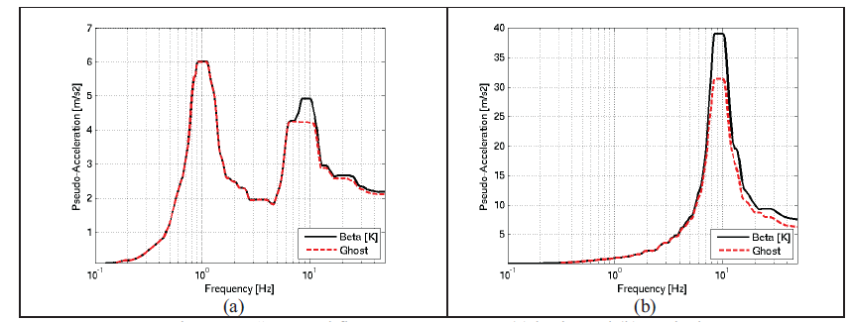

Figure 2. Comparison of the floor response spectra (a) horizontal (b) vertical

Clearly, the use of the more realistic ghost methodology results in a reduced seismic demand, and hence in a less conservative estimation of the fragility of the equipment.

1. **Improvement in the determination of capacity of electrical equipment** 
   1. ***State of the art***

The estimation of the capacity of electrical cabinets of Nuclear Power Plants is often based on the qualification tests of the cabinet on a shaking table. It can be assumed that the capacity is defined by the required response spectra defined for the test qualification. This spectrum can then be compared to the seismic demand at the floor anchorage.

It is conservative in the sense that even though the cabinet did not effectively fail during the test, the equipment behavior beyond tested levels remains unknown and in the standard fragility methodology based on EPRI TR-103959 de-facto no significant margin can be credited.

This contributes to the consequence that electrical cabinets are identified as generic high contributor to the seismic risk.

* 1. ***Better understanding and characterization of the failure modes***

Electrical cabinets contain a large number of electrical components. Among them, relays are known to be weak points (“bad actors”), because of possible chattering. Chattering induces an interruption of electrical signal during few milliseconds that could have detrimental consequences on the plant operation during the earthquake. This is considered to be one of the most likely failure modes of an electrical cabinet.

In order to better assess the dynamic behavior of relays, sine sweep tests are performed on individual components. The sine sweeps are unidirectional, acceleration controlled, with constant amplitude. Several tests with increasing acceleration amplitudes are performed in order to identify maps of failure, as presented in Figure 3.



Figure 3. Illustrative failure map of a relay

In order to evaluate the capacity of the component, an artificial sine sweep test is built. Its amplitude varies with the frequency in order to match the limit of the safe zone. Its response spectrum defines the capacity of the component.

* 1. ***Estimation of the capacity to seismic demand of the electrical cabinet***

At this stage, it is mandatory to build the link between the seismic demand at the anchorage level of the cabinet and the seismic demand at the level of the electrical / I&C devices.

*In – depth analysis*

In order to define the seismic demand at the level of the component, the transfer function of the cabinet between the anchorage and the device has to be determined.

Tests performed on cabinets, sine sweep tests or seismic excitation tests, can be used for extracting damping and Eigen frequencies of dominant modes. These are then supplemented by numerical simulations in order to retrieve transfer function for any positions within the cabinet, or to identify the dynamic behavior of a non-tested cabinet, providing its design is similar to tested cabinets.

Electrical cabinets are rather stiff and low damped structures. In general, electrical cabinets exhibit few modes in the frequency range of the seismic excitations, Eigen frequencies are typically higher than 10 Hz. Figure 4 shows the typical behavior of an electrical cabinet.

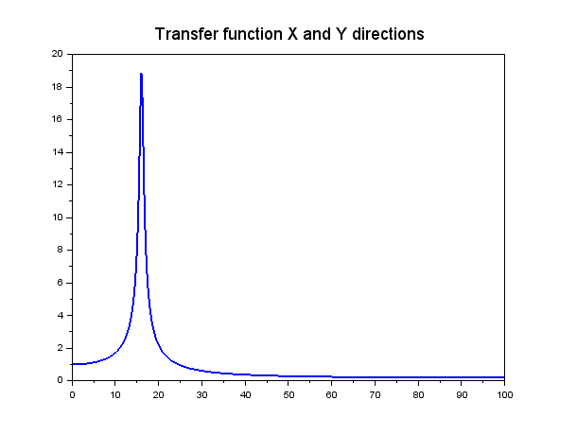

Figure 4. Illustrative transfer function of a cabinet between the anchorage and an inner position

The capacity to demand ratio for the cabinet can then be established by performing the following steps. Firstly, time histories for a given seismic scenario are generated, either by direct calculations or from the floor response spectrum. Then the corresponding time histories at the level of the devices are estimated thanks to the transfer function of the cabinet. Their response spectrum is compared to the capacity of the device, in order to get the minimum capacity to demand ratio for each component. Particular attention is paid to the zero period acceleration which is compared to the maximum quasi static acceleration measured in tests. Finally, the minimum ratio of all the safety-relevant devices is the capacity to demand ratio of the cabinet devices.

Considering the large number of cabinets in a nuclear power plant, this method would require a large effort in order to analyze all cabinets.

*Simplified method*

In order to get a quick view of the electrical cabinets that could be significant contributors to the seismic risk, a simplified method is developed, taking advantage of the dynamic properties of the electrical cabinets.

In a first stage, for each device, the corresponding capacity at the anchorage level is determined by applying the inverse transfer function of the cabinet to the sine sweep defining the safe zone of the devices. The minimum of all the evaluated capacities defines the capacity of the electrical cabinets at the anchorage level. This capacity can then directly be compared to the probabilistic seismic demand at the floor level to get the capacity to demand ratio of the cabinet.

This simplified method is approximate. Nonetheless, it permits a first analysis of the seismic risk for the electrical cabinets in a very efficient way.

Figure 4 and 5 show a comparison of the in-depth method and simplified method. In Figure (4), the comparison of the capacity of a component and of the seismic demand is performed at the anchorage level (base level), following the simplified methodology. Figure (4a) shows the comparison in terms of response spectrum. Figure (4b) illustrates the evolution of the capacity to demand ratio as a function of frequency. Figure (5) presents the same data but this time following the in-depth methodology, i.e. comparison of the capacity and the demand at the level of the component. A very good agreement is found validating the simplified method.

Hence, all electrical cabinets presenting a large ratio capacity to seismic demand ratio with the simplified method do not need a deeper investigation. For the remaining cabinets, it is necessary to perform an in-depth study, in particular to characterize the ZPA seen by the device.

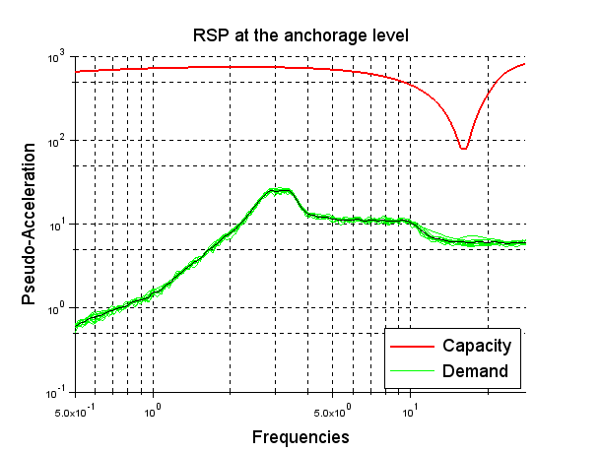 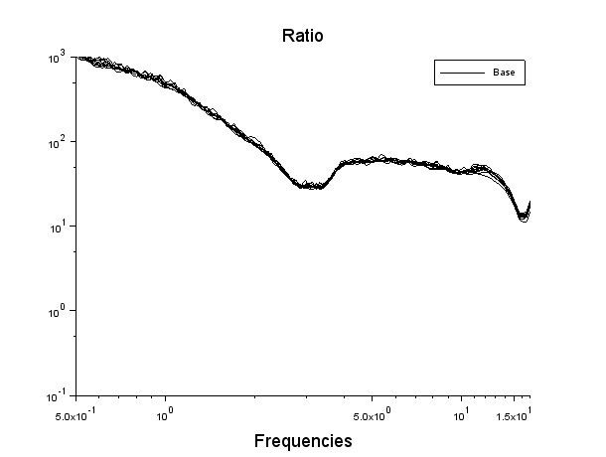

Figure 4. Comparison of the capacity to demand at the anchorage level; (a) response spectrum, (b) ratio

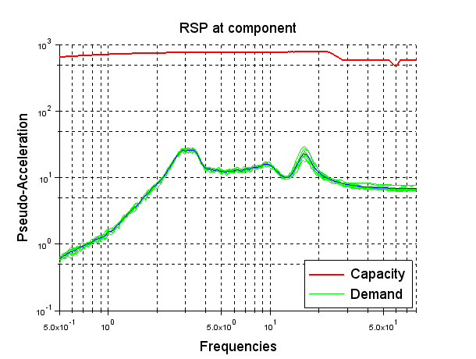 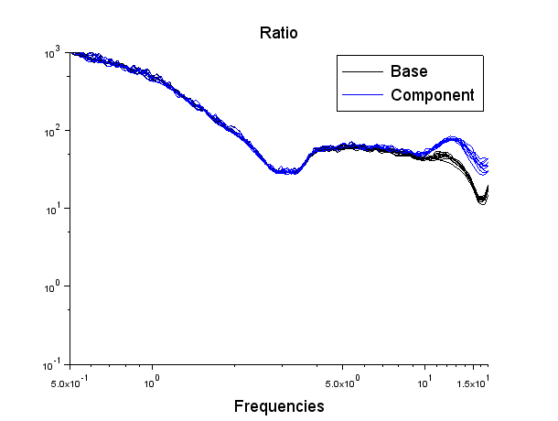

Figure 5. Comparison of the capacity to demand at the device level; (a) response spectrum, (b) ratio

* 1. ***Towards an integrated tool***

Considering the nature of the analyses, it is envisioned to develop a generic database and automatic query to assess the seismic risk of electrical cabinets at an early stage.

This database is composed of 4 tables: plant, seismic demand, electrical cabinet and device tables.

1. **Conclusion**

Identification of generic high contributors allows concentrating R&D on the understanding and modelling of ultimate capacity of those components. In particular, methodological improvements are a way to increase the robustness of the prediction of the seismic risk associated with those components. In this paper, two methodological developments that can lead to a better prediction of the capacity of high contributors to the seismic risk have been presented. Hence, as dissipation is known to play an important role in the estimation of the capacity of structures, a new method has been developed to better model dissipation of linear structures supported by non-linear supports. What’s more, as electrical cabinets have been identified as potentially high contributors to the seismic risk, in this paper, an innovative strategy in order to better assess their capacity to demand ratio has been presented. In particular, a simplified method that allows performing a first evaluation in a very efficient is proposed.

**References:**

[1] Nadim Moussallam et al. 2015- SMIRT 23

Application of proportional “ghost” damping for sliding or yielding structures in time history dynamic analyses

1. The SME is the seismic demand level assumed in the SMA; the margin between the SME and the design basis earthquake (DBE) is the minimum acceptable margin.